PIN CONFIGRATION OF CD4011

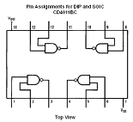

The CD4011 BC Quad 2-input Nand buffered B series gates are monolithic complementary MOS (CMOS) integrated circuit constructed with N- and P-channel enhancement mode transistors. They have equal source and sink current capabilities and confirm to standard B series output drive. The devices also have buffered output, which improve transfer characteristic by providing very high gain.

All input are protected against static discharge with diodes to Vdd to Vss.

FRETURES: -

- Low power TTL
Fanout of 2 driving 74L compatibility: or 1 driving 74LS
- 5V-10V-15V parametric rating
- Symmetrical output characteristics
- Maximum input rating 1ua to at 15V over full temperature range

Order number | Package number | Package Description
CD4011BCM | M14A | 14-Lead Small Outline Integrated Circuit(SOIC) JEDEC MS-012, 0.150*Narrow
CD4011BCN | N14A | 14-Lead Plastic Dual in Line Package(PDLP) JEDEC MS-001,0.300* Wide

SCHEMATIC DIAGRAM OF CD4011BC

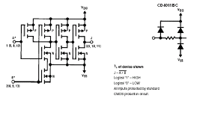

ABSOLUTE MAXIMUM RATING:-

Voltage at any pin -0.5V to Vdd +0.5V
Power Dissipation (Pd)
Dual in Line 700mV
Small outline 500mV
Vdd Range -0.5Vdc to 18Vdc
Storage Temperature (Ts) -65degC to 150degC
Lead Temperature (TL)
(Soldering, 10 Seconds) 260degC
Operating Range (Vdd ) 3Vdc to 15 Vdc
Operating Temperature Range
CD4011BC -55degC to 125degC

