ABOUT THE COMPANY

INSTUMENTATION LIMITED is a Govt. of India Enterprise set up in 1964 with the prime objective of attaining self reliance in the field of control & automation for the process industry. Today IL is manufacturing and supplying control equipments on turnkey basis to various sectors of the industry (viz. power, steel, fertilizers, chemical, petrochemical refineries, pharmaceutical, cement, paper, textiles, space, oil and gas)
IL has its plants at Kota, Jaipur & Palghat (Kerala). With over 25 years of experience and a dedicated work force, IL has measured all complexities of control system requirements and can lead you right through your project from system design, detailed engineering, manufacturing, installation, final commissioning to after sales service & customer training.
IL is now diversifying in the field of Telecommunication, Power electronics & Railway signaling system.
IL after establishing itself as an undisputed leader has crossed the Indian borders to supply equipment (on turkey basis) in international markets. IL has supplied instrumentation on Turkey basis for two thermal power stations in Malaysia established a service center at Kufa complex in Iraq; supplied instrumentation for Ethiopian petroleum company of Ethiopia; supplied instrumentation for Esphahan steel plant., Iran. And also a major break through has been made in capturing the market for Hi-Tech Digital Control System for refineries in the U.S.S.R.

ORGANISATION STRUCTURE

Keeping in view the magnitude of operations & requirements, the company has been divided in five units as per organization chart enclosed. The Palghat unit is engaged in manufacturing the control values, safety valves and allied products. The Digital Electronics unit is engaged in manufacture of CONTRONIC-3 product and TOSDIC Distributed Digital control instrumentation. Kota unit is manufacturing Electronic Transmitters, BBK. Range of instruments, Gas Analyzers, Pneumatic instruments, Defence instruments & Control Panels etc.
The commercial unit of the company looks after the control instrument needs of Thermal Power plants & steel plants. The project are undertaken on Turkey basis & encompass activities right from system design stage to auction and commissioning.
Marketing unit cater to the needs of small system & retail market viz. refineries, chemicals, cement, fertilizers and other process industries.
Co-operation function of company in being looked after by co-operation head quarter unit. Corporate R&D center is engaged in future development in the field of process control instruments. Each unit is further divided into various functional section of efficient & smooth functioning of units and then company as a whole.

TELECOM – PRODUCTS

ELECTRONIC EXCHANGES

The centre of Development of Telematics (C-DOT) was established with the view to develop indigenously a telephone switch to be the standard equipment in the telephone exchanges of the country. The telephone switch is the heart of a telephone exchange & perform all operations required to connect to subscribers as & when they desire.

THE TELEPHONE SWITCH
The purpose of telephone exchange or switch is to connect any subscriber to any other subscriber. The two subscriber may be in entirely different parts of the world even. In the latter case, the connections may have to pass through one or more than one trunk exchanges. The operations of setting up of a call involves the following steps:
Calling subscriber alerts the exchange that he wants to make a call.
The operator in exchange connects himself to the calling subscriber.
The operator gets the number of the party to whom the connection is to be made.
The operator checks whether the called party is free.
If the called party is free, the operator switches on a link between the calling number and called number; or else he provides the engage tone (the operator is now free to attend other callers)
When the call is over, the operator is alerted that the link is no longer required.
The operator releases the links which may be now used for other calls.
In the manual exchange, these operations are performed by a human operator; in an automatic exchange they are performed by machines, which till recently were electro-mechanical, now the trend is to have electronic switches only. Electronic exchanges are preferred because they are compact, need less power, are faster, require less maintenance & because they can provide facilities which are quite impractical.
For instance, forwarding incoming calls to new number when the subscriber leaves home and visits another station when the subscriber leaves home and visits another station for a short while can be done fairly easily electronically. Then any subscriber can receive whenever he or she is, with mechanical switches that is quite impossible.
The performance of a switch is determined mainly by four parameters.
- The total number of switches.
- The total number of subscribers that may be connected.
- The total number of calls that may be made at any time.
- And the maximum number of calls that may be attended to in an hour. The last one is also called Busy hour Call Attempts (BHCA).

THE BHCA PROBLEM
Generally, large exchanges at any rate are of blocking type – not all subscriber can put in call simultaneously. This is done on the assumptions, quite reasonably too, that not all subscribers will be busy at one and the same time; in fact, most of the time, most telephones will be idle. So, statistically, the number of connecting links or lines inside the exchange can be much smaller than the number of subscribers and yet they may all get the connection as and when desired for instance only a 100 lines may be provided in an exchange having 1000 subscribers –on an assumption that 100+100 subscribers only will be busy at any one instant. If by chance, more subscribers contact the exchange, they will get a busy tone & they will have to wait till some line or other gets cleared.
In India, in all offices, each telephone is used by a number of people, so such telephones are often kept engaged virtually by someone or other. That is all official telephones tend to remain very busy during office hours. As a result, in a blocking type exchange where the number of connecting lines within the exchange is limited, many cannot get connection lines even if the called subscriber happens to be free. What is more important is the busy hour call attempt (BHCA) problem.
In non blocking exchange where the number of connections equals the subscribers, if a thousand connections are required in an hour, the number of call attempts will be little more than thousand ( extra calls are required whenever a subscriber is busy). In a block9ng type of exchange, extra calls have to be made both when the called subscriber is busy, and when the exchange itself is unable to handle more calls. So in a country like India where telephones are scarce and each telephone is used by many people it is great advantage to have non blocking type of switches.

ELECTRONIC EXCHANGES IN INDIA

In India, there are currently three electronic switches in use (or under test). These are E-10Bmanufactured under license from Alcatel of France by the India Telephone Industries (ITI) manakpur, U.P.; IL indigenously developed & manufactured by ITI at Banglore & the C-DOT switch developed by the Center for development of Telematics with a number of companies licensed to manufacture the same.
A telephone exchange may be divided into three parts; the subscriber interface, the trunk interface and the service interface. The subscriber interface, as its name implies, links the subscriber’s instrument (telephone, facsimile & whatever) to the exchange, identifies whatever the subscriber wants to make a call or has completed a call. It include RLC & RSU. Trunk interface performs the operations required when the connections have to be made with a remote exchange while the service interface control dial, busy number unobtainable tones, performs the signaling etc. In E-10B all these are distinct in ILT & C-DOT, subscriber interface and trunk interface are combined together but service interface is different.
E-10B is less flexible because even for small exchange, the full control switch & control operation maintenance center has to be installed. So it is not economical tfor exchanges with less than 10,000 lines. In this respect C-DOT is more flexible. It is fully modular – it can be used with small exchanges with only 512 ports(terminals) or four of these could be put together to make a 2048 (2k) switch. Further still four 2k switch & finally a 32k switch even. That is like the multiunit trains operated on suburban railways- as and when required, more & more of the basic module can be coupled to form a larger & larger unit.
However because the same switches are used for three (subscriber, trunk and services) interfaces, a 512 C-DOT cannot connect 512 subscribers, but some smaller number around 300-400 depending on other demands. This is the case when it is added as a non blocking switch. If certain amount of blocking is accepted, appreciably more number of subscribers can be controlled.

C-DOT EXCHANGES
C-DOT exchanges are the family of Digital switching system (DSS) for local, random & transit applications (or a combination of these) for rural, urban and metropolitan areas.

C-DOT DSS FAMILY
The C-DOT Digital Switching System (DSS) family of products utilizes four basic modules:
- BM – Base module
- CM – Central module
- AM – Administration module
- IOP – Input output processor
The BM provides all the appropriate interfaces to the terminal equipments.
Subscribers lines – Ordinary analog, PBX, coin collection bones etc.
Trunks – Analog 2-wire, E7M 2-wire E&M 4wire, digital etc.
Remote module – Line concentration (LC) / Remote Switching Unit(RSU)
The BM converts analog information of 512 termination (lines & trunks) to PCM format, performs signaling interface and organizes, through time switching, information in two 512 channel links for the CM. Base module is also capable of handling 512 terminations on a ‘stand alone’ exchange mode performs exchange maintenance & administration function with help of IOP, just as the Am. In ‘stand alone’ single base module RAX configuration, IOP & ADP (Alarm Display Panel) are connected to BM since BM handles all AM functions.
CM provides space switching capabilities to connect – 32 BM’s together. This provides for a time –space –time (TST) switching configuration capability to handle non blocking switching up to16,000 terminations by interconnecting 32 BM’s.
IOP is a full- fledged 16 bit computer system. IOP communicates with AM for various administrative-functions. It interfaces a variety of peripheral devices such as disk, magnetic tapes (spool, cartridge) printer, VDU’s for printing maintenance & administrative reports. It also provides the man machine command position. ADP displays health of all units and terminations (lines & trunks) in the exchange. ADP is connected to AM through DDLC message link.
INTRODUCTION

The C-DOT 128 RAX is a digital stored program controlled (SPC) switching system with a capacity of 128 terminations.
These terminations include subscriber lines, trunk to other exchanges & tones etc. The RAX employs a completely non-blocking switching network which form the basis of a high capacity , total availability switching system.
The system has been designed to suit the distinctive needs of developing countries like India. The system incorporates the following design features to meet the rigorous demands of such an environment.
Low power components are used to reduce power consumption & hence the cooling requirements.
Duplication of all electronics ensures that no failure affects more than & terminations.
High system reliability is ensured by automatic online diagnostics for fault isolation & recovery.
Care of installation.
Flexible system of dimensioning.
Any easy to use, exhaustive set of subscriber, maintenances & system features.

C - DOT SBM – RAX OR MAX

The C-DOT Single Base Module(SBM) Exchange:
C-DOT supports 512 terminals in its minimum non-blocking configuration. The architecture supports concentration upto 1:4 on lines but in case of concentration, the configuration no longer remains non blocking. With 1:4 concentration on terminations, C-DOT SBM RAX is flexible enough or it to work as a remote module(RM) or as a Rural Automatic Exchange(RAX) – capable of local switching & metering. RM is connected to the BM of the parent exchange via digital links. It can serve remote subscribes with the same feature & services as provided to the subscriber connected to the host exchange. Normally, all outgoing calls between subscribers connected to RM are routed via the parent exchange. However in case of PCM link failure, local switching can be done by RM itself.
C-DOT SBM RAX can also work as an integrated local & Trunk exchange(ILT). It works as both a local exchange, it can work in tandem with the Trunk Automatic exchange(TAX).

C-DOT SBM RAX ARCHITECTURE ORGANISATION

C-DOT SBM RAX comprises of following units:
Base Module(BM)
Input Output Processor(IOP)
Alarm Display Panel(ADP)

Base Module(BM): It consist of the following units
Time Switch (TS)
Terminal Unit (TU) (4, TU1 to TU4)
Service Unit (SU)
Control Unit (CU)
Time Switch (TS) is a fully non blocking switching network for switching time slots for eight, 128 channels, 8mb/sec serial PCM links.
Four of the eight 128 channels links are used for terminating service unit (SU) which provides necessary service link tones, DTMF receivers & MF sender & receiver units. Rests of the three links are used for providing 3-party conferencing facility which is exploited for implementations of conference & trunk offer features.
Terminal units provide interface to ordinary subscribers, CCB subscribers, PABX subscribers, inter exchange analog & digital trunks & digital links from remote concentrator or Remote Base module. One terminal unit can support a maximum of 128 terminations & employs one signaling procedure card (SPC) and one Terminal Interface Controller (TIC) card for managing the processing function.
The analog lines & trunks are offered BORSHT function on the Terminal cards (TC) equipped on TU’s. these functions are-
Battery fed
Overvoltage protection
Ringing
Supervision
Coding & Decoding
Hybrid
Testing
Ringing function & access to external line for testing are achieved through separate relays.
Control Unit (CU) consists of a Base Processor (BP) and Base Message Switch (BMS). BP is the 16-Bit microprocessor based master control in the C-DOT SBM RRAX and performs all the call processing, exchange administration and maintenance functions. For all these functions it exercises control over all the TU’s and SU. All the interprocessing messages are routed through BMS. BP is connected to IOP and BDP through direct HDLC message links since it handles all the administrative function of a multi BM exchange.
Each TIC has a control channel reserved on 128 channel link to the TS for message communication with BP. All the control channels are switched by TS on the services and control interface controller (SCIC) which is used for interfacing service & control unit to TS. A maximum of 16 channels are provided for message communication on BM’s. all the message channels from TIC’s, SCIC and controller card of SU are switched on to the BP by the BM’s. Similarly message from BP are routed to their respective destinations by the BM’s.
Bp has a direct message link to the Time Switch Controller (TSC) for switching & required network paths in the time switch (TS).
An add-on CCITT NO-7 signaling unit (NO:TSU) using the standard TIC interface can be connected to the time switch. The NO:TSU is designed to handle a number of different protocol channels working at 64kb/sec. a number of such protocols channels are nailed up to time slot 16 of digital trunks via the switching network. Some of these channels are also used for message communication through the BM’s or for handling CCITT specified protocol message channel to PBAX, remote module (RM) etc.

CONCENTRATION
More than one (but maximum of four) TU’s can share the 128-channel link towards TS, thus enabling the concentration of more than 128 terminations (max. 512) on to the links. N case of concentration of more than one terminal unit on the same 128 channel link, the configuration will no longer be non blocking. So with concentration of 1:4, C-DOT SBM AX can support maximum of 2048 lines and trunk termination. In most of the practical situations in a single BM exchange, one terminal unit is equipped with trunk cards only and the remaining three with line cards. The concentration is, in those cases, provided on three 128 channel links only which have line terminal units connected. For maximum of 1:4 concentration on three line TU’s maximum of 1536 lines terminations and 128 trunk termination can be supported. Normally concentration is not given on trunks (TU’S).

INPUT OUTPUT PROCESSOR (IOP)
IOP is the front end computer system which supports man machine communication and interface to mass memory.
Mass memory id available in the form of disk, cartridge and magnetic tape transport (MTT). Disk is utilized for storing program & data backup. Most of data reports being generated by the system are logged on the disk memory. MTT’s are used for transport of data from system to either software center or to the billing center for functions like charging, fault analysis, traffic analysis etc. the IOP also provides access interfaces to video display unit, hard copy printers etc.

ALARRM DISPLY PANEL (ADP)
ADP displays the health of the units and terminations (lines or trunks) in the exchanges. ADP receivers health report of units and terminations from BPC through direct HDLC message link provided between them.

REDUNDANCY IN ARCHITECHTURE
All the units controlling more than 8 subscribers are duplicated. Thus TIC, TS, SCIS, BMS, BP and IOP are duplicated. Duplicated TIC, TSC, SCIC, BMS & IOP have individual memory units. BP has duplicated memory units. All the links in the system (message or speech) link TC-TIC, TIC-TS, SCIC-TS, BMS-SCIC, BP-IOP are duplicated too.
IOP supporting mass memory devices, printers and video display units is also duplicated.

SALIENT FEATURES:
Non blocking switching matrix upto 512 termination.
Flexibility in configuration growth.
BHCA upto 8000 can be handled.
Constant current source for line feed.
Per channel PCM codec.
Distributed power supplies.
Digital tone generation.
Same size of PCB’s throughout the system.
Redundancy in hardware at all levels except at line & trunk interface.
Distributed processors.

SYSTEM ARCHITECTURE

OVERVIEW
The CDOT 128 RAX has been designed by reconfiguration the basic building block for high capacity systems of the C-DOT-DSS family. The system is highly modular & flexible to the changing technology.

SYSTEM ARCHITECTURE
All subscriber lines & trunks are interfaced to the system through the terminal interfaces. Four terminals interfaces from a terminal group (T6) & each terminal interface caters to 8 terminations. Thus, the 16 terminal interface can serve a maximum of 128 terminations.

TERMINAL GROUP (TG)
Analog information over the terminations are first changed to digital form at a bit rate of 64 Kbps. Such a 32 PCM (pulse code modulation) channels from the four terminal interfaces, are time division multiplexed (TDM) to generate the PCM 32 link with a data rate of 2.048 Mbps. Thus from the 16 terminal interfaces we get four PCM links which are connected to the switching network.

SWITCHING NETWORK(SN)
It is a completely non blocking network & allows for higher traffic handling capacitors. The four PCM 32 links from the terminal groups undergo time- division multiplexing (TDM) to generate PCM 128 channel links of a bit rate of 8 Mbps.
After switching of channels is done under the control of terminal interface controller (TIC) the 128 PCM channel link is demultiplexed to regenerate the four PCM 32 links at 2.048 Mbps which carry the switched information back to the terminal interfaces.

SIGNAL PROCESSOR (SP):
Signaling information relating to termination such as the dialed digits, ring, tip, trunk seizure etc. is separated at the terminal interface and carried to the signal processor (SP) on a tome multiplexed link. The SP passes on this information to the terminal interface controller. Similarly the SP is used by the TIC for effecting any “drives” in the terminations e.g. ringing current reversal etc.

RAX CONTROL PROCESSOR:
RCP is a microprocessor based processor which handles the call processing function. RCP sends the terminal interface controller (TIC) over the HDLC link.

TERMINAL INTERFACE CONTROLLER (TIC)
terminal interface controller (TIC) drives the identities of the calling & the called terminals & establishing a path through the switching network between these terminals. The TIC communicates with the RCP on the HDLC link for call relates information.

MAINTENANCE PANEL:
Maintenance panel is connected to the RCP via a RS-232C link for system operations & maintenance functions.

POWER AND RINGING:
A DC-AC converter generates the various voltages required for the system operations & also provides ringing for the subscriber loops.

CALL PROCESSING

OVERVIEW:
Call processing involves the interaction of the software module in the C-DOT 128 RAX with the hardware. Both the hardware & the software must co-operate to bring about any successful telephony event. Call processing is the most important function done by the various system modules.
Call processing is done on an event basis, that is any terminal event which take place is detected & reported on the form of a message. They then communicate with each other to process the call. Call handling involves the various messages exchanged between the terminal processor (TP), RAX Call Processor (TCP), and maintenance process (MP).

CALL HANDLING:
A typical call sequence in the C-DOT 128 RAX can be described in the following four phases:
- Origination and dial tone sending.
- Digit reception and analysis.
- Called party answer and conversation.
- Disconnection.
(Here subscriber ‘A’ is calling subscriber ‘B’)

CALL PHASE | EVENT | INTERPROCESSOR  MESSAGE | ACTION
ORIGINATION | ‘A’ GOES OFF HOOK | TP→RCP | NO ACTION
ORIGINATION | ‘A’ GOES OFF HOOK | RCP→TP | DIAL TONE SENDING TO ‘A’
DIGIT RECEPTION & ANALYSIS | DIGITS DIALLED BY ‘A’ | TP→RCP | NO ACTION
DIGIT RECEPTION & ANALYSIS | FIRST DIGIT RECEIVED | RCP→TP | DISCONNETING DIAL TONE TO ‘A’
DIGIT RECEPTION & ANALYSIS | REQUIRED NUMBER OF DIGITS RECEIVED | RCP→TP | RING FEEDING TO B AND RRINGBACK TO A
CONVERSATION | ‘B’ ANSWERS | TP→RCP | NO ACTION
CONVERSATION | ‘B’ ANSWERS | RCP→TP | CONNECT THE SPEECH LINK BETWEEN A & B
DISCONNECTION | ‘A GOES ON-HOOK | TP→RCP | NO ACTION
DISCONNECTION | ‘A GOES ON-HOOK | RCP→TP | DISCONNECT A & B SPEECH LINK

MESSANGERS DURING CALL HANDLING

1. ORIGINATION AND DIAL TONE SENDING:
Subscriber ‘A’ goes off hook, TD sends a message to RCP indicating this event.
RCP analysis this message to TP, to send dial tone to subscriber ‘A’.

2. DIGIT RECEPTION AND ANALYSIS:
Subscriber ‘A’ dials the digits. TP codes these digits and sends a message to RCP.
On reception of the first digit , RCP sends a message to TP to disconnect the dial tone to subscriber A.
On reception of a required number of digits, RCP performs the digit analysis and gets the called subscriber ‘B’ number. RCP sends a message to TP, to feed ring to the subscriber ‘B’ and to connect ring back tone to subscriber ‘A’.

3. CALLED PARTY ANSWER AND CONVERRSATION:
When ‘B’ answers, TP sends an answer message to RCP. RCP sends a message to TP to connect both the parties. RCP increments the meter of subscriber ‘A’.

4. DISCONNECTION:
When ‘A’ goes on hook , TP sends a message to RCP reporting this event. RCP sends a message to TP to disconnect ‘A’ and ‘B’.
The call is thus processed.

LOCAL FEATURE OERVIEW

NUMBERING SCHEME

LOCAL NUMBERING:
The C-DOT 128 RAX follows a flexible numbering scheme (3 to 6 digits) of the form AXX or BAXX or DCBAXX, where DBCA exchange code can be programmed at site through man machine commands. This features enable RAX to get integrated in the network with linked numbering scheme.
The telephone number DCBA00 has been reserved monitoring number for the system. The telephone number DCBA99 is reserved as alarm reporting number to be installed both at switch room and at maintenance supervisors residence in parallel and telephone number DCBA98 is reserved as a non metered complaints number to be installed at switch room.
In certain maintenance operations related to line and trunk lifting also the some telephone (DCBA298) is required.

TRUNK NUMBERING:
INCOMING CALLS:
The system expects a number of the port either AXX or XX for all the incoming calls from the different directions.
However for incoming calls from operator direction, the complete subscriber number of the form DCBAXX is required to be dialed.

OUTGOING CALLS:
The system can have multiple trunk routes designated as follows:
‘O’ TAX
‘S’ MANUAL OPERATORR
‘X’ ACCESS TO ANOTHER MAIN EXCHANGE

SYSTEM FEATURES:
- Calling party release.
- Called party release (affected after 60 seconds).
- Tone tin\me out.
- Inter digit time out (is given after 5 seconds).
- Charging units upto 1,00,000.
- Trunk offer.
- Real time clock.
- Redundancy scheme.
- Non blocking transmission & switching network.
- Equal usage of trunk outlets.
- DC Battery back up.
- Diagnostic to card level.
- Automatic system alarm is case of duplicate unit.failure, battery low and power supply unit failure.
- Remote testing facility to check system status.
- Traffic measurements.
- Call attempts.
- Interchange calls.
- Answered outgoing calls.
- Answered incoming calls.
- Calls abandoned due to no dialing.
- Calls abandoned due to incomplete number dialing.
- Calls abandoned due to invalid number dialing.

SUBSCRIBER FEATURES:
- Unrestricted.
- Restricted STD.
- Restricted outcoming calls.
- Restricted incoming calls.

OPERATION AND MAINTENANCE FEATURES:
- Addition of a subscriber.
- Deletion of a subscriber.
- Addition of a trunk.
- Deletion of a trunk.
- Real time clock setting.
- Class service restriction.
- Maintenance panel.
- Traffic reading.
- Meter reading.
- Automatic diagnostic.
- Manual diagnostics.
- Line & trunk testing.
- Fault reporting
- Local
- Remote

PRODUCT DESCRIPTION

INTRODUCTION:
The C-DOT 128 RAX is the basic building block of higher capacity switching network system of the C-DOT DSS family. The C-DOT 128 RAX uses only nine types of printed circuit cards. Any combination can be achieved by using a combination of these card types.
All the system circuitry of the C-DOT 128 RAX is packaged into various card types, each card type representing a functional unit of system.
The cards are interconnected through the back plane or the motherboard which is mounted on a card frame. The cards are jacked into the card frame and connected to mother frame with the help of pluggable connectors.
The maintenance panel, which is a desktop unit consisting of LED indicator, push button keys display etc. caters to the operation & maintenance feature of the C-DOT 128 RAX.
The main distribution frame is physically separated from the RAX & provides to facilitate interconnection between exchange side terminations and line side terminations.

PRINTED CIRCUIT BOARD:
Each card type is the system represents a functional unit. The functional unit is further classified into functional blocks. The electronic components, comprising the circuit are mounted on printed circuit board (PCB) or cards.
Single layer, two layer and four layer cards are used depending upon circuit complexity, component layout & component density. All the cards are jacked into a card frame.

CARD FRAME:
In each RAX cabinet, provision exist for housing two card frames. In the C-DOT 128 RAX only one card frame is used which can accommodate a maximum of 26 cards. The second card frame may be used if the number of subscribe line to be catered increases. The card frame is selected on guide angles and fix in front by screws.
The motherboard is mounted on the back side of the card frame. The cards are jacked in, side by side in a plane perpendicular to that of mother board. The cards are supported on the top. Bottom and sides by guide plates. This ensures proper alignment of cards.

MOTHER BOARDS:
The mother boards is a printed circuited board. The tracks on the mother board provide interconnections between cards. Reverse euro male connectors are mounted on the motherboard. The cards have been reverse euro female connectors which plug into the corresponding male connectors present on the motherboard. For different card types, different reverse euro male connectors are used.
Use of pluggable connectors ensures quick replacement for maintenance or repair purposes. For ease of jacking in and pulling out of cards, card ejectors are used to identify different types of cards. This reduces the possibility of damage to cards circuitry due to wrong insertion.

SYSTEM CABINET:
It is constructed of four vertical uprights with top and bottom frames. The top frame and bottom frame are welded to the vertical uprights & open able doors are provided on both sides.
The design of the cabinet allows satisfactory operation of the systems in high dust environment. An air filter, which has separate framework is slided between the two foot rests from the bottom front.
The cabinet is designed such that the system id capable to working in a non-air conditioned environment with provision for circulation of air.

POWER DISTRIBUTION PANEL:
This is mounted on the top rear side of the RAX cabinet. It has power supply connections and filter connections and serves as a multi way junction between the power requirement equipment & various loads.
The power equipment supplies various voltages, which are passed through a filter. Independent fuses are provided for all loads so that any short circuit or over loading will affect only a particular load. P1 type filters and HRC fuses are used to ensure heavy duty operation.
Interface signals for the maintenance panel line tester equipment etc are brought out a one point on the RAX motherboard (i.e. on the ‘a’ connector position of the 26th card slot which is vacant).

POWER SUPPLY:
The C-DOT 128 RAX operates from -48V, 5A DC source. This voltage is generated from the commercial AC supply of 220V, 50Hz. by using a rectifier and float charger. In case the commercial AC supply fails, the C-DOT 128 RAX will function through the 25 cell battery backup. The 48V battery setup with keep the system running, in case of primary AC supply failure.
The battery is charged from the output of the rectified AC voltage step down by mains transformer. The rectifier, float charger from and the battery unit is housed outside the system cabinet. The output is given via the main distribution frame.
From the -48V supply, various system voltages i.e. +5V, -12V, +12V, -9V are generated in the power supply cards.

MAINTENANCE PANEL:
The maintenance panel which consists of numeric & functions keys, alphanumeric LC display, diagnostic and LED’s etc is a desktop unit and cater to diagnostic and maintenance feature of the C-DOT 128 RAX. The maintenance panel encloses two cards and their related circuitry.
The operating personal can use an exhaustive set of man machine commands in order to carry out different administrative and traffic observation function. Line diagnostic programs greatly facilitate fault detection, isolation and rapid connection by either manually or automatically.

OPERATIONS:
The operation functions are basically broadly classified into five sections:
Billing Administrative
Maintenance Panel tests
Subscriber Administration
Traffic Administration
Trunk Administration
Supervisor uses only seven basic command keys, they are:
METER → Meter information code
SUB → Subscriber administrative mode
TEST → Maintenance panel test mode
TIME → Setting time mode
TRAFFIC → Traffic administrative mode
TRK → trunk administrative mode
MISC → Additional subscriber/trunk administrative function and user/super user access.
With the entry of above basic command keys, the system enters into one of the modes listed with the associated basic command keys and expects the second level of command keys, which are usually the digit keys 0 to 9.
Using the key combination the system maintenance supervisor carry out the various operating functions. Trunk administrative services are available to the maintenance supervisor with the entry of ‘TRK’ command key.
The trunk direction is given by the following keys;
0- Trunk direction 0.
9- Trunk direction 9.

BILLING ADMINISTRATION:
Billing administration and services applicable to billing are available to the maintenance personnel with the entry of meter command key. With the entry of ‘TIME’ command the maintenance supervisor can set a new time, date & duration. The time setting is in a 24 hour format.

MAINTENANCE PANEL TESTS:
The entry of basic command keys ‘TEST’ will put the maintenance panel in test mode. The following tests may be performed by using the sub commands- test the 16 character liquid crystal display; test beeper etc.

SUBSCRIBER ADMINISTRATION:
This mode is entered with the entry of basic command key ‘SUB’. The sub commands are for different services like- adding the subscriber; removing the subscriber; class of service for subscriber; class of service details of a subscriber; test access.

SUBSCRIBER TRAFFIC ADMINISTRATION:
The basic command “TRAFFIC” will enable the traffic administration functions and services. The following sub commands can be used to get the various traffic data.
Call attempts.
Intra exchange answered calls.
Call congestion in various trunk directions.
Answered outgoing calls.
Answered incoming calls.
Call abandoned due to invalid number dialing.

DUPLICATION SCHEME:
In the C-DOT 128 RAX, the system hardware elements i.e. printed circuit cards on which the system circuitry resides are duplicated in order to make the system fault tolerate. The duplication schemes for various class of cards are as below:

1) CONTRL CARDS-
These are the cards which control the operation of the whole system. The control cards of the C-DOT 128 RAX are-
RAX control processor (RCP) card; Terminal interface controller- switching network TIC/SN card; signal processor(SP) card.
The salient feature of the duplication scheme in the control cards are:
At a time only one (out of copy 0 & copy 1) and the same copy of three cards is active.
If a fault access in the active copy of any one three cards, all the three cards will utilize the respective duplicate copy i.e. copy 1.
The fault is non propagation i.e. fault in any one of the cards does not affect the other cards.
Any fault in these cards is reported on the system maintenance panel and an alarm is given for a fixed duration of time.
The new cards (which is replaced in place of a faulty card) is updated by the active control circuit through the serial communication link between the two sets of the control cards.
Any fault in the control cards does not effect the terminal interfaces.

TONE GENERATION (TGD) CARDS:
The TGD card sends all the supervisory tones required for the operation of the C-DOT 128 RAX. This card is also duplicated & has the following features:
Only one copy of the card is active at a time.
Fault is non – propagative.
Fault cards is automatically taken over by the passive copy.
Faults are reported on the maintenance panel & alarm sounded for a given period of time.
Fault in the TGD card do not affect the terminal interfaces.

POWER SUPPLY UNIT (PSU) CARD:
This card generates the voltages required by the system such as 5V, -5V, +12V, -9V, and ringer supply. The PSU card is essentially duplicated and its output is distributed according to the scheme below:
Both PSU’s supply power to the whole frame all the time. In the event of failure of one of the PSU’s, the other PSU can still supply power to the entire frame.

TERMINAL INTERFACES & CONFERENCE CARD:
These includes the subscriber line card and the trunk card. These cards are not duplicated and have the following fault features;
Fault remain until the card is replaced.
Fault is diagnosed by using both manual & automatic diagnostic aids.

MAINTENANCE PANEL:
This is connected to both the copies of the RCP card via the ACIA link. In case, the standby panel is connected to the system and the faculty panel removed.

MAIN DISTRIBUTION FRAME:
The main distribution frame is physically separated from the RAX. It provides interconnecting between the exchange side (equipment side) terminations & the line side terminations.

TOTAL FAIL ALARM:
A separate unit called total fail alarm (TFA) is connected to the RAX through a cable and monitors the system performance every 3 minutes by making a call on subscriber port no. 80. If the system fails completely even in simplex working the unit generates an audio visual alarm. In addition a relay change over contact is provided to activate any additional alarm devices.

ASSEMBLY SHOP

ELECTRONIC TRANSMITTERS
Electronic cell transmitters being manufactured in technical collaboration with M/S Fuji, Japan is of capacitance type, used for measuring pressure, differential pressure, flow rate, liquid level & other process variables. It employs a unique floating cell structure and is available in various compact models with wide measuring ranges.
Salient Features:
- Wide rangeability, world wide standards.
- High static and differential pressure, light weight.
- Highly accurate (20% or 25%)
- Outstanding improvement in linearity (accuracy +/-0.2%)
- Excellent overpressure & temperature effects.
- Strong environmental resistance and easy maintenance.

GAS ANALYZERS AND POLLUTION MONITORING INSTUMENTS:
IL manufactures gas analyzers and pollution monitoring instruments in technical & collaboration with M/S Mannesmann Hartmann & Braun, west Germany. The range covers almost all types of online gas analyzes viz. paramagnetic infrared, line gas analyzers, thermal conductivity & PH analyzers. IL’s gas concentration measurement instruments functions mainly on physical principles. Their robust design allows these to withstand the stress & strain of every day industrial operations and can be employed to identify noxious concentration in environmental atmosphere.
Salient Features:
- High accuracy.
- Improved sensitivity.
IL also offers:
- Zirconia probe oxygen analyzers in collaboration with Westinghouse.
- Dissolved oxygen & hydrazine analyzer model oxyflux-4 (oxytrace-4) in collaboration with Dr. Thiedig & Co.; West Germany.
- Steam and water analysis system (SWAS).
MICROPROCESSOR-BASED RECORDER/CONTROLLERS:
IL now offers microprocessor based recorders in technical collaboration with M/S ABB Kent, U.K. The microprocessor based strip chart recorder is designed to providing recording upto six input channels in a compact instrument with improved accuracy, reliability & ease of programming. Besides strip chart recorders this range also includes circular chart recorder and digital display controller.

ANNUNCIATORS:
CMOS based annunciators, in our house R&D, are available in integral, wall mounting and remote configuration featuring all standard requirement.
Salient Features:
- Group alarm indication.
- Earth fault monitoring.
- Widely acceptable sequence (field selectable)
- Time delay (upto 30 sec.)
- Optical input isolation.
- Plug in power supply (110/220/230V AC)
- Mother board concept.

RAILWAY SIGNALING SYSTEM:
IL has achieved a high degree of excellence in designing, manufacturing, supplying, installation, testing and commissioning of railway signaling systems comprising of panel interlocking, route relay interlocking, colour light signaling etc.
The complex circuit designs for these systems are carried out on computer aided system. The manufacturing range of IL manufacturing Co. Japan include various types of signaling relays, track circuits, audio frequency track circuit equipment, modernized systems like CTC, SSI etc.

Salient Features:
PI, RRI, CLS systems include fail-safe circuit designs. Manufacture of high quality “Domino” type panels and racks; All varieties of metal to carbon relay (Q-series); Power supply system for signaling applications.

CONTROL PANELS AND DESKS:
For electronic and pneumatic instruments in different types, colours and finishes to suit the customers specific requirements.

CONROL VALVES:
IL manufactures a wide variety of control valves viz. globe, butterfly, angle, three way, bellow sealed, flowing, microflow, top and bottom guided, double seated, low noise etc. to cover all conceivable application in technical collaboration with world renowned M/S Yamatake Honeywell, Japan. Pneumatic and electrical actuators are also available.

Salient feature:
Globe valves ranging from ½” to 12” and Butterfly valves ranging from 80mm to 2500mm. are available, materials of all specifications available. Pressure ratings from ANSI 150 to ANSI 2500 Rangeability 1:30 and 1:50.

UNINTERRUPTIBLE POWER SUPPLY SYSTEMS:
CVCF UPS:
The transmitorised state of the art UPS system being manufactured in technical collaboration with world renowned M/S Fuji Electric Co. Japan, ensures a high quality uninterrupted power supply to the control & instrumentation computer installations and many other vital applications in the process industries, communication systems, hospitals etc. the salient features of IL’s transistorised UPS are:
- Available in a wide range from 10KVA to 200KVA, Single phase & three phase, normal & parallel redundant configurations.
- High reliability and excellent performance due to use of power transistors.
- Higher efficiency, higher conservation of energy and low operating cost.
- Higher efficiency even at low loads.
- Twelve pulse rectification (resulting in very low input harmonic current).
- IC based circuit for paralleling of invertors.
- Low noise, better operating convenience.
- Compact and light-weight (low installation cost).

MINI UPS: Mini UPS being manufactured in technical collaboration with world renowned M/S Fuji Electric Co. Japan is ideally suited for computer applications. The system provides protection against power black out power disturbance & electrical noises. The system employs state of the art technology using MOSFET in PWM control technique. As a result very high frequency switching is achieved. IL mini UPS is truly “ON LINE” type and supplies regulated power to critical load at all times.

UPS OPERATING MODES:
UPS system has three operating mode which can be designated as
1.Normal mode
2.Emergency mode
3.Recovery mode

1. NORMAL MODE:
The rectifier charger draws power from the ac mains & convert it into DC. This DC power is supplied to the inverter which converts it back into AC power to feed the critical load connected to the output of the inverter. A small amount of DC ower is also supplied to the battery which is connected to the output of the rectifier charger. The battery is thus kept in a fully charged condition by the rectifier charge. In this condition the battery is said to be on float across the rectifier charger.
In this mode the battery does not supply any power to the inverter.

2. EMERGENCY MODE:
Emergency mode occurs when there is an interruption in the AC input to the rectifier charger. Interruption like voltage dip below the limit acceptable to the rectifier charger to fall. But the input of the inverter cannot fall because the battery is across inverter input & it maintains the voltage. AC mains is interrupted, the source of the inverter input current gets instantaneously transferred from the rectifier charger to the battery when the output voltage generated by the rectifier charger falls below the battery voltage. The battery which was earlier on float (charged) instantaneously goes into discharge & then supplies power to the inverter till the AC mains resumes or the battery gets fully discharged. During this mode current cannot flow back from the battery into the AC mains because the voltage reverse biases the diodes or THYRISTORS in the rectifier charger.

3. RECOVERY MODE:
The recovery mode commences when the AC mains resumes after the interruption. When the generated voltage of the rectifier exceed the battery voltage. The input current of the inverter gets instantaneously transferred from the battery to the rectifier charger. During this mode the rectifier charger not only supplies power to the inverter but also supplies charging current to the battery to restore the charge lost by the battery during the emergency mode. When the battery gets fully charged, the charging current decreases progressively and the battery reverts to the float mode and the UPS to the normal mode.
The duration of the recovery mode depends on the extent of battery discharged, approximately 10 to 20 hours depending on the battery specifications and the design of the rectifier charger.

Salient Features:
- Available in a wide range from 1KVA to 10KVA single phase type.
- Excellent transient response.
- Switching frequency 32KHz.
- Low harmonic distortion even with non linear loads.
- High efficiency.
- Very high reliability.
- Built in sealed maintenance- free high quality batteries.

INSTRUMENTATION

The Instrumentation plays a vital role in set up of any industries. Basic instruments employed in the IL are as follows :

Temperature Transducer

Pressure Transducer
- Level Measurement
- Flow Measurement
We will discuss all the instruments separately one by one in detailed manner consisting of working principle & operation.

1. Temperature Transducer
Temperature is the vital parameter which needs measurement & control on the most of the industrial processes. Varios techniques of measurement of temp. can be classified as under
Temperature Measuring Techniques

Contact Type Non Contact Type

Mechanical Electrical method Radiation Optical pyrometer
Method

Filled Bimetallic Thermocouples Resistance
system Thermometer

Here we have Contact type , electrical method based Thermocouples & Resistance Thermometer are employed for small temp. recordings & for analyzing temp. of kiln it uses Non Contact type Pyrometers.

Thermocouples : The operation of this class of thermometer is based upon see back effect which is as follows:
When wires of two different metals are joined together to form two junctions, it is called thermocouples. If one of these junctions is kept at higher temp. than the other, a thermal e.m.f. is generated across the wire. This emf is proportional to temp. differences between two junctions. The most common thermocouples used in industries are
Type of thermocouple |  | Temp. range
+ve wire | -ve wire | ⁰C
Iron  copper | Constantum  Constantum | 0to 800⁰C  -185 to +300⁰C

Thermo wells : Thermocouples are not generally placed in the process steam straightway. They are placed inside a protracting tube, called thermowell. Its function is to isolate the tc from corrosive atmosphere. It allows to maintain pressure in a pressure vessel & also protect the thermocouple from mechanical damage. It is also used to make replacement of the tc easier without shutting down the process.

Potentiometric ckt: The emf due to TC is balanced against the voltage drop along the slide wire has shown in fig. until the instrument reads zero. The position of the contact arm C is then measure of the TC emf & hence the temp. Nickel spool resistance N provides cold junction compensation B& M helps to reduce the current from battery to 1 to 2mA, R is voltage adjusting resistance.
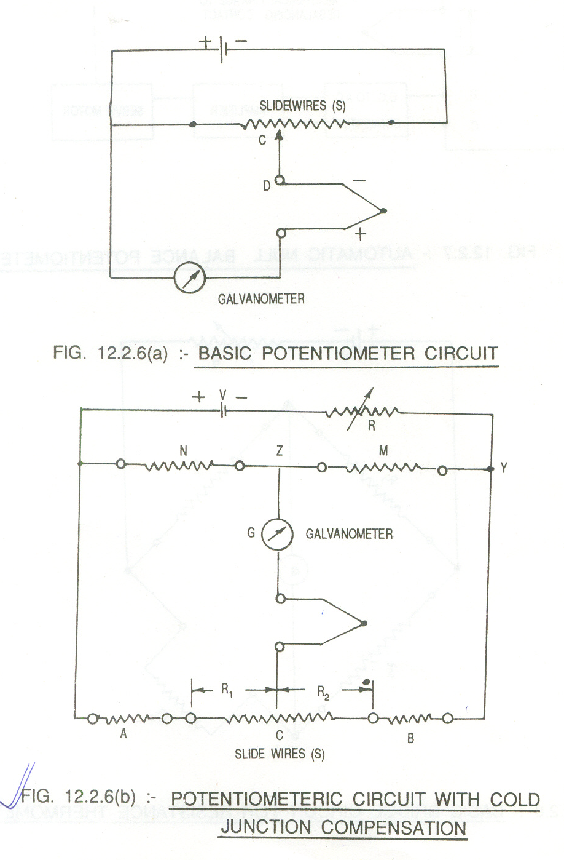

Resistance Thermometers : The operating principle of these thermometers is that the electrical resistance of a wire increases as its temp. increases. Platinum is the most widely used material since it is useful over a wide range of temp. from –240 ⁰C to +164 ⁰C.

Measuring ckt: When subjected to heat, resistance RT of the Pt wire (RTD) increases. The element is connected in one arm of the Wheatstone bridge. The other arms of the bridge have fixed resistor. A batterty is connected across the bridge. As RT increases the bridge is unbalanced which is detected by milivoltmeter. This unbalanced voltage can be amplified & calibrated in terms of temperature. In null balanced condition R3 is varied until there is no deflection in the voltmtr. At balance

R1/R2 = R3/RT

RT= R2.R3/R1

Since R2 & R1 are fixed RT can be found from the above equ. & calibrated in terms of temperature. The ckt. diagram is shown below

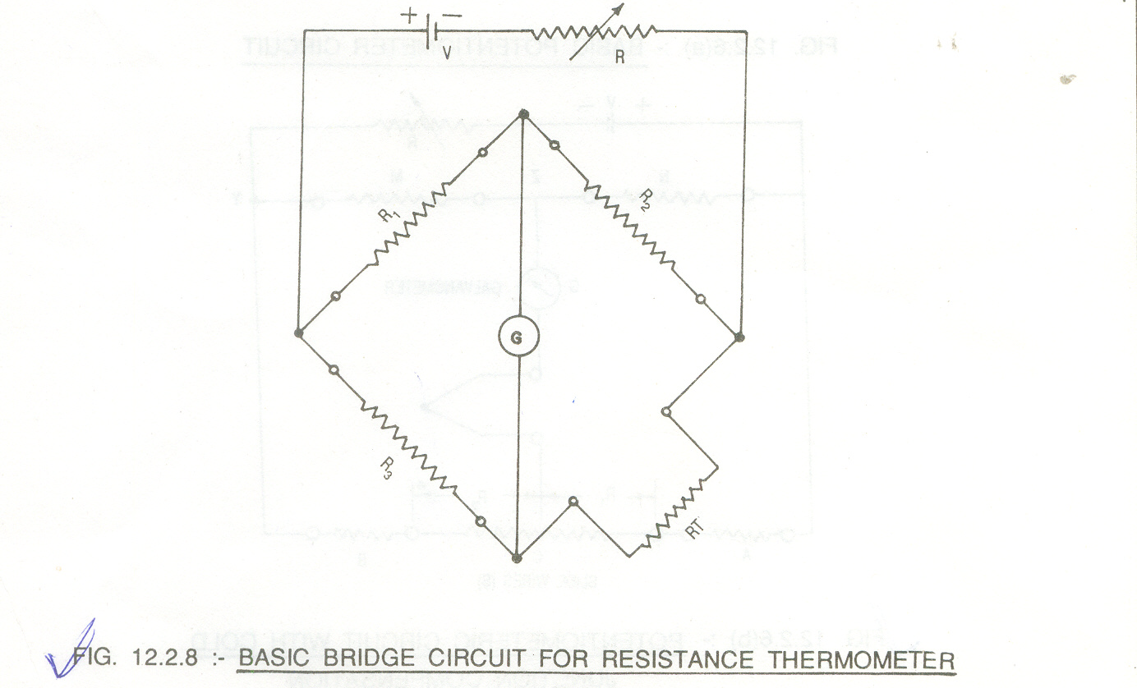

Non Contact Type ( Pyrometers)
When the temp. being measured are higher than those which can be measured by mercury thermometer, the instrument used is called pyrometer. Here for measuring kiln temp. we use Radiations Pyrometers.

Radiation Pyrometer : The operation involves measuring thermal energy radiated by black body when that body is heated. The Stefan Boltzman law governing the principle stated by the formula
W = KTa⁴
Where, W – Total radiation per unit area per sec.
Ta – absolute temp.

K - Stefan Boltzman Constant factor
RP picks up the radiant heat by means of Stefan Boltzman law & focuses the heat waves on a vacuum tube containing thermocouple. The pot. is mostly used with RP & it operates just as it does contact with the hot substance. These pyrometers can be used for measuring temp. upto 5500 ⁰C. The RP is shown below.

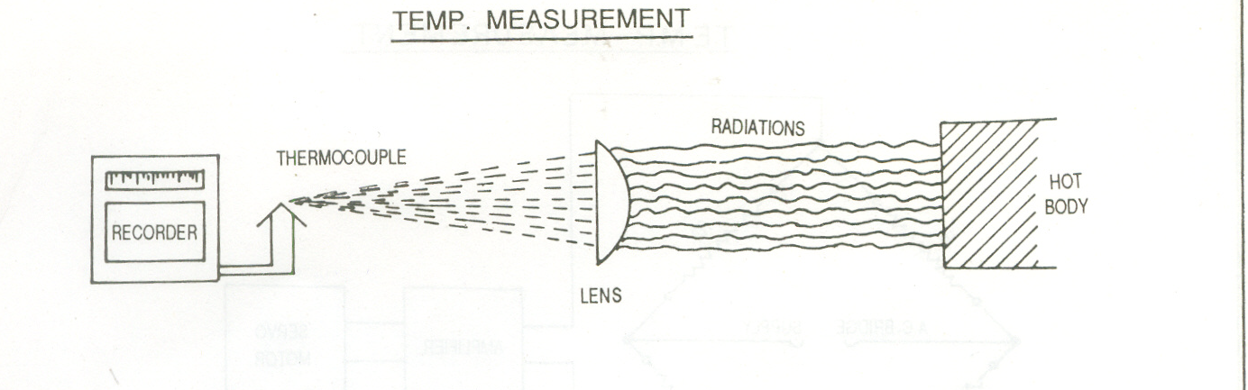

2. PRESSURE MEASUREMENT
The measurement of pressure is fundamentally of two types :
- The Absolute Pressure Measurement, measure actual pressure of a fluid with help of gauge.
- The Differential Pressure Measurement, the gauge measures the difference of the pressures between two portions of fluid.

The mostly preffered transmitter for pressure measurement employed is Capacitance Transducers catogarised under Electronic pressure sensor.

Capacitance Transducers : The basic operating principle involved in all capacitive pressure sensors is the measurement of change in capacitance resulting from the movement of an movable electrode. The elastic element mostly used is stainless steel diagraph exposed to the process pressure on one side & to the reference pressure on other. Depending on the reference pressure used, the unit can detect absolute, gauge & differential pressures.
The unit shown incorporates two capacitor plates. A high voltage, high-frequency oscillator is used to energise the sensing element. Changes in process pressure deflect the diaphragm, & the resultant change in capacitance is detected by the bridge ckt. The two-plate design can be operated in balanced or unbalanced modes. If the ckt is operated in balanced mode, the output voltage is fed to a null detector, & the capacitance arms are varied to maintain the bridge at null. In this mode, the null setting itself is a measure of process pressure. If the ckt operates in unbalanced mode, the ratio between output voltage & excitation voltage is the indication of process pressure.
CPT have many advantages like good accuracy, Rangeability, linearity, & speed of response. Their limitations include temp. sensitivity, high output impedance, & corrosion sensitivity.
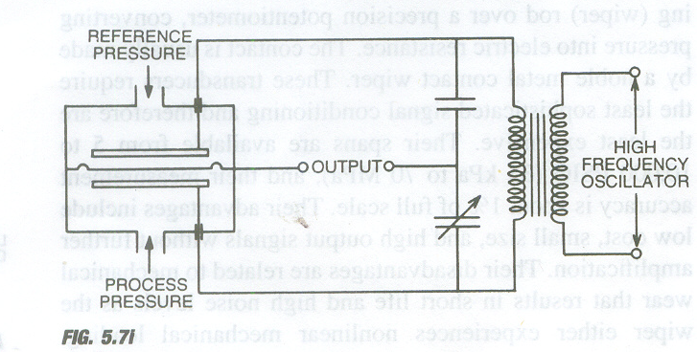

FLOW MEASUREMENT
No processes variable measurement is more important ia an chemical plant than the detection of flow rate. This is essential to determine the material balance for processing units.

Electromagnetic Flow Meter : The electromagnetic flowmeter consists of a tube of non-magnetic stainless-steel. This is based on Faraday’s law of electromagnetic induction which states that the voltage induced in a conductor of length moving through a magnetic field H is proportional to the velocity V of the conductor, E = cHdV,
Where, c is a dimensional constant.
The two electrodes are mounted opposite to one another on the tube wall. The ends of the electrodes are in contact with the fluid flowing in a tube. Surrounding the tube is a magnet with its field at the right angles to the electrodes. As the fluid, which must be an electrical conductor flows through the magnetic field a voltage is produced.
The voltage produced depends upon the strength of magnetic field, distance between the electrodes, the velocity of conductive fluid through the tube.
Therefore, if the strength of the magnetic field & the distance between electrodes is held constant the voltage produced will be entirely due to rate of flow. The voltage produced is then amplified & measured by suitable instrument as shown.

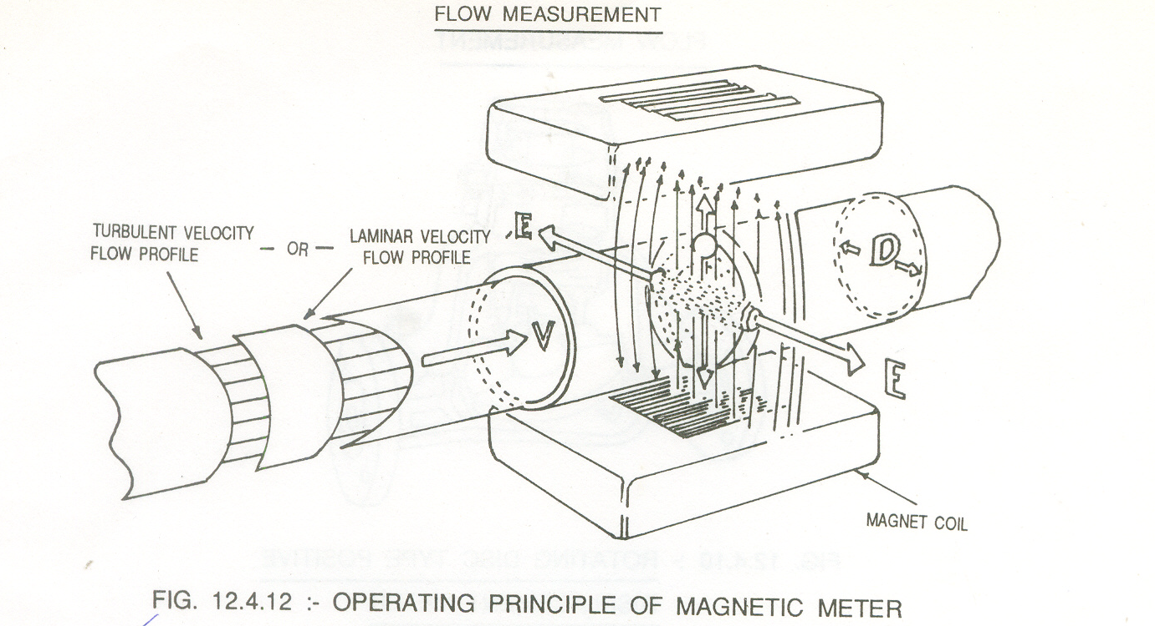

LEVEL MEASUREMENT
The level in tank or silo can be detected by many different techniques. The frequently used sensor for level measurement is the capacitance level sensor discussed below:

The Capacitance Level Sensor : As a low-voltage high-frequency (MHz) signal is applied to the probe, a minute current flow is caused from the probe to the ground. As changes in level cause a change in the capacitance between the probe & ground, this affects the minute that are detected by extremely accurate bridge ckts.
The size of the capacitor is a function of the physical & of the dielectric constant of the material (K) between the plates as follows:
C = 0.6 KX/Log₁₀(A/B)
Where : C = total capacitance in farads

K = dielectric constant of material between the plates
X = length of active portion of tube
A = inside diameter of tank
B = outside diameter of bare probe

Variation in process level cause a change in the total capacitance (C), which is measured by a ckt that is excited by a low-voltage radio frequency (RF) oscillator at a frequency of a few MHz.

Conclusion

Hence in the last I can say that taking training in such an organization proved to be very beneficial for me. I learnt quite a lot about electronic exchange, various transducers, microprocessor based recorders and the basis of processing industries. I also got first hand knowledge of how an industry works.

