“Resume Tracking System”
(Application for tracking records of candidate)

A Project Report
Submitted in Partial Fulfilment for
B.E.Third year
(2005-2006)

Submitted By:
ASHA VISWAMBHARAN

GUIDED BY:
Mr A.R.SRIRAM

SUBMITED TO:
Mr K.R.CHOUDHARY
HEAD OF DEPARTMENT
COMPUTER-SCIENCE

M.B.M.EngineeringCollege
Jai Narayan Vyas University,
Jodhpur (Rajasthan)

ACKNOWLEDGEMENT

I WOULD LIKE TO EXPRESS SINCERE GRATITUDE TO Mr Sunil Rawat (Head of Software Deptt.) FOR GRANTING ME THE OPPORTUNITY TO UNDERTAKE THE PROJECT AT Systematix Technologies Pvt. Ltd.

I WOULD ALSO LIKE TO EXPRESS THANKS TO MY PROJECT GUIDE Mr.Ajay Borasia WHO PROVIDED ME THE INITIATION ,NECESSARY GUIDANCE AND WHO MOTIVATED ME BY SHOWING KEEN INTEREST IN PROJECT AND ENCOURAGING TO CARRY OUT THIS PROJECT .

I WOULD LIKE TO THANK OUR HEAD OF THE DEPARTMENT Mr K.R. Choudhary FOR HIS GUIDANCE AND ALSO ALL OUR STAFF MEMBERS OF COMPUTER SCIENCE DEPARTMENT.

Priya Dani
B.E. Third Year
Computer Science

Table of contents

1. Objective……………….4

2. Scope…………………..6

3. Introduction…………..8

4. Project Description…….10

5. Reference and bibliography….36

“OBJECTIVE”

The objective of this Project is to make a “Resume tracking system”. In the “Resume tracking system the records and various status of candidate having interview for a company is maintained and tracked.

With the help of this existing system ,you can manage information related to a particular subject or purpose such as tracking candidate information or maintaining their status records in various stage of records.

“SCOPE”

Many multinational companies are providing job for the candidate. The job selection of candidates are done through campus interviews. The project “resume tracking system” assists the company or organization in keeping records and status of candidate in various interview level.

Using the existing system, you can manage all your information from a single database file. Within the file, divide your data into separate storage containers called tables; view, add, and update table data using online forms; find and retrieve just the data you want using queries; and analyze or print data in a specific layout using reports.
To store your data, create one table for each type of information you track. To bring the data from multiple tables together in a query, form, or report, you define relationships between the tables.

To find and retrieve just the data that meets conditions you specify, including data from multiple tables, create a query. A query can also update or delete multiple records at the same time, and perform built-in or custom calculations on your data.

“INTRODUCTION”

The project uses the MS-ACCESS database.MS-ACCESS is a database management system.DBMS provides the facility of data storage and retrieval on computers hard drive.

A database is a collection of information related to a particular subject or purpose, such as tracking customer orders or maintaining a music collection. If your database isn't stored on a computer, or only parts of it are, you may be tracking information from a variety of sources that you're having to coordinate and organize yourself.

Using Microsoft Access, you can manage all your information from a single database file. Within the file, divide your data into separate storage containers called tables; view, add, and update table data using online forms; find and retrieve just the data you want using queries; and analyze or print data in a specific layout using reports.

“PROJECT
DESCRIPTION”

In this project following task are carried out:

1. Database creation.
2. Table creation
3. Query creation
4. Form creation
5. Report generation

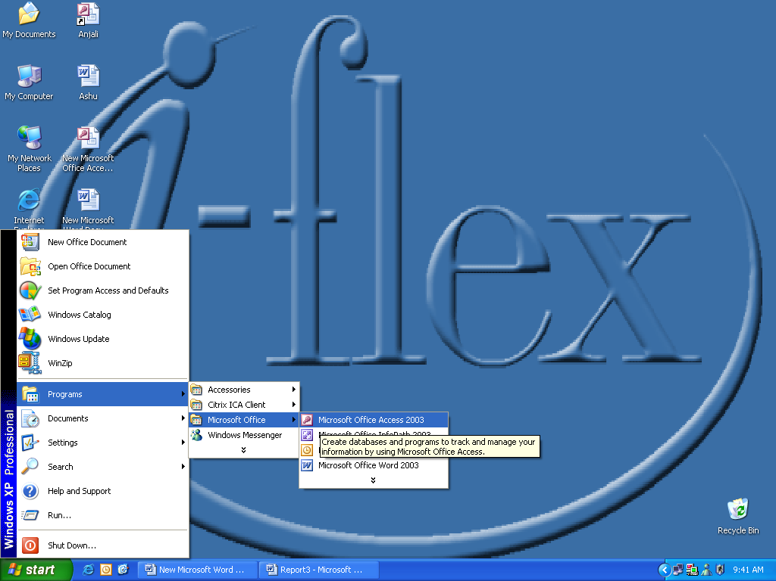

1.Database creation:-Database is created as:MS-ACCESS->File->New
Name the Database.The Database created is Resumist.

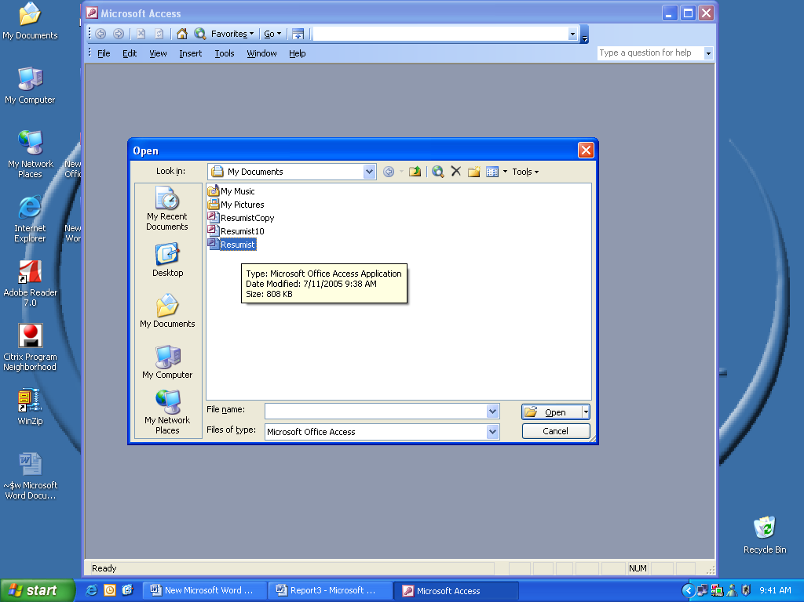

2.Table creation:-After Database creation table is created .The table is created as:-Table->Create table in design view
TABLES:
A table is a collection of data about a specific topic, such as products or suppliers. Using a separate table for each topic means we can store that data only once, which makes your database more efficient and reduces data-entry errors. Tables organize data into columns and rows.

In table Design view, you can create an entire table from scratch, or add, delete, or customize an existing table's fields.

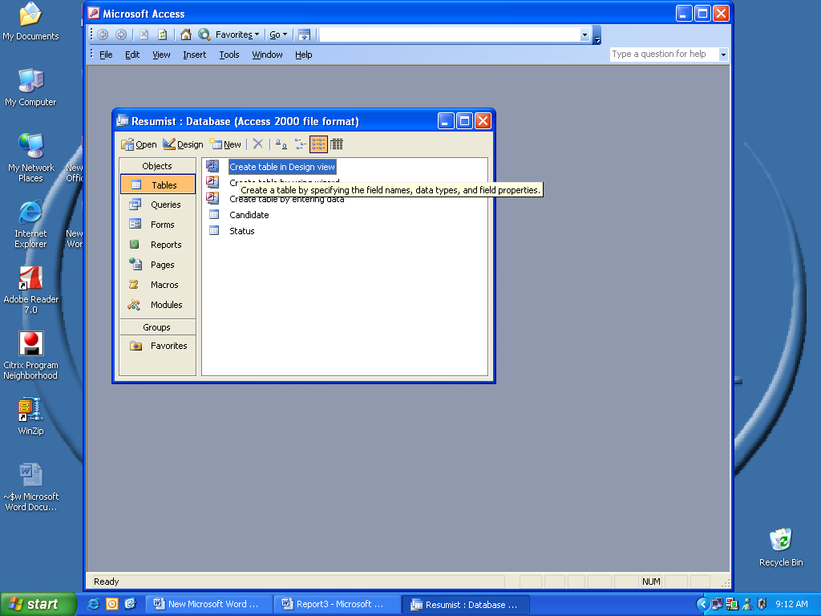

The table created are

1.Candidate table

2.Status table

Table#1 Candidate Table
DATAFIELD AND DATATYPE OF CANDIDATE TABLE:
Data field | Data type | Size
Candidate passport no | Text | 10
Candidate name | Text | 25
Date of birth | Date/Time | General date
Address1 | Text | 15
Address2 | Text | 15
Address3 | Text | 15
State | Text | 10
Country | Text | 15
Phone no | Text | 15
Mobile no | Text | 15
Resume | OLE object

Table#2 Status Table
DATA FIELD AND DATA TYPE OF STATUS FIELD
Data field | Data type | Size
Candidate passport no | Text | 10
Candidate name | Text | 25
Interview1 | Text | 15
Final status | Text | 15
Comment | Text | 15

RELATIONSHIP CONCEPTS:-Relationship is used to link the tables created.Here we have two table candidate table
and status table.Both the tables are linked with each other through Candidate passport no.Candidate passport no is a primary key in Candidate table and it serve as foreign key in status table.There exist one to many relation between candidate table and status table

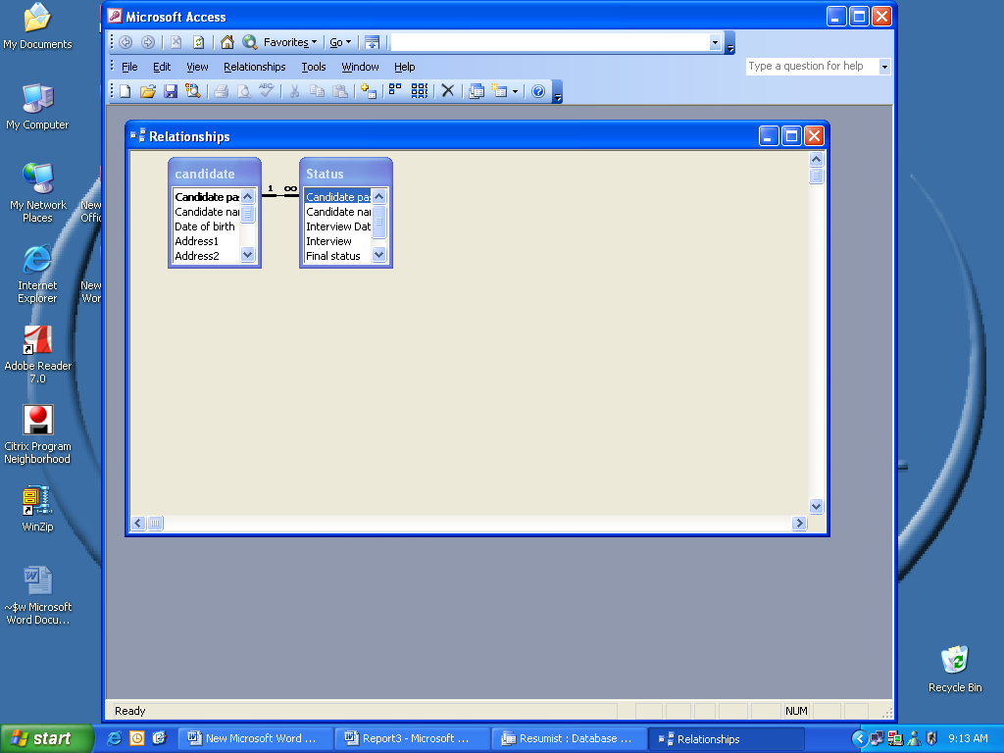

3 Query creation:-Query created as:-Query->Create query in wizard.
Use queries to view, change, and analyze data in different ways. You can also use them as the source of records for forms and reports.
The most common type of query is a select query. A select query retrieves data from one or more tables using criteria you specify, and then displays it in the order you want.
We create a query with a wizard or form scrach in query Design view. In Design view, we have to specify the data you want to work with by adding the tables or queries that contain the data, and then by filling in the design grid.
The Query created are

Query#1
1.Candidate info:-The query info consist of candidate name ,passport no,date of birth,address,phone&Resume

Query#2

2. Candidate status:- The query Candidate status consist of status of the candidate after interview.

Query#3

3.Candidate select- The query select consist of those candidates who are rejected in the interview

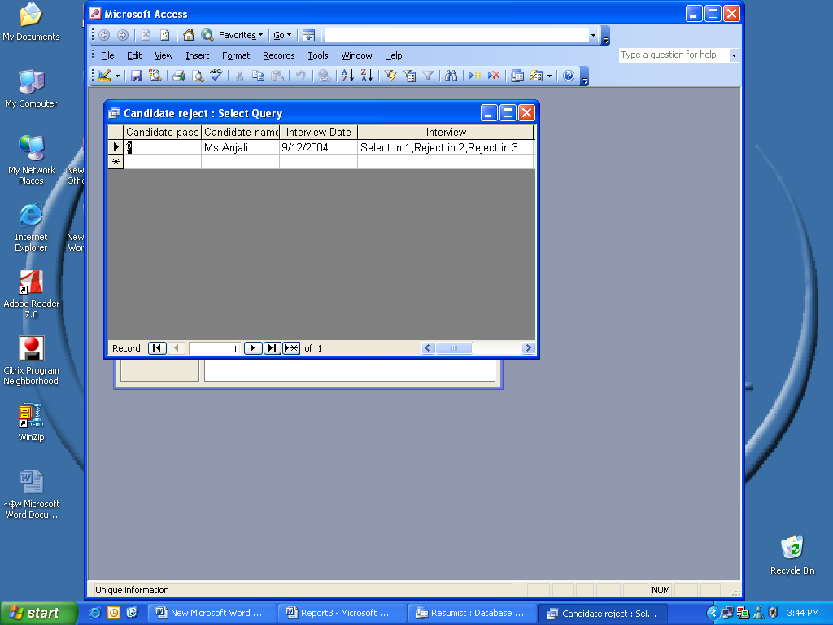

Query#4

4.Candidate reject:- The query reject consist of those candidate who are selected in the interview.

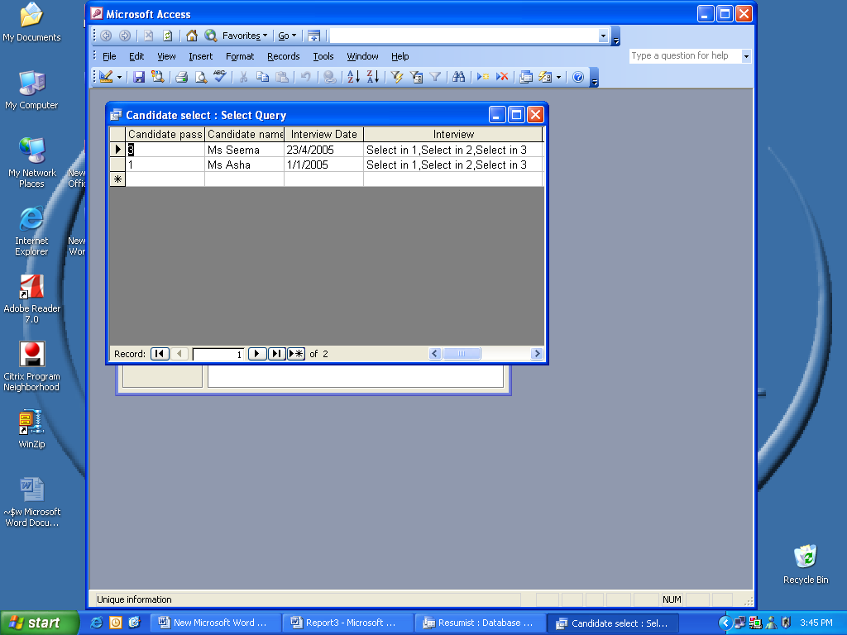

Query#5

5.Status Category :-The query status category gives the candidate status information on the basis of interview date.

In the query status category the default date can also be given.For query to run enter the begning and ending date.Then it display the name and status of candidate
According to their Interview date.
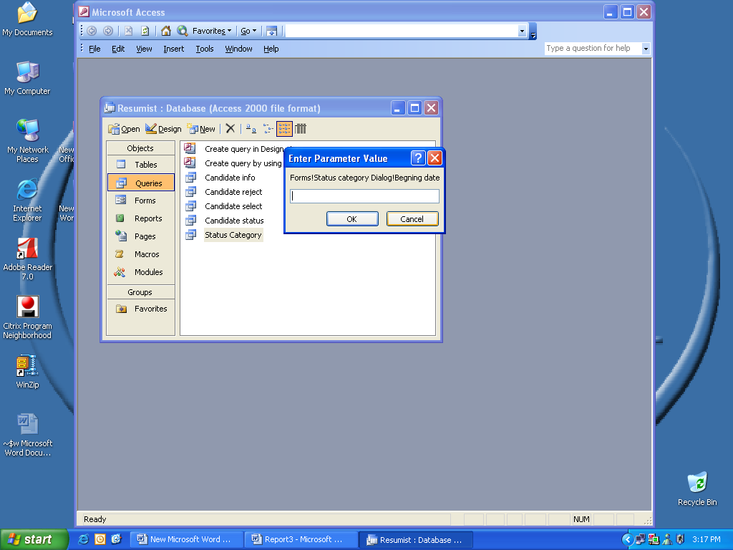

3.Form creation:-Form is created as:-Form->Create form in design view.
The form created are:

1.Status1

2.Status2

3.Status3

4.Status Category Dialog

5.Status report dialog

6.Startup

7.Main Switchboard

The Main Swithchboard includes all the Form and report created

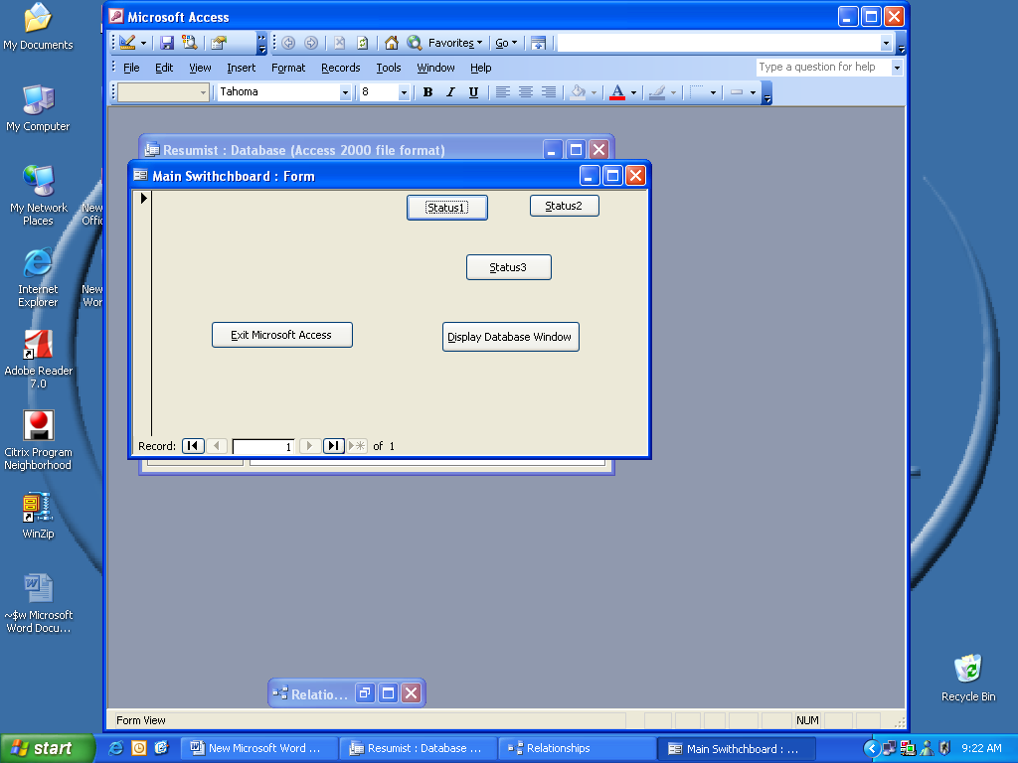

The Status1 Form Consist of a form and subform.The form includes Candidate passport no,Candidate name.Date of birth,Address1,Address2,Address3,State,Country,Phone no,Mobile no and Resume field.The status subform include Interview date, Interview,Final status and comment.

The Candidate passport no, Candidate name,Final status and comment field includes label and Text box.

Interview field includes label and Combo box.Combo box is used to enter the desired item list.In the Combo box by using the value list we can enter the required values to be displayed.

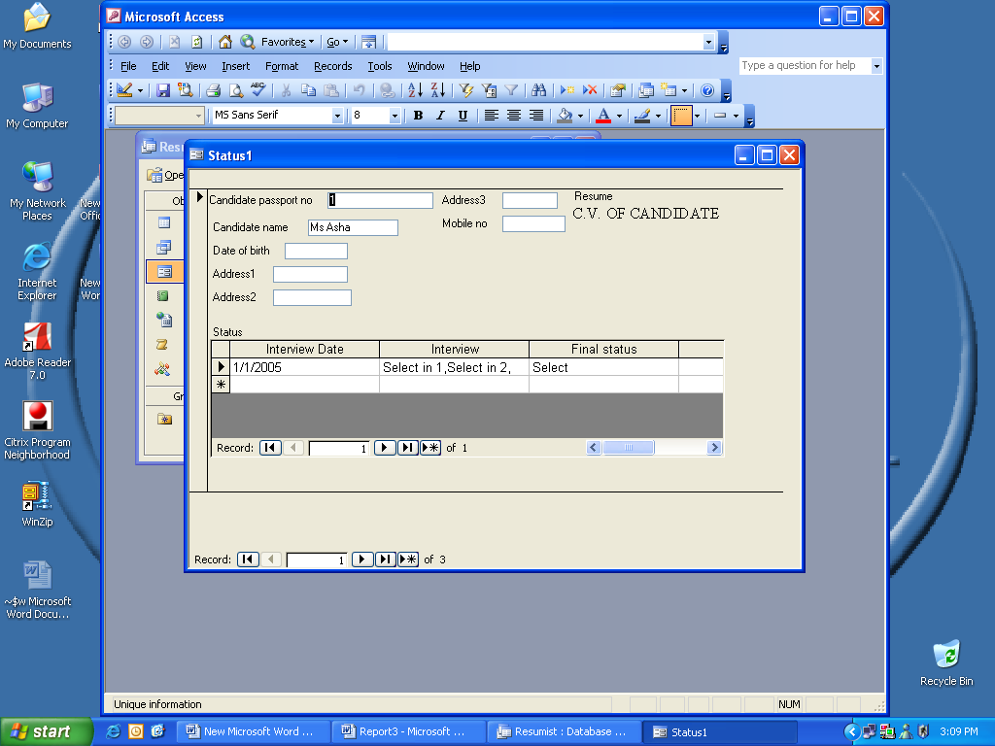

The Status2 Form Consist of two page tab

1General info

2Personal info

General info includes
1.Candidate passport no
2.Candidate name
3.Resume

Personal info includes
1.Date of birth
2State
3Phone no
4Mobile no
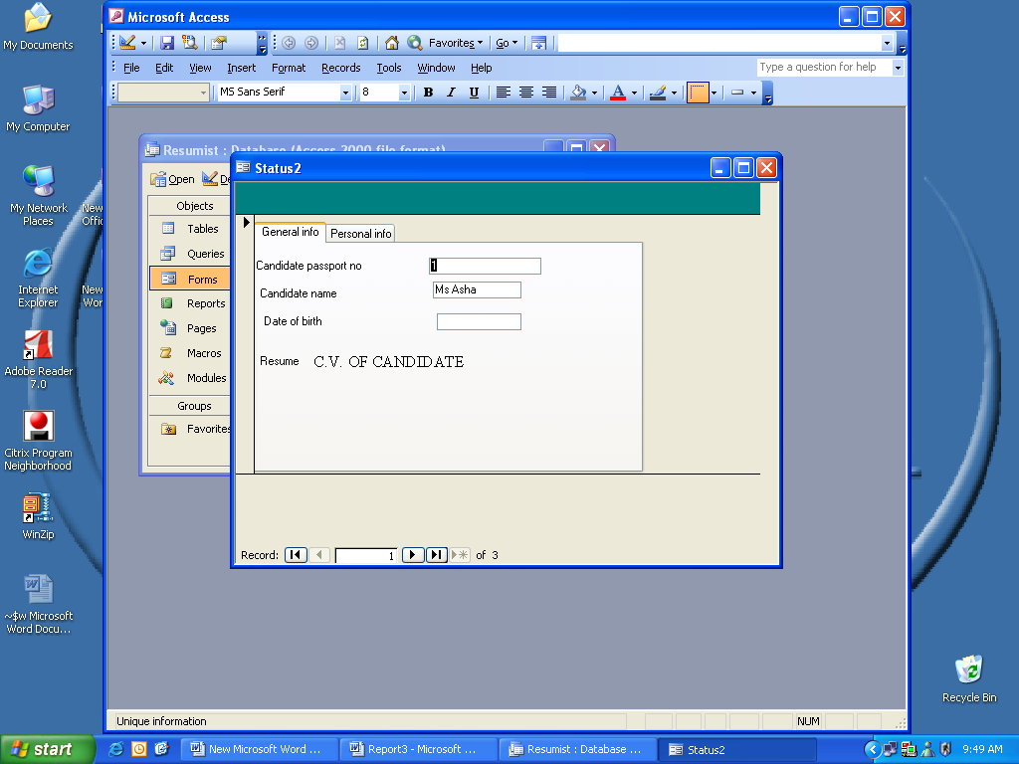

The Status3 form is a datasheet view.It includes Candidate passport no,Candidate name,Interview,Final status and Interview Date.

The Status Category Dialog form consist of Candidate status with interview date

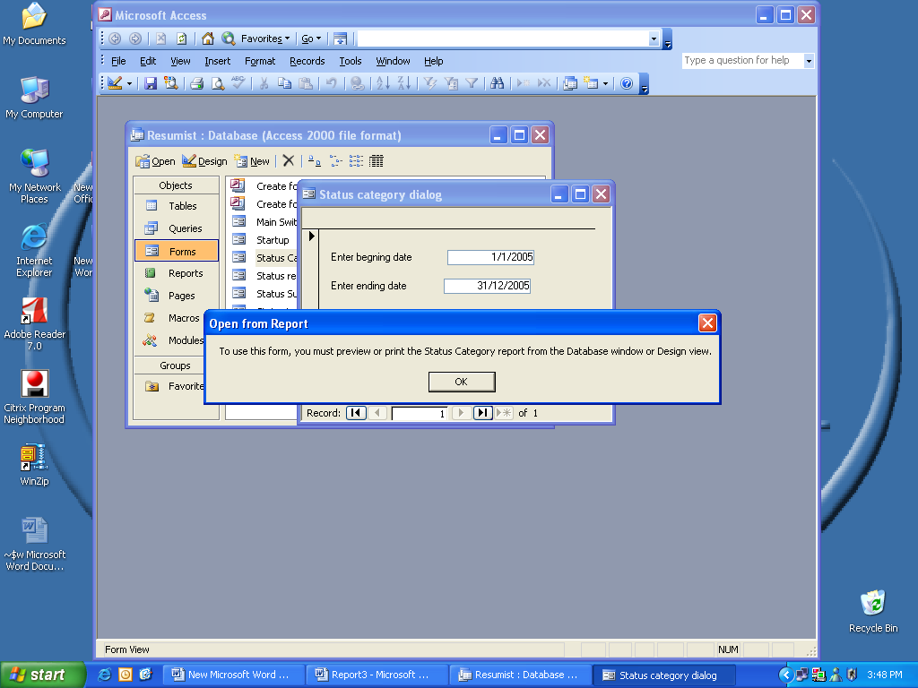

The Status report dialog consist of the runtime reports.The Status report dialog includes two reports :

1.Candidate select

2.Candidate reject

In the status report dialog we can preview and print the given reports.
. 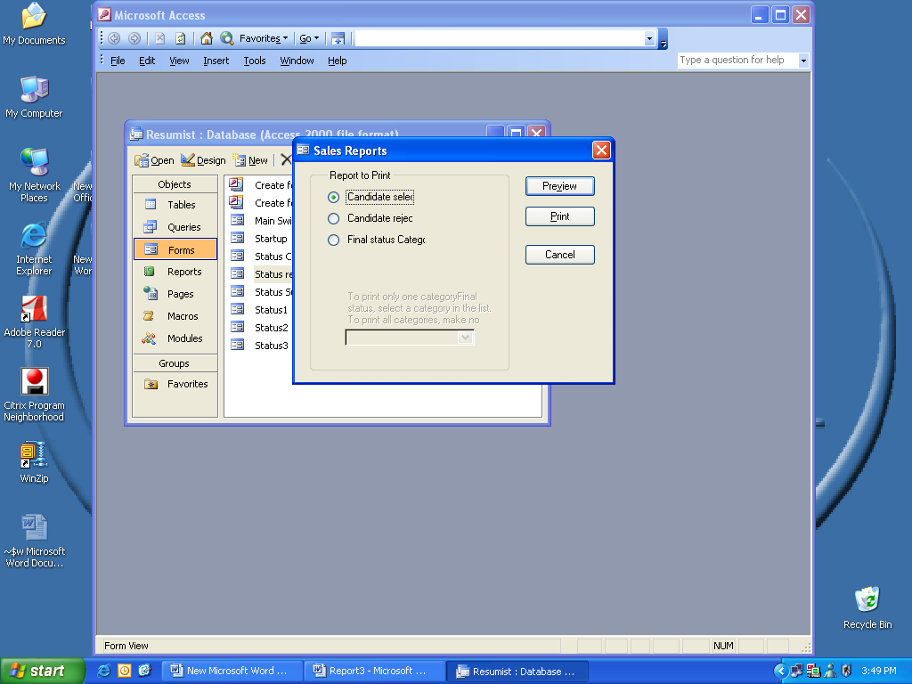

4.REPORT GENERATION:-Report is created as Report:->Create report in wizard.The report created are:
1.Candidate info
2.Candidate status
3.Candidate select
4.Candidate reject
5.Status Category
The Candidate info shows the general and personal info of Candidate.

The Candidate Status shows the status of candidate
The Candidate select shows the status of candidate who are selected 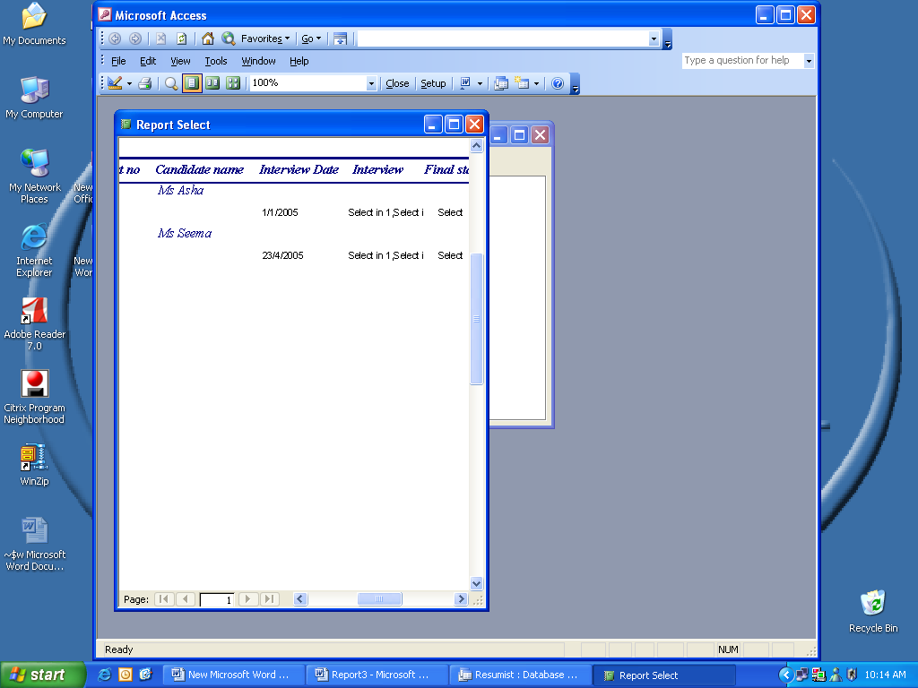

The Candidate reject shows the status of rejected student.

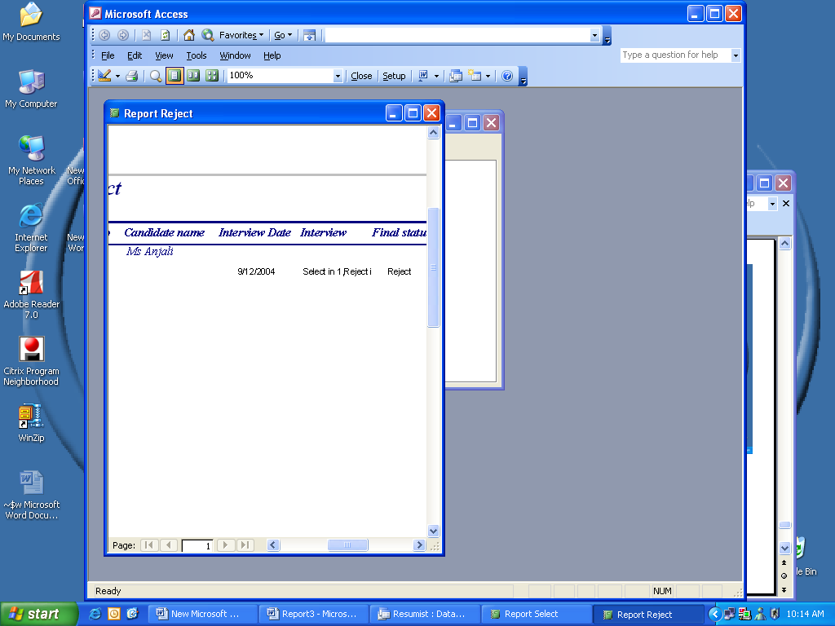

The report Status Category shows the status according to the Interview Date.

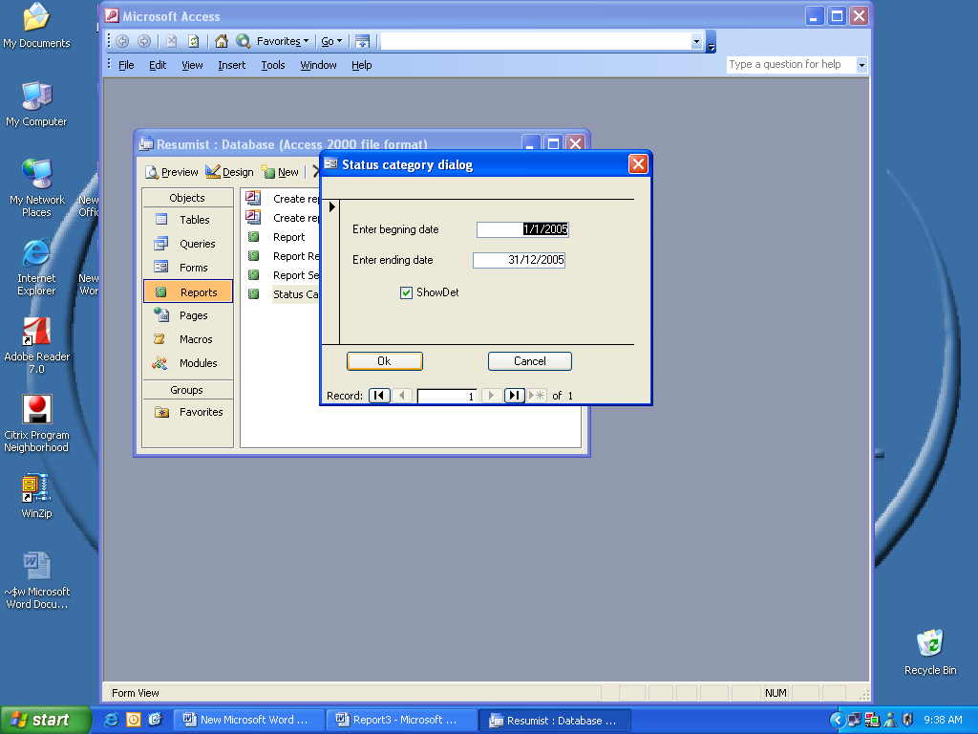

Reference and Bibliography:-

1.Ms Access Tutorials

2.Visual basic Dummies by Tech media

3.Visual basic6.0 by Evangelus

