Contents

- Scope of Document

- Acknowledgement

- Introduction to Reliance Infocomm

- Networking in RELIANCE

- Introduction to MCN, Jaipur

- Brief Overview of the SWITCH Department at MCN, Jaipur

- Brief Overview of the TOWN OFFICE, Jaipur

- Brief Overview of the CMP department, Jaipur

- Brief Overview of the WEB WORLDS, Jaipur

- Brief Overview of the WEB WORLD EXPRESSES, Jaipur

- Transport Department

  - Overview of technologies
  - Works

- Data Department

  - Overview of technologies
  - Network Architecture
  - DCN & RDN
  - Works

- The Reliance Experience

Scope Of Document

The scope of this document is to review and understand in detail the Reliance network architecture, the transport methodologies and the data layer application’s support provided throughout the network area. The document briefly skims through the various departments and their related works at MCN Jaipur. A brief introduction of Web Worlds, Web World Expresses is also given. The work done in Town Office, Jaipur, which is the main office & CMP, where all external affairs are solved is also highlighted in this report. The DCN and RDN aspects of the network are discussed in detail and the forthcoming ventures of Reliance Infocomm under the DATA department are also mentioned.

This document has been prepared by the student of IV Semester B.E. Computer Science Department of JODHPUR INSTITUTE OF ENGINEERING AND TECHNOLOGY.

GAURAV SOLANKI
gaurav_solanki3@hotmail.com

Acknowledgement

It’s a general phenomenon that any technical education is incomplete without a formal exposure to the real world industry and the related field of work and being a part of a technical program the same held true for us. RELIANCE INFOCOMM, the major earthshaking technical venture by one of the biggest business houses of India THE RELIANCE group was the ideal place that a student would like to be exposed in order to get first hand experience of the corporate world and to understand the physical implementations of world class technologies in the real world scenario.

At the outlet I would like to extend my sincere thanks &gratitude to MR. C.K.MOHAN –HEAD IT Infrastructure, Reliance Infocomm, Rajasthan to give me an opportunity to do my project in a highly reputed company. He has nurtured my talent and enhanced my knowledge to a great extent.

I would like to extend my sincere thanks & gratitude to Mr.Shivanand Rai –HEAD IT OF IMSC, for immense involvement, cooperation, & guidance that he extended throughout the project.

I would like to sincere thanks to Mr. Nitin Kalra & Mr.Naveen Jain –IT DEPARTMENT, for lending their hands whenever I was in trouble. He always made me learn new technologies & shared different ideas while providing with a chance to implement.

I am also very grateful & thankful to Mr. Dheeraj Sachdev, Mr. Ashish Masih sir for their valuable guidance & consistent support.



“To create an advanced facilities based, intelligent, next generation communication network, with terabit bandwidth, that will leapfrog India into the center-stage of global communication and information technology spa0ce.”

Late. Dhirubhai H. Ambani

Founder Reliance Group

Introduction to Reliance Infocomm

Infocomm is the synergy of information and communication services brought about by the digitalization and convergence. In the fast moving and competitive knowledge era, Infocomm is not only a driver of growth but also competitiveness. Reliance Infocomm is revolutionizing telecommunication in India by provisioning services that would match with the leading operators of the most developed countries. These services are the outcome of state-of-the-art network technologies that have been inducted in the Reliance Infocomm network.

The network consists of the latest switching, transmission and access technologies. The core of the network consists of fiber deployed throughout the country. Deployed over the fiber media are the DWDM and SDH transmission technologies in ring topology to provide ultra-high bandwidth capacity and failure proof backbone. Besides circuit switched technologies, the backbone also has IP architecture and uses MPLS technology to carry data on an overlay network. In addition gigabit Ethernet will provide broadband services on wireline access.
Reliance Infocomm offers a complete range of telecom services, covering mobile and fixed line telephony including broadband, national and international long distance services, data services and a wide range of value added services and applications that will enhance productivity of enterprises and individuals.
Mobile telephony, fixed line telephony and Internet service now come with a range of solutions that make the experience of communication entirely different and pleasurable. As a one-stop shop for new age telecommunication solutions, Reliance has laid out one of the biggest fiber optic networks in the world. Digital and broadband-capable, this 70,000 km of terabit capacity network, covering over 600 towns and cities in India, has enabled Reliance to develop a number of innovative communication applications that seamlessly blend together to deliver world-class communication solutions.
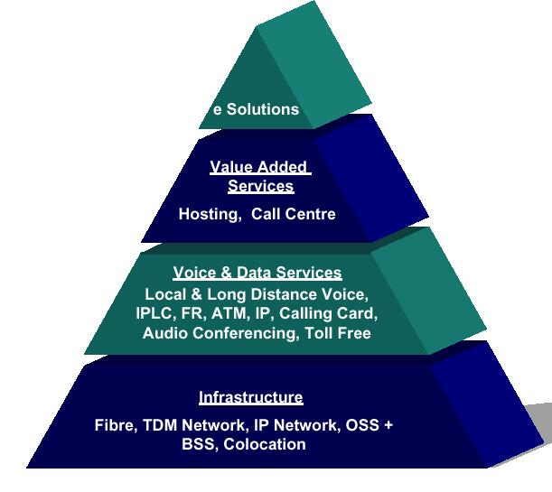
Fig. Hierarchy of Services
Telecommunication networks are the infrastructure for provisioning Infocomm services. The Reliance Infocomm network consists of 70,000 kilometers of optical fiber cables spanning the length and breadth of India. These cables can carry thousands of billions of bits per second and can instantly connect one part of the country with another. This physical network and its associated infrastructure will cover over 600 cities and towns in 18 of the country's 21 circles, 229 of the nation’s 323 Long Distance Charging Areas (LDCAs) and broadband connectivity to over 190 cities. This infrastructure will be backed by state-of-the-art information management systems and a customer-focused organization.
An interesting aspect of the network is the manner in which these fibers are interconnected and deployed. Reliance's architecture is so fault-tolerant that the chances of failure are virtually nil. Reliance's ring and mesh architecture topology is the most expensive component to implement, but assures the highest quality of uninterrupted service, even in the event of failure or breakage in any segment of the network. Reliance has 77 such rings across the country with at least three alternative paths available in metros. Connected on this topology, the service has virtually no chance of disruption in quality performance.
Access networks determine the services that can finally be delivered to customer. The network has wireline access technologies based on fiber as well as copper. Fiber in the access network makes broadband services easy to deploy. The wireless access network deployed for CDMA 1X is spectrum efficient and provides better quality of voice than other networks and higher data rates. CDMA 1X also provides an up gradation path to future enhancements.
Through the term broadband connotes relative access speeds, it now generally refers to access speeds of 1.5 Mbps and higher. As content on the Internet and intranet becomes multimedia, broadband technologies are important for accessing the content and to provide video based corporate services.
Reliance Infocomm has extended fiber in its access network. This gives the network a capacity to have very high access speeds. Reliance has deployed broadband based on gigabit Ethernet. This will enable Reliance to provision broadband services of high quality and performance.

NETWORKING IN RELIANCE

Contents

Topic

Network Infrastructure

Strengths of the Reliance Network

Services Basket – Mobile and Fixed Voice

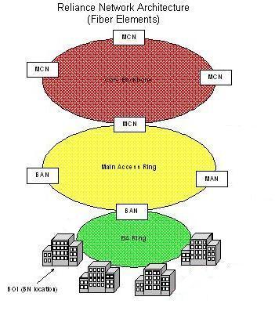
Network Architecture
Core Backbone
Main Access Ring
Building Access Ring

Let’s understand the elements mentioned in the diagram in greater detail:

- Building Node (BN): A Building Node (BN) is electronic equipment, which converts optical signals to electronic signals (voice and data).
- BA Ring: This is the medium that connects all the Building Nodes about which you have learnt in a previous session.
- BAN: At BAN, the information is checked for the recipient’s address and routed accordingly.
- Main Access Ring: This is the medium that connects all BANs under an MCN.
- MAN: As the traffic in a metropolitan is more, another element called a Metropolitan Access Node is added between the BANs and the MCN. It helps in controlling the large traffic. Each MAN has a number of BANs under it. Therefore in case of a metropolitan, there will be four layers, (BN) Building Node, BAN, MAN and MCN.
- MCN: MCN is the place where information is received from other MCNs, MANs or BANs. Here the information is checked for the recipient’s address and routed accordingly.
- Core backbone: This is the medium that connects all MCNs in the country
Gateway: The gateway routes international traffic.

The network architecture is similar to our postal system.

Central Sorting Office
Gateway
General Post Office
Area Post Office

Wireline and Wireless Network

All services run on the same network. However, there is a slight difference between the wireline and wireless connectivity to the customer.

In a wireline network, your phone is connected to the Building Node through a copper wire, whereas in case of a wireless network, your mobile phone is connected to a radio station through radio waves. The radio station is connected to the BAN through the Fibre Optic cable. The two types of connectivity are shown below.

Wireline Network

BAN
Building Node
Copper Cable
Your Wireline Phone
Fibre Optic Cable

Wireless Network


BAN
Fibre Optic Cable
Your Mobile Phone
Radio Station

Our network is the most powerful network in India.
Strengths of the Reliance Network

Feature | Benefit
Fibre optic based network  - High capacity  - Less loss while transmission | - Good speed  - No congestion  - Reliability
Ring topology | Information flows in rings and hence in case of breakdowns has an alternative path to travel on
Free fibre optic cables available | - More capacity can easily be provided to the existing customers  - New customers can easily be added to the existing system
Free ducts available for laying more cables | - More capacity can easily be provided to the existing customers  - New customers can easily be added to the existing system
Wide interconnection pipes | No congestion at interconnection points
IP based network | Supports a wide range of services
India wide presence | - The link does not break no matter where you take your mobile phone  - No change in the service when you move from one area to the other
Fibre right upto the customer’s building | - No congestion  - High speed  - Reliability

BENEFITS OF FIBRE OPTICS:

Feature | Benefit
Bandwidth | - Good speed  - No congestion
Delay | - Good speed
Interference | - Security  - Undisturbed connection
Weather | - Reliable connectivity
Security | - Security of information transmitted and received

Services Basket

The services that we offer can be categorised as follows:
- Mobile Voice
- Fixed Voice
- Wireless Data
- Wireline Data
- Internet
- Collaboration
- IN Services
- Hosting and Applications

Mobile Voice
Mobile voice includes services that transmit voice for mobile users.
Enterprise mobile phone is a mobile wireless telephone that offers, NLD, ILD and Internet access. It is based on CDMA technology. It is superior to others because of features such as abundant minutes at low costs, superior technology. The same service is also being offered to consumers under the name Reliance India Mobile.

FWT Single
FWT Single or Fixed Wireless Terminal Single allows you to make long distance calls at flat rates. Here a fixed terminal is installed at the customer’s premisis and this fixed terminal is connected to our network through radio waves and not through cables unlike a normal telephone line. FWTs are more rugged than mobile handsets. They are designed to operate for longer continuous hours and work better even in poor coverage areas. They resemble our traditional cordless phones.

Fixed Voice
These are those voice related services that can be accessed only from the location at which they are installed such as the customer’s office.

POTS –Plain Old Telephone Service
A POTS connection fulfills all such wishes and requirements. As the name suggests, it is a plain old telephone service that you have been using for making and receiving calls. In addition to this, it is also a convenient way to effectively manage your calls.

Centrex
A Centrex is meant for such customers who are looking for a more user friendly private exchange. A centrex is a wireline telephone connection with the features of a PBX. In a Reliance Centrex, every user gets a direct line that also works as an intercom. A centrex doesn’t need a PBX equipment at the customer’s premises. It is maintained and managed through our own system.

PBX Trunks
A PBX Trunks is best suited to meet the telecom needs at Savings. PBX Trunks is a single direct line that can provide calling facility to a number of extensions.
This works out to be much cheaper than a direct line for each user. The graphic below shows the design of a PBX Trunks service.
One direct line

Extension 1
Extension 2
Extension 3
Extension 4
Extension 5

ISDN
ISDN is another voice based service. However, apart from voice, it also carries data, and video traffic. It is a dial up connection that offers high capacity. It is best suited for small offices or residences. It provides digital service without requiring new transmission wiring to the home.

Wireless Data
Today’s business environment calls for a lot of movement/ touring. . For example, mobile access to the company’s information server is being provided to most sales executives so that they can keep themselves updated even when not in office.
Keeping pace with the changing times, service organisations are also bringing the service to the consumer’s doorstep. A number of service organisations such as banks, Municipal Corporations, etc. are trying to meet such needs of its customers by placing ATMs, kiosks in every nook and corner of the city.

Connectivity Products
To provide services such as ATMs, Lottery Terminals as close to the consumer’s place as possible, we have come up with CDMA connectivity for connecting the ATMs to the banks. This is a superior technology as compared to Satellite connectivity, which is currently being used for ATM connectivity.

Wireline Data
Branches of an office at different locations would very often need to be linked so that data can be shared between the various offices. To meet such requirements, wireline data services are required .

Leased Lines

A Leased Line is a dedicated circuit of a given bandwidth for data transmission. It connects two or more sites of a single customer.

IPLC – International Private Leased Circuit
International Private Leased Circuit (IPLC) is a type of lease line that is used for connecting a site in India with a site in a foreign nation.

IP VPN – Internet Protocol Virtual Private Network
IP VPN service is used to connect two or more sites to share data. IP VPN provides a high speed, reliable connection between two or more sites.

Internet
Almost everybody today accesses the Internet for some purpose or the other. Two types of Internet services are there:

Dial up Internet
A dial up Internet connection is one, which involves dialing through a telephone to the service provider for the connection to be established. It is best suited to the requirements of a single user. This facility offers reliability and quick connectivity.

Dedicated Internet
A dedicated Internet access is an uninterrupted Internet service at high speeds. Corporate houses, where a large number of users need to connect to the Internet at the same time. For example, a software organisation, where a large number of people continuously need to upload and download content to and from the Internet.

Collaboration
Collaboration refers to one to multi-party communication. It enables you to hold conferences and meetings while sitting in the comfort of your house. In addition, it saves a lot of money when compared to air travel for those face to face meetings. It increases productivity by allowing far more meetings when necessary and allows you to stay in your own office where all your resources reside!

Video
You would have seen on news channels that a journalist sitting in a remote location can be seen live in the studio and thereby on your TV sets. The technology that makes this possible is known as video collaboration.

Video collaboration provides a live interactive, full motion audiovisual communication between two or more distant parties.

Audio
You can sit in the comfort of your house and hold a group discussion with your team members over the phone through audio collaboration. All you need to have is a POTS connection and the phone numbers of people you want to connect to.

IN-Intelligent Network Services
Intelligent network services are the services that require centralised control and management capability.

Toll Free Number

MTNL has chosen customer service numbers free of charge or toll free.

Universal Access Number

The caller to the UAN pays for the local call charges even if he or she is calling from a different city. The called party who is the subscriber of UAN pays for the forwarded local or long-distance part of the call. In addition to this, a subscriber can also maintain the same number even when he changes his physical location.

Calling Card

Calling cards can be used to make local, national and international long distance calls from any location and from any phone by dialling a toll free service access number and entering the card number along with the PIN.

VVPN – Voice Virtual Private Network

Voice Virtual Private Network (VVPN) service allows an organisation to have voice connectivity within a closed user group amongst its multi-location offices. The VVPN integrates the existing telephone lines at all the enterprise locations such that there is seamless communication across all the users.

It also helps reduce calling costs since you can avail of special packages. It is also more convenient as it allows you to choose special short digit numbers to connect directly to your offices.

Televoting

Many corporate houses use televoting as a promotional media. Let’s learn more about this service.

Through the televoting service, the subscriber can organize a poll or contest over the telephone. The caller to the televoting number is prompted to press the digit corresponding to his vote/opinion/answer. All votes are then counted and the result is sent to the subscriber.

Hosting and Applications
Web sites are hosted on the Web. They are provided space on the Web. Services like site management, complete application monitoring, etc are also offered.

Dedicated Hosting
Dedicated hosting provides greater reliability, scalability and performance as compared to shared hosting.

Shared Hosting
It is called shared hosting because the server is shared by other customers but logically separated from each other.
It is a reliable and cost-effective solution targeted at small and medium size businesses that are looking to establish an online presence and require shared infrastructure to host their Websites.

Co-location
For businesses, that want to manage their servers on their own, co-location is the best option.
Co-location is a service relationship in which the customers bring their own hardware and software equipment and co-locate it in our system for a contracted fee. Here the equipment is managed and monitored for uptime. However, server management such as data or content management takes place from the customer’s end.

Enterprise E-mail
Most corporate houses today have their own mailboxes. For example, when you mail to an employee of Reliance, you mail at xyz@ril.com. This is because Reliance has its own mailbox. Having one’s own mailbox not only provides more space but it’s functioning can also be customized and controlled based on your requirements.
The package of services ranges from a dedicated mailbox space on the server, unique user names and passwords for users to complete IT support and hardware and software purchases..

Product Functionality Description
POTS

Plain Old Telephone Service (POTS) is the basic communication circuit between the Reliance telephone exchange and customer premise equipment like a telephone, fax machine, key telephone system (KTS), modem or even PBXs. It enables the user to carry out either one or all the following activities:

- Make and Receive Telephone Calls
- Transmit and Receive Fax Messages
- Gain Dial-up access to the Internet


RIC Phone
Call goes to RIC Access Network
Call goes to RIC Core Network
Called Phone
Core Network forwards the call to the called party

A POTS line gives the user, basic access to the Reliance voice switch, whereby he / she can make and receive calls.

SCHEMETIC DESCRIPTION OF CONNECTION OF POTS IN RELIANCE

Caller

Receiver

Centrex



Access
Network

Reliance
Core
Network

Terminating Phone

Reliance voice switch builds a Centrex solution over a group of POTS lines.

Product Functionality Description
ISDN

Integrated Services Digital Network (Basic Rate Interface) provides digital communication facility to small offices / residences over the same twisted pair of copper wires that connect ISDN-BRI users to the Reliance exchange for analog voice service.

ISDN-BRI provides two bearer (B) channels at 64Kbps and a signalling/data channel (D) at 16Kbps. The two B channels can be used in any combination, both for voice or both for data, one for voice and one for data simultaneously. The D channel can be used for network signalling (such as touch-tone dialling signals) and packets of data.

In simple words – ‘ISDN is a Digital Solution facilitating the simultaneous transport of voice and data services on a call by call basis over one single line’.

Let us look at the concept of ISDN through a simple diagram.

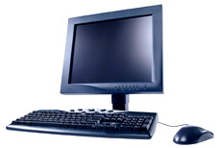

NT1
Reliance

Core
Network

Other
Terminating PSTN

TA
WAN connectivity
Reliance

Access
Network

Voice
Data

POI (Point of Interconnect)

This is a diagram showing the ISDN BRI Channel:

- The B channels are the “Bearer Channels”. They carry a major part of the traffic – voice / data / image / sound, etc.
- The D channel is the “Data Channel”. This channel carries data related to call signalling / error checking / call set up / user packet data. This channel can have many uses without interfering with voice or data calls in progress.

One BRI=2B+1D

The physical connection diagram for an ISDN Basic Rate interface is shown below:

INTERNAL AND EXTERNAL CUSTOMERS OF RELIANCE

MCN JAIPUR

The major distribution of departments at various MCNs across the country and some of the various other facilities of the reliance Infocomm is done with the nature and scope of the work and the priority listing of the particular MCN . MCN Jaipur being one of the 21 MCN locations that has switches makes it an important component of the nationwide network with the function of providing the switching operations to the local access network. The facility is divided into 6 major departments that handle individual operations:

MCN JAIPUR

DATA
O & M
SWITCH
TRANSPORT
SAX
RF
ACQUISITION
ILD
NLD
RDN & DCN
IT
TECH.

Fig. Hierarchal structure of departments
The various given departments in the chart are given a formal overview in the successive documents. Each department has its set functional details upon which the works are carried out, all the departments have to report to the MCN In-charge and hence subsequently to the NOC ( Network/National Operations Center, Mumbai where the same kind of hierarchal structure is followed but at the national level.

The various departments and related works are as follows:

SWITCH- The term switching deals with the core telecom fundamental of call processing.

RF- The RF department deals with core CDMA issues and hence is responsible for transferring a subscriber from the local BTS and hooking the call to an access network as well as it takes care of the transfer of signals through the air media.

DATA- The data department is the caretaker of the physical network and is hence responsible for the logical internetworking of all the physical components of Reliance Setup as well as the various different facilities across the country.

TRANSPORT- The department acts as a media with the help of which all the relevant data to each of the departments is transferred at a preconceived transfer rate that the machine of a particular department recognizes and further uses for processing.

SAX- Based on the principle of corDECT this department is the last mile solution provider to the very rarely populated mobile user area. They provide these services using an external agency in between.

O & M – The maintenance works in all company owned infrastructure assets that may include the building, the external optical fiber cable etc. all these are the responsibility of the department and hence it has to do routine checks.

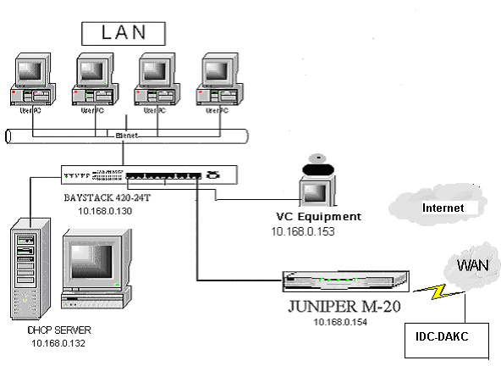MCN WAN CONNECTIVITY DIAGRAM

SWITCHES DEPARTMENT

Introduction

The reliance venture which embarks upon providing communication across the country at dirt cheap prices for the general public, wrests its major share of services provided by the mobile revolution the whole idea that was initially perceived by the visionary was to provide this basic telephonic services almost at negligible expense with a privately owned network across the nation. The mobile revolution has brought about a mammoth change in the way we perceive the original idea of telephonic communication. Reliance leaped into the mobile market with its latest 1X CDMA technology providing the users the required services using the technology taken from Qualcomm . Once the signal from the mobile reaches the access network the switch comes into play and the complete tenure right from the locking of the mobile to the access network to the cutting off the communication window the switches play a central part.

Switching In General

Access network

The main switching function in a local exchange is to interconnect timeslots to and from the subscriber access network and the trunk (transport) network.The main function of the access network is to connect users, for instance telephone subscribers, to a unit, switch, that can set up a path for exchange of information between two or more users. The connections between the users and the switch form the access network.
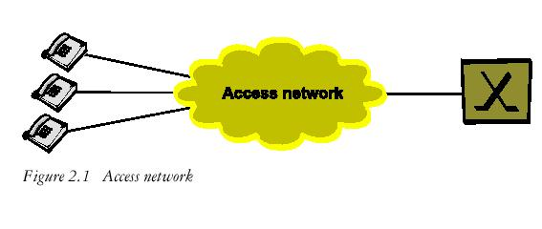

Remote subscriber multiplexer
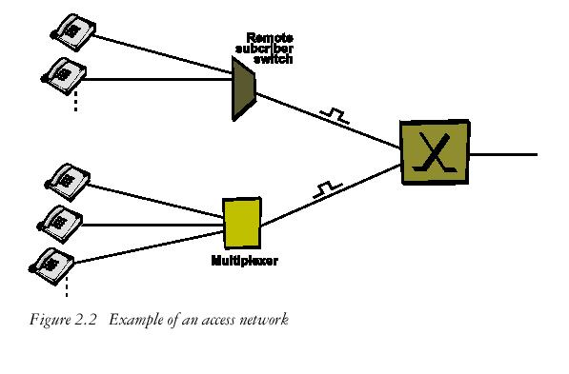

In the access network, multiplexers are used to digitize the analogue signal and this makes it possible to increase the distance between the subscriber and the exchange. A remote subscriber multiplexer for 30 analogue subscriber connections performs pulse code modulation of the speech to and from the sub-scribers. The digitized speech samples are multiplexed so that one digital link carries 32 timeslots, each containing 64 kbps of speech samples. The bit rate of such a link is 2.048 Mbps, a so-called PCM (pulse code modulated) link. Each subscriber has a dedicated timeslot on the link towards the local exchange.

Remote subscriber switch

In the access network a large number of subscribers can be connected to a concentrator, a remote subscriber switch (RSS). Some switching functionality is moved out from the local exchange to the remote subscriber switch. The RSS is connected to the local exchange via 2.048 Mbps links. Since the RSS works as a concentrator there are no dedicated time-slots for the connected subscribers. Though physically separate from the local exchange, the RSS is under complete control of that exchange. RSS brings all of the functions and services of the local exchange closer to the subscriber. Calls between two subscribers connected to the same RSS, detached from a local exchange, can be switched within the RSS. Calls between one local subscriber and one subscriber connected to another exchange are switched through the group switch in the local exchange. The International Telecommunication Union Telecommunication Standard Sector (ITU-T) states that the main function of switching is to establish, on demand, a connection from a desired inlet to a desired outlet.

Two general types of switching are used for the connection of sub-scribers:

• Circuit switching
• Packet switching

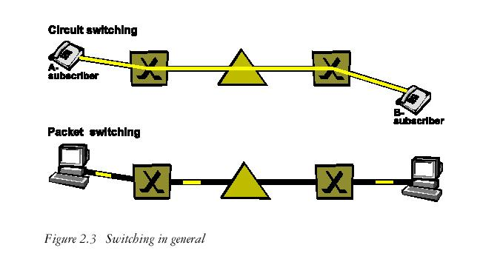

Circuit switching

Circuit switching means that the public switched telephone network allocates a circuit between the A-subscriber and the B-subscriber for the duration of the whole call.

Packet switching

Packet switching is a form of time division multiplexing on demand. Transmission is only requested when sufficient data to fill a packet is available at the transmitter. At other times the transmission medium may be used to transmit packets between other sources and destinations.

Digital switching

The two principles of digital switching are (see Figure 2.5):
• time switching
• space switching

Time switching is based on time division multiplexing (TDM) systems such as pulse code modulation (PCM). A PCM link can be shared in time by a number of speech channels. Each channel's share of this time is known as a timeslot, and each timeslot carries a speech sample.

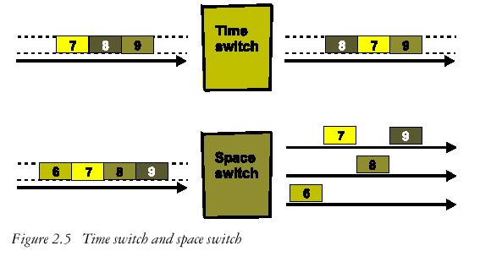

In Figure 2.6 the speech samples from subscribers A, B, C and D are transmitted in a fixed order and are received in the same order. This allows speech connections to be set up between subscribers, A to E, B to F, C to G, and D to H. What we need is a method that allows connection of any subscriber on the left-hand side to any subscriber on the right-hand side. This is achieved by utilizing a control store (a data store containing control information) to switch the connections in the required order.

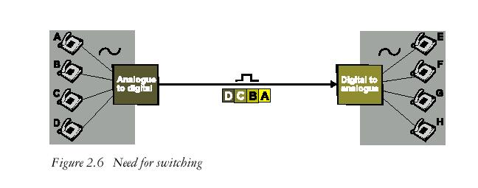

The control store manipulates the order in which information is read
out of the speech store (a data store containing speech information).

Time switch

A simple time switch is made up of:

• A speech store for temporary storage of the speech samples
• A control store which controls the reading out from the speech store

In Figure 2.7 the speech samples are read into the speech store in a fixed order: A, B, C, D. The values in the control store (that is, 3, 1, 4, 2) determine the order in which the speech samples are read out (that is C, A, D, B). As a result, the C–E, A–F, D–G and B–H speech connections are established.

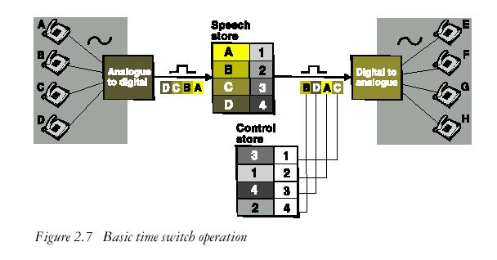

Space switch

Space switching is used to switch timeslots from an incoming PCM system
to an outgoing PCM system. The space switch is composed of a matrix of cross-points (electronic gates). To connect a timeslot in an incoming PCM system to a time-slot in an outgoing PCM system, the appropriate cross-point of the space switch is operated for a defined period (an internal timeslot).

Signaling

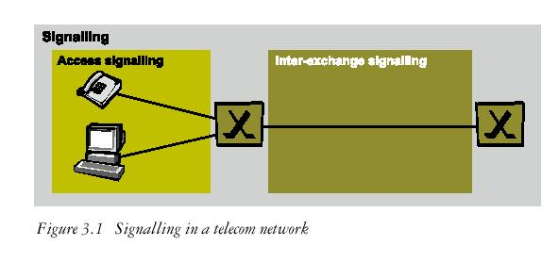

The basic purpose of signaling in telecom traffic systems is to deliver control information to different applications in order to influence procedures. The signaling in the access network differs in some aspects from signaling in the trunk network. It is therefore necessary to distinguish between access signaling and inter-exchange signaling.

Access signaling
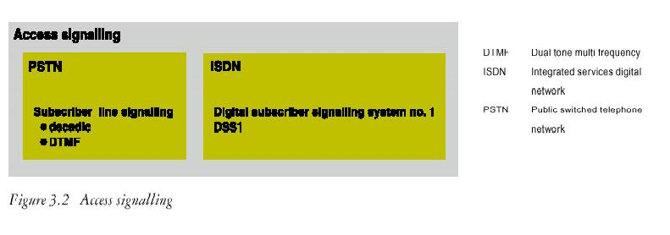

Signaling systems

For access signaling there are different systems:

• Analogue subscriber line signaling for PSTN
• Digital subscriber signaling system no. 1 (DSS1) for ISDN.

Signaling on the analogue subscriber line between a telephony sub-scriber
and the local exchange is described in Figure 3.3.
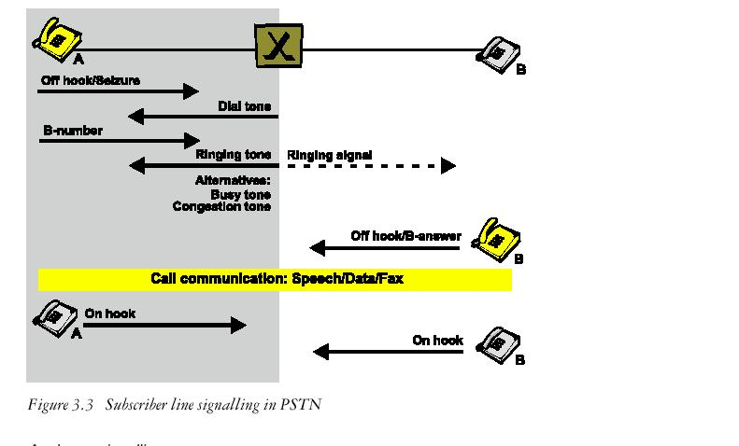

Analogue signaling

On an analogue connection, information about the B-subscriber’s number is normally transferred to the exchange either by dedicated pulses or as a combination of two tones. The combination of tones is known as dual tone multi frequency (DTMF) signaling. Two tones are used for each digit.

Digital signaling

Digital subscriber signaling system no. 1 (DSS 1) is the standard access signaling system in ISDN and PLMN. This is also called a D-channel signaling system. D-channel signaling is defined for digital access only. The signaling protocols are based on the open systems interconnection (OSI) reference model layers 1 to 3.

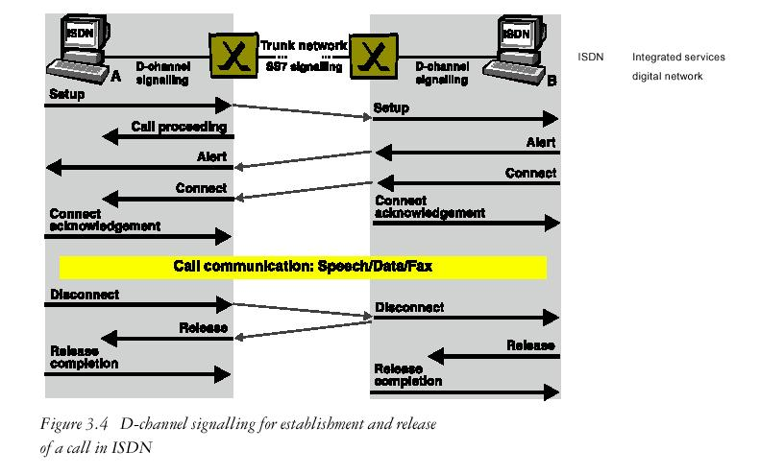

The signals are sent as data packets:
• The Setup message contains the information required to set up a call
• The Call Proceeding confirms the requested call establishment
• The Alert confirms that the B-terminal is aware that a call will arrive
• The Connect confirms that the B-terminal accepts the call

Inter-exchange signaling

Signaling equipment and signaling handling are required for the
exchange of information between nodes in the telecommunications net-work.
Inter-exchange signaling can be divided into two main categories (see
Figure 3.5):

• channel associated signaling (CAS)
• common channel signaling (CCS)

The division into channel associated signaling and common channel signaling can be regarded as a division into “old” and “new” signaling solutions.
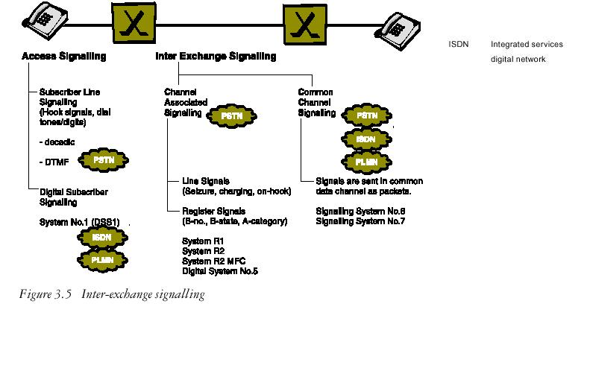

Channel associated signaling

Channel associated signaling is closely associated with the traffic com-munication channel. Signals and traffic are transferred on the same path
through the network. The signals are divided into two categories:

• Line signals
• Register signals

Line signals give information about, for example:
• idle line
• Seizure of line
• B-answer
• Charging pulses
• Clear line

Register signals carry information about, for example:
• B-number
• B-status information
• A-number (in some cases)

Transfer of signals

The register signals and the line signals on digital links are transferred
in the PCM frames.
On a PCM link with 32 time slots per frame the register signals
are transferred in the same timeslot as is reserved for the speech or other
user data. The line signals are transferred in timeslot 16 where 4 bits
are used for each call in a multiframe of 16 frames.

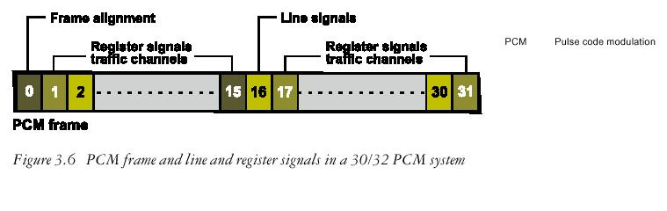

On a PCM link with 24 timeslots per frame the line signals are transferred
through one bit in every sixth frame. Register signals are transferred the same way as in a 30/32 PCM system
. 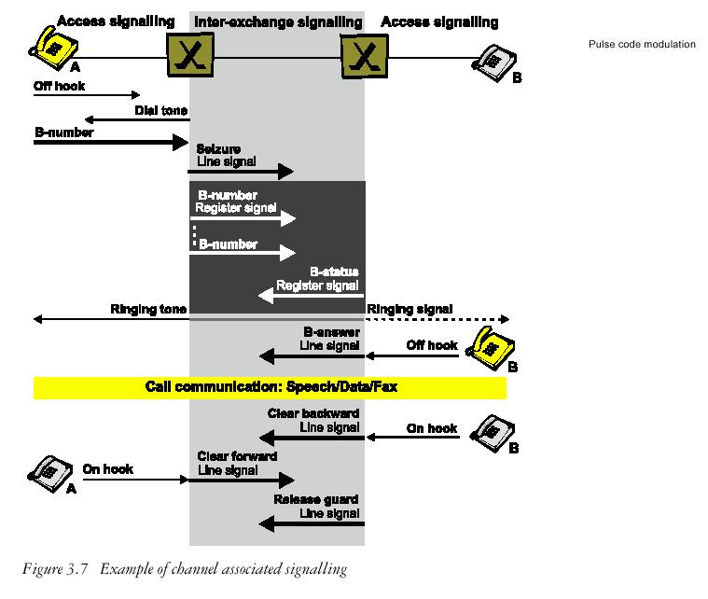

The register signals are only used during the call set-up phase. The line
signals can be sent and received before, during, and at the end of the call.

EQUIPMENT USED

The following switches are used at the facility with the specific tasks assigned to each of the groups :

ERRICSON SWITCHES- AXE-10
LUCENT SWITCHES-5ESS,6ESS

WORKS

The department deals with the following issues regularly:

- the constant monitoring of the calls through the WINFOL software solution provided with Ericsson switch
- co-ordinating POI problems with BSNL
- taking timely logs of the machine environment
- help isolate the problems related to switches with association to NOC
- troubleshooting costumer related technical issues

TOWN OFFICE, JAIPUR

The Town Office of Reliance Infocomm is like a heart of reliance. All the internal affairs are taken into consideration in the town office. Marketing, customer care, sales department etc is done under this office.

TOWN OFFICE WAN CONNECTIVITY DIAGRAM
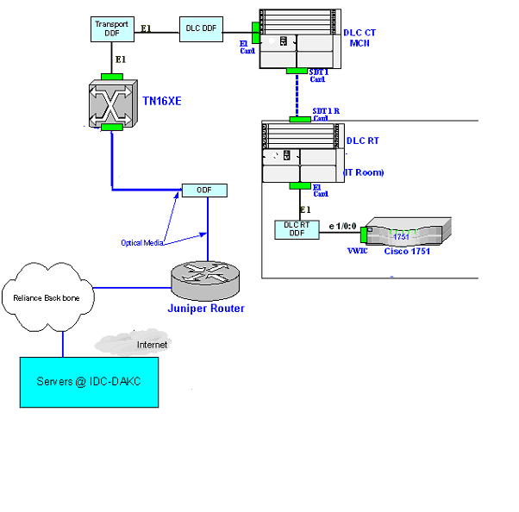

CMP DEPARTMENT, JAIPUR

CMP stands for City Maintenance point. All the external affairs are maintained and solved here. Here, there is FA team i.e., Fixed Access team who are responsible for installing routers ,switches and DLC’s where needed.DLC’s are Digital Loop Carrier.

CMP CONNECTIVITY DIAGRAM

WWE, JAIPUR

WWE stands for Web World Expresses. The main difference between web worlds and Web World Expresses is that in WWE only Customer Care is given preference &it is under the Franchisee of some one but in WW Customer Care, JavaGreen, Surfing, Gaming, VO, VSAT, etc are there which is under reliance only.

All the problems of customers are solved here. Customers are interacted with new schemes, new technologies, etc.

All the bills are paid in WWE. New connections are also allotted here. There are 15 WWE in Jaipur.

WWE CONNECTIVITY DIAGRAM

TRANSPORT DEPARTMENT

Introduction

This department acts as the postman of media, which delivers the data of each department to its subsequent address without the loss of the original form and content. This has been made possible by the enhanced overhead information that the modern protocols provide which makes it easier for the transport engineers to carry out their intended job using the relevant equipment.

Technologies Involved

Key points
- Made of extremely pure silica glass to reduce loss (attenuation) of light
- Core surrounded by lower refractive index cladding to guide light
- Single mode fiber core is only around 0.000010 meters in diameter
- Level of attenuation determines best wavelength at which to transmit
- Lowest loss in standard optical fiber at 1550nm (3rd transmission window)

Modulation Revisited

Key Points
- Laser light needs to be modulated to represent 1s or 0s.
- The non-input-to-zero (NZR) modulation format is common use to and doesn’t return to zero light output when transmitting successive 1s.
- Return-to-zero (RZ) formatting may have advantages for long distance applications.
- Direct modulation involves switching the laser on and off rapidly, when an electrical current representing the digital data.
- Advantages of direct modulation include its simplicity & cost effectiveness; disadvantages include poor chirp performance (leading to dispersion) and poor performance at high bit-rates.
- External modulators act as a shutter to transmit or block light from a laser that is operated by a constant electrical current.
- Advantages of external modulation include improvement in chirp performance and suitability for every high bit rates; disadvantages include complexity and cost.
- Electro-optic modulators split laser light into two paths and then cause phase shifts to either cancel out the 2 waves (to give a 0) or combine them (to give a 1).
- Electro-absorption modulators are reverse biased lasers that can absorb or transmit light and can be integrated within the transmission laser in a small package.

Transmission Networks

Early transmission networks were analogue, voice only, covered short distances and could only accommodate two users. Modern Transmission networks provide multiple services, including digital voice and data. They may have to accommodate millions of users, operate at very high speed, cover long distances and ensure 99.999% network availability.
Fixed Access Networks
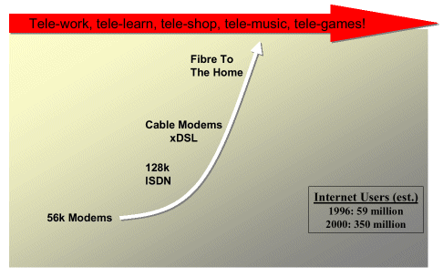
Mobile Access Networks
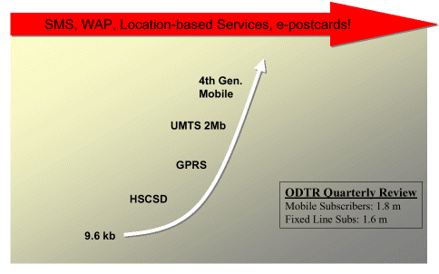
Enterprise Networks
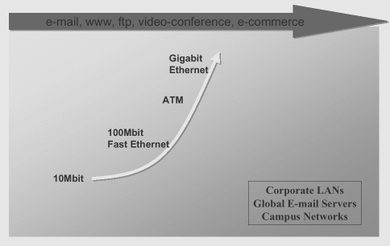

Definition
The purpose of a transmission network is to multiplex together multiple low bit rate digital traffic streams into higher bit rate traffic streams for efficient transport between access points.
The main principles in developing modern networks are Pulse Code Modulation, Time Division Multiplexing and Standard Multiplexing Hierarchies (e.g. PDH, SDH, SONET). Line code and modulation scheme defines the bit rate that can be run over the telecom network (1.544Mbps in Japan, 64Kbps in Japan).

Pulse Code Modulation
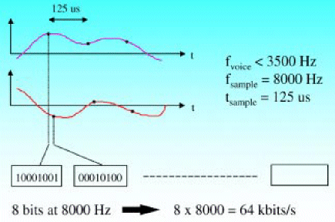

Time Division Multiplexing
Multiplexing is the assembly of a group of lower bit-rate individual channels into a higher bit-rate aggregate.
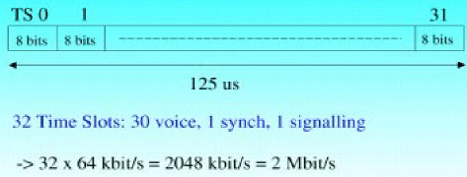

Multiplexing Hierarchies
PDH
- Plesiochronous Digital Hierarchy
- Multiplexes plesiochronous signals together into higher bit rate signals.
- 64 kbit/s, 2 Mbit/s, 8 Mbit/s, 34 Mbit/s, 140 Mbit/s, (565 Mbit/s)
SDH/SONET
- Synchronous Digital Hierarchy
- Multiplexing hierarchy for digital synchronous and plesiochronous signals over mainly optical transmission media.
- 155 Mbit/s, 622 Mbit/s, 2500 Mbit/s, 10 Gbit/s

Plesiosynchronous Digital Hierarchy (PDH) Multiplexing Structure

The old multiplexing structure used by the telecommunications network was PDH. This is being phased out, as there are a number of problems with it. Its chief characteristics are as below:
- Max Line Capacity: 565 Mbit/s
- Multiplexer Mountain – No direct access to individual 2Mbit/s streams (add/drop)
- Manual wiring and re-wiring needed to make any change to the network configuration
- Limited supervision facilities
Modern networks are far more dynamic than their predecessors. This involves switching and extensive supervision of the setup. Old PDH equipment doesn't allow for this. PDH also made inefficient use of varying bandwidth requirements as all signals had to go through the entire bandwidth pyramid.

The Synchronous Digital Hierarchy (SDH)

It’s the common standard for high bit rate Fiber Optic Transmission. In the year 1986 work started on development of SDH standards. It first approved Recommendations in 1998.

Principle of Synchronous Multiplexing
‘Synchronous Multiplexing requires that the data streams to be multiplexed have rates that are derived as integer sub-multiples of the aggregate rate and that they all derive their structure from that of the aggregate.’

Synchronous Transport Module (SDH Frame)
SDH in comparison to PDH (Bit rates)
PDH Standard (Bitrates) | SDH Denomination | SDH Transport Capacity | Corresponding SDH Bit rates
64 Kbit/s | "VC-0" | - | -
1.5 Mbit/s | VC-1 (VC-11) | - | -
2 Mbit/s | VC-1 (VC-12) | - | -
6 Mbit/s | VC-2 | - | -
34/45 Mbit/s | VC-3 | - | -
140 Mbit/s | VC-4 | STM-1 | 155 Mbit/s
 | VC-4 x 4 | STM-4 | 620 Mbit/s
 | VC-4 x 16 | STM-16 | 2500 Mbit/s
 | VC-4 x 64 | STM-64 | 10 Gbit/s
STM-1 Frame:
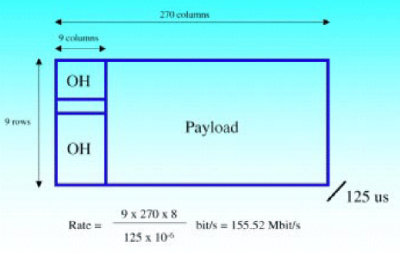
fig. Above can be explained with the help of the following calculations.
The 2-Dimensional Frame has 9 rows * 270 columns = 2430 bytes. Transmitted once every 125 msec (800 frames/sec).
=> 2430 bytes * 800 = 1944000 bytes/sec
=> 1944000 * 8 = 15552000 bit/sec
=> 155520 Kbit/s
=> 155.52 Mbit/s
The Payload contains User Data (ATM cells, IP packets, PDH frames). The total Information area is of 140 Mbits (out of 155Mbit/s).

Data for Network Management:
Information processed by equipment at various points in the network to provide certain functionality in the network:
- Trail Trace - misconnection of the physical media most common
- Error Monitoring
- Automatic Protection Switching

Benefits of SDH

Tributary Unit info indicates where a signal multiplexed into a larger frame is located inside the payload of the frame. This is the main advantage of SDH. The control information allows us to handle a huge amount of information and extract very exact details about it.
The SDH Multiplexer is about the size of a microwave oven and does the same job as a classroom the size of L240 half filled with PDH equipment.
Control and line-break tracing is one of the key network management functions that SDH facilitates. Its benefits include:
- Capacity
  - Fiber transmission up to 10 Gbit/s (STM-64) & ability to transport existing digital hierarchies plus future signals e.g. 34 MB ATM.
  - Low rate tributaries visible within the high-speed signal.
  - Availability
  - Advanced protection methods (SNC/MSP/MS-SPRing)
  - Network level re-routing

- Manageability
  - Faster provisioning, remotely from NMC
  - Built in capacity for remote monitoring of network performance
  - End to end supervision of circuits
  - Flexible re-routing of circuits in software

Multiplexing Strategies

The sending of many different wavelengths down the same optical fiber is known as Wavelength Division Multiplexing (WDM).Modern network in which individual lasers can transmit a 10 Gigabits/sec can now have several different lasers each giving out 10 Gigabits/sec through the same fiber at the same time. The no. of wavelengths is usually a power of 2 for some reason. So WDM system will use two different wavelengths, or 4,16,32,64,128, etc. Systems being developed at present will usually have no more than maybe 32 wavelengths, but the technology advancement will continue to make a higher number of wavelengths possible. The act of combining several different wavelengths of the same fiber is known as multiplexing. At the receiving end, these wavelengths need its own light detector to convert it
back into useful information.

Dense Wavelength Division Multiplexing

It is a technology that allows multiple information streams to be transmitted simultaneously over a single fiber at data rates as high as the plant will allow. The technology has evolved to the point such that the parallel wavelengths can be densely packed and integrated into a transmission system, with multiple, simultaneous, extremely high signals in the 192 to 200 terahertz (THz) range. The most common form DWDM uses a fiber pair –one for transmission and the other for reception. 16 channel DWDM system can support 40 Gb/s second with each of the channels serving as a unique STM-16 carrier.

DWDM involves using Multiple Optical Signals in the same optical fiber. The characteristics of DWDM are:

- Carrier frequency 192.3 - 195.4 THz
- Channel spacing 100GHz (0.8 nm)
- Capacity per channel 100 Mb/s to 10 Gb/s
- Capacity per Fiber
- 3.2 Gb/s @ 100 Mb/s * 32 channels
- 80 Gb/s @ 2.5Gb/s * 32 channels
- 320 Gb/s @ 10Gb/s * 32 channels
DWDM is enabling by a device known as the DWDM receiver. It uses high quality lasers to ensure signal purity, good optical power and optical signals transmitted on distinct wavelengths. There are a large number of benefits from using DWDM:
- Allows fast expansion of capacity on existing routes
  - 32 Channels @ 10 Gbit/s
  - 320 Gbit/s on a single fiber pair (today Max. 10 G with SDH)
- Longer Transmission Distances before Regeneration
  - 80km with SDH, 600 km with DWDM
- Saves time & cost of laying new fibers
  - Reduces equipment mountains at regenerator sites & associated build, operation & maintenance costs
- Higher Granularity protection switching
- Allows multiple clients to be carried directly and in parallel on the same fiber
One drawback to DWDM however is that it is analogue. Fiber Attenuation breaks down optical power, Dispersion means the receiver may not receive the signal, Cross-talk and Noise interfere with the data carried in the signal itself.

Already the DWDM technology is used for the following applications:

- DWDM is ready made for long distance telecommunications operators that use either point-to-point or ring topologies.

- This large amount of capacity is critical to the development of self-
healing rings, which characterize today’s most sophisticated telecom
networks. Using DWDM it is possible to construct 40 Gbps ring, with
16 separate signals using only 2 fibers.

- Its economical in increasing capacity, rapidly provision new
equipment for needed expansion, and future proof their infrastructure against unforeseen bandwidth demand.

- The transparency of DWDM systems to various bit rates and protocols
will also carriers to tailor and segregate services to various customers along the same route. It is possible to provide two separate customers STM-4 and STM-16 connectivity.

- DWDM systems with open interfaces give operators the flexibility to provide SONET/SDH, asynchronous/PDH, ATM, Frame relay, and other protocols over the same fiber. Open systems also eliminate the need for additional high-performance optical transmitters to be added to a network when the need arises to interface with specific protocols.

Transport Network Today
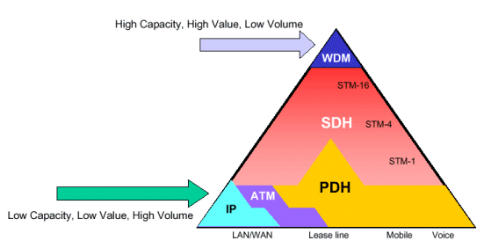

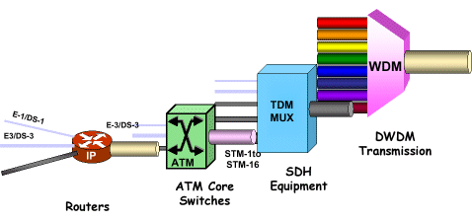

Transport Network Tomorrow
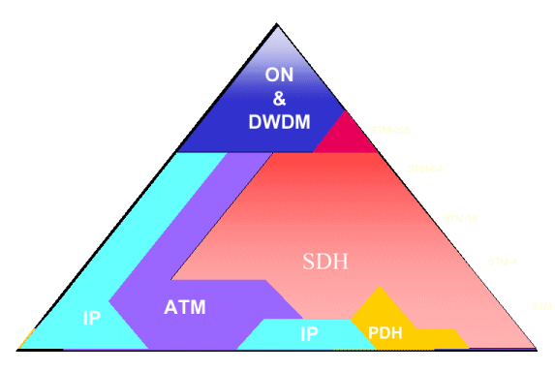

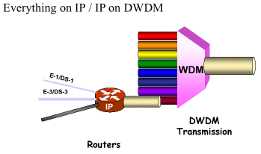

WORKS

- Physical interconnections between switches and POI , to other
elements like switch . Involves wiring at DDF (Digital distribution
Frame) ,connectivity of E1’s etc.
- Interconnections checking between various operators
- All the OSP operations are supervised by the department
- All the major changes in relation to a plant event are commissioned through the department
- It also provides the fault identification services to the central agency in the network as well as updates the EMS(Element Management System).

DATA DEPARTMENT

INTRODUCTION

The two departments that are responsible for the handling of the data that moves across the 70,000 kms stretch of the national network are the transport and the data divisions. The nature of the work involved in data department, a robust design and a great amount of planning goes behind the scene in order to make the whole network click. The national long distance (NLD) network consists of TDM and IP network components, which are carried on the transport network.

The data packets are transmitted on the NLD backbone using IP over SDH or IP over DWDM architecture. This is made possible only because of the use of Multi Protocol Label Switching (MPLS), which addresses the issues related to Traffic Engineering and Quality Of Service. Access services then provide the last mile connectivity in the different cities. The Network is designed to provide a single network that will transparently carry multiple data, voice, and video application in a converged manner. The bunch of services that are supported by the network are mentioned below:

- VOIP
- Internet
- Dial VPN
- Voice Virtual Private Network (VPN)
- ISP services
- Web Stores
- Data Communication Network (DCN)
- Wireless Data Traffic
- Enterprise Intranet
- Extranet

The department is broadly divided into two sections namely
- Reliance Data Network (RDN)
- Data Communication Network (DCN)

Technologies Involved

INTERNETWORK

An internetwork is a collection of individual networks, connected by intermediate networking devices, that functions as a single large network. Internetworking refers to the industry, products, and procedures that meet the challenge of creating and administering internetworks. Figure 1-1 illustrates some different kinds of network technologies that can be interconnected by routers and other networking devices to
create an internetwork.

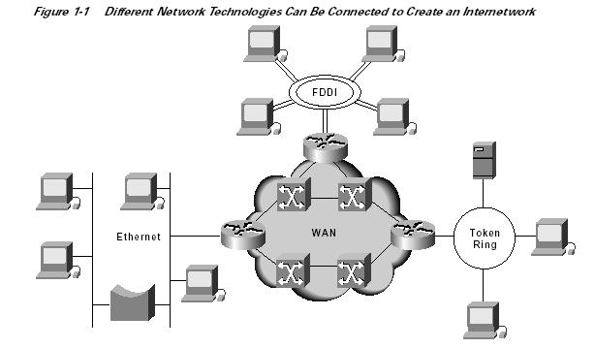

Wide-area networks (WANs) interconnect LANs with geographically dispersed users to create connectivity. Some of the technologies used for connecting LANs include T1, T3, ATM, ISDN, ADSL, Frame Relay, radio links, and others. New methods of connecting dispersed LANs are appearing everyday. Today, high-speed LANs and switched internetworks are becoming widely used, largely because they operate at very high speeds and support such high-bandwidth applications as multimedia and videoconferencing. Internetworking evolved as a solution to three key problems: isolated LANs, duplication of resources, and a lack of network management. Isolated LANs made electronic communication between different offices or departments impossible. Duplication of resources meant that the same hardware and software had to be supplied to each office or department, as did separate support staff. This lack of network management meant that no centralized method of managing and troubleshooting networks existed.

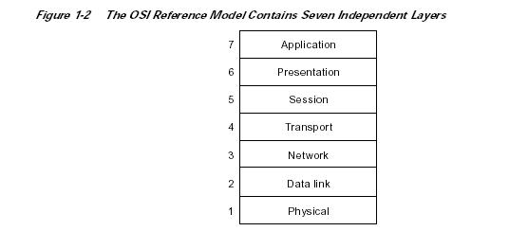

Characteristics of the OSI Layers

The seven layers of the OSI reference model can be divided into two categories: upper layers and lower layers. The upper layers of the OSI model deal with application issues and generally are implemented only in software.. The lower layers of the OSI model handle data transport issues. The physical layer and the data link layer are implemented in hardware and software.

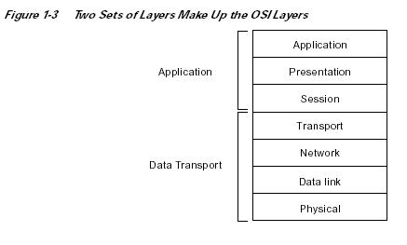

Protocols
A protocol is a formal set of rules and conventions that governs how computers exchange information over a network medium. A protocol implements the functions of one or more of the OSI layers. A wide variety of communication protocols exist. Some of these protocols include LAN protocols, WAN protocols, network protocols, and routing protocols. LAN protocols operate at the physical and data link layers of the OSI model and define communication over the various LAN media. WAN protocols operate at the lowest three layers of the OSI model and define communication over the various wide-area media. Routing protocols are network layer protocols that are responsible for exchanging information between routers so that the routers can select the proper path for network traffic. Finally, network protocols are the various upper-layer protocols that exist in a given protocol suite. Many protocols rely on others for operation. For example, many routing protocols use network protocols to exchange information between routers. This concept of building upon the layers already in existence is the foundation of the OSI model.

OSI Model and Communication Between Systems

Information being transferred from a software application in one computer system to a software application in another must pass through the OSI layers. For example, if a software application in System A has information to transmit to a software application in System B, the application program in System A will pass its information to the application layer (Layer 7) of System A. The application layer then passes the information to the presentation layer (Layer 6), which relays the data to the session layer
(Layer 5), and so on down to the physical layer (Layer 1). At the physical layer, the information is placed on the physical network medium and is sent across the medium to System B. The physical layer of System B removes the information from the physical medium, and then its physical layer passes the
information up to the data link layer (Layer 2), which passes it to the network layer (Layer 3), and so on, until it reaches the application layer (Layer 7) of System B. Finally, the application layer of System B passes the information to the recipient application program to complete the communication process.

Interaction Between OSI Model Layers

A given layer in the OSI model generally communicates with three other OSI layers: the layer directly above it, the layer directly below it, and its peer layer in other networked computer systems. The data link layer in System A, for example, communicates with the network layer of System A, the physical layer of System A, and the data link layer in System B. Figure 1-4 illustrates this example.

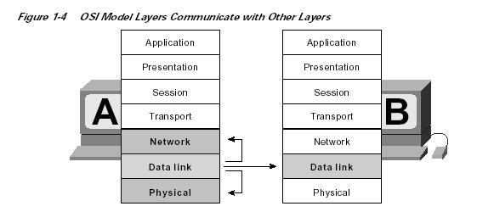

OSI Layer Services

One OSI layer communicates with another layer to make use of the services provided by the second layer. The services provided by adjacent layers help a given OSI layer communicate with its peer layer in other computer systems. Three basic elements are involved in layer services: the service user, the service provider, and the service access point (SAP). In this context, the service user is the OSI layer that requests services from an adjacent OSI layer. The service provider is the OSI layer that provides services to service users. OSI layers can provide services to multiple service users. The SAP is a conceptual location at which one OSI layer can request the services of another OSI layer. Figure 1-5 illustrates how these three elements interact at the network and data link layers.

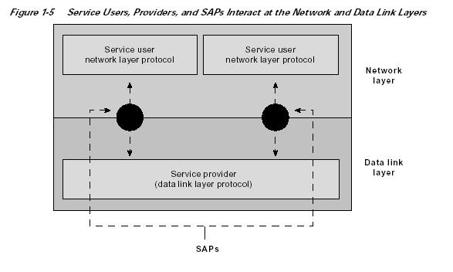

OSI Model Layers and Information Exchange

The seven OSI layers use various forms of control information to communicate with their peer layers in other computer systems. This control information consists of specific requests and instructions that are exchanged between peer OSI layers. Control information typically takes one of two forms: headers and trailers. Headers are prepended to data that has been passed down from upper layers. Trailers are appended to data that has been passed down from upper layers. An OSI layer is not required to attach a header or a trailer to data from upper layers. Headers, trailers, and data are relative concepts, depending on the layer that analyzes the information unit. At the network layer, for example, an information unit consists of a Layer 3 header and data. At the data link layer, however, all the information passed down by the network layer (the Layer 3 header and the data) is treated as data. In other words, the data portion of an information unit at a given OSI layer potentially can contain headers, trailers, and data from all the higher layers. This is known as encapsulation. Figure 1-6 shows how the header and data from one layer are encapsulated into the header of the next lowest layer.
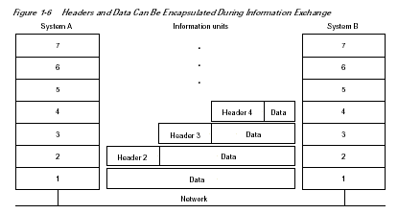

Information Exchange Process

The information exchange process occurs between peer OSI layers. Each layer in the source system adds control information to data, and each layer in the destination system analyzes and removes the control information from that data. If System A has data from a software application to send to System B, the data is passed to the application layer. The application layer in System A then communicates any control information required by the application layer in System B by prepending a header to the data. The resulting information unit (a header and the data) is passed to the presentation layer, which prepends its own header containing control information intended for the presentation layer in System B. The information unit grows in size as each layer prepends its own header (and, in some cases, a trailer) that contains control information to be used by its peer layer in System B. At the physical layer, the entire information unit is placed onto the network medium. The physical layer in System B receives the information unit and passes it to the data link layer. The data link layer in System B then reads the control information contained in the header prepended by the data link layer in System A. The header is then removed, and the remainder of the information unit is passed to the network layer. Each layer performs the same actions: The layer reads the header from its peer layer, strips it off, and passes the remaining information unit to the next highest layer. After the application layer performs these actions, the data is passed to the recipient software application in System B, in exactly the form in which it was transmitted by the application in System A.

OSI Model Physical Layer

The physical layer defines the electrical, mechanical, procedural, and functional specifications for activating, maintaining, and deactivating the physical link between communicating network systems. Physical layer specifications define characteristics such as voltage levels, timing of voltage changes, physical data rates, maximum transmission distances, and physical connectors. Physical layer implementations can be categorized as either LAN or WAN specifications. Figure 1-7 illustrates some common LAN and WAN physical layer implementations.

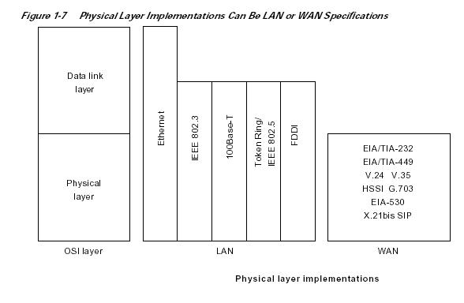

OSI Model Data Link Layer

The data link layer provides reliable transit of data across a physical network link. Different data link layer specifications define different network and protocol characteristics, including physical addressing, network topology, error notification, sequencing of frames, and flow control. Physical addressing (as opposed to network addressing) defines how devices are addressed at the data link layer. Network topology consists of the data link layer specifications that often define how devices are to be physically connected, such as in a bus or a ring topology. Error notification alerts upper-layer protocols that a transmission error has occurred, and the sequencing of data frames reorders frames that are transmitted out of sequence. Finally, flow control moderates the transmission of data so that the receiving device is not overwhelmed with more traffic than it can handle at one time. The Institute of Electrical and Electronics Engineers (IEEE) has subdivided the data link layer into two sub layers: Logical Link Control (LLC) and Media Access Control (MAC). Figure 1-8 illustrates the IEEE sub layers of the data link layer.

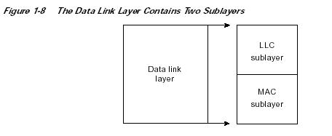

The Logical Link Control (LLC) sublayer of the data link layer manages communications between devices over a single link of a network. LLC is defined in the IEEE 802.2 specification and supports both connectionless and connection-oriented services used by higher-layer protocols. IEEE 802.2
defines a number of fields in data link layer frames that enable multiple higher-layer protocols to share a single physical data link. The Media Access Control (MAC) sublayer of the data link layer manages protocol access to the physical network medium. The IEEE MAC specification defines MAC addresses, which enable multiple devices to uniquely identify one another at the data link layer.

OSI Model Network Layer

The network layer defines the network address, which differs from the MAC address. Some network layer implementations, such as the Internet Protocol (IP), define network addresses in a way that route selection can be determined systematically by comparing the source network address with the
destination network address and applying the subnet mask. Because this layer defines the logical network layout, routers can use this layer to determine how to forward packets. Because of this, much of the design and configuration work for internetworks happens at Layer 3, the network layer.

OSI Model Transport Layer

The transport layer accepts data from the session layer and segments the data for transport across the network. Generally, the transport layer is responsible for making sure that the data is delivered error-free and in the proper sequence. Flow control generally occurs at the transport layer. Flow control manages data transmission between devices so that the transmitting device does not send more data than the receiving device can process. Multiplexing enables data from several applications to be transmitted onto a single physical link. Virtual circuits are established, maintained, and terminated by the transport layer. Error checking involves creating various mechanisms for detecting transmission errors, while error recovery involves acting, such as requesting that data be retransmitted, to resolve any errors that occur. The transport protocols used on the Internet are TCP and UDP.

OSI Model Session Layer

The session layer establishes, manages, and terminates communication sessions. Communication sessions consist of service requests and service responses that occur between applications located in different network devices. These requests and responses are coordinated by protocols implemented at the session layer. Some examples of session-layer implementations include Zone Information Protocol (ZIP), the AppleTalk protocol that coordinates the name binding process; and Session Control Protocol (SCP), the DECnet Phase IV session layer protocol.

OSI Model Presentation Layer

The presentation layer provides a variety of coding and conversion functions that are applied to application layer data. These functions ensure that information sent from the application layer of one system would be readable by the application layer of another system. Some examples of presentation layer coding and conversion schemes include common data representation formats, conversion of character representation formats, common data compression schemes, and common data encryption schemes. Common data representation formats, or the use of standard image, sound, and video formats, enable the interchange of application data between different types of computer systems. Using different text and data representations, such as EBCDIC and ASCII, uses conversion schemes to exchange information with systems. Standard data compression schemes enable data that is compressed at the source device to be properly decompressed at the destination. Standard data encryption schemes enable data encrypted at the source device to be properly deciphered at the destination. Presentation layer implementations are not typically associated with a particular protocol stack. Some well-known standards for video include QuickTime and Motion Picture Experts Group (MPEG). QuickTime is an Apple Computer specification for video and audio, and MPEG is a standard for video compression and coding. Among the well-known graphic image formats are Graphics Interchange Format (GIF), Joint Photographic Experts Group (JPEG), and Tagged Image File Format (TIFF). GIF is a standard for compressing and coding graphic images. JPEG is another compression and coding standard for graphic images, and TIFF is a standard coding format for graphic images.

OSI Model Application Layer

The application layer is the OSI layer closest to the end user, which means that both the OSI application layer and the user interact directly with the software application. This layer interacts with software applications that implement a communicating component. Such application programs fall outside the scope of the OSI model. Application layer functions typically include identifying communication partners, determining resource availability, and synchronizing communication. When identifying communication partners, the application layer determines the identity and availability of communication partners for an application with data to transmit. When determining resource availability, the application layer must decide whether sufficient network resources for the requested communication exist. In synchronizing communication, all communication between applications requires cooperation that is managed by the application layer. Some examples of application layer implementations include Telnet, File Transfer Protocol (FTP), and Simple Mail Transfer Protocol (SMTP).

Information Formats

The data and control information that is transmitted through internetworks takes a variety of forms. The terms used to refer to these information formats are not used consistently in the internetworking industry but sometimes are used interchangeably. Common information formats include frames, packets, datagrams, segments, messages, cells, and data units. A frame is an information unit whose source and destination are data link layer entities. A frame is composed of the data link layer header (and possibly a trailer) and upper-layer data. The header and trailer contain control information intended for the data link layer entity in the destination system. Data from upper-layer entities is encapsulated in the data link layer header and trailer. Figure 1-9 illustrates the basic components of a data link layer frame.

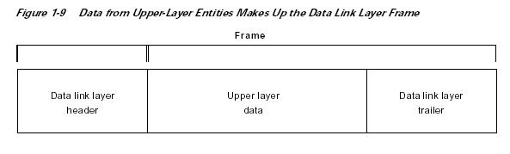
A packet is an information unit whose source and destination are network layer entities. A packet is composed of the network layer header (and possibly a trailer) and upper-layer data. The header and trailer contain control information intended for the network layer entity in the destination system. Data from upper-layer entities is encapsulated in the network layer header and trailer. Figure 1-10 illustrates the basic components of a network layer packet.

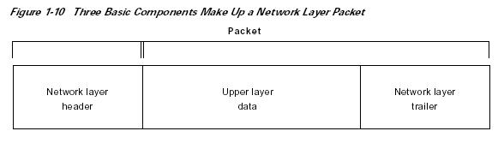

The term datagram usually refers to an information unit whose source and destination are network layer entities that use connectionless network service. The term segment usually refers to an information unit whose source and destination are transport layer entities. A message is an information unit whose source and destination entities exist above the network layer (often at the application layer). A cell is an information unit of a fixed size whose source and destination are data link layer entities. Cells are used in switched environments, such as Asynchronous Transfer Mode (ATM) and Switched Multimegabit Data Service (SMDS) networks. A cell is composed of the header and payload. The header contains control information intended for the destination data link layer entity and is typically 5 bytes long. The payload contains upper-layer data that is encapsulated in the cell header and is typically 48 bytes long. The length of the header and the payload fields always are the same for each cell. Figure 1-11 depicts the components of a typical cell.

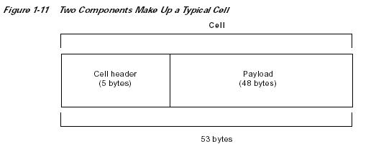

Data unit is a generic term that refers to a variety of information units. Some common data units are service data units (SDUs), protocol data units, and ridge protocol data units (BPDUs). SDUs are information units from upper-layer protocols that define a service request to a lower-layer protocol. PDU is OSI terminology for a packet. The spanning-tree algorithm uses bPDUs as hello messages.

Internetwork Addressing

Internetwork addresses identify devices separately or as members of a group. Addressing schemes vary depending on the protocol family and the OSI layer. Three types of internetwork addresses are commonly used: data link layer addresses, Media Access Control (MAC) addresses, and network layer addresses.

Data Link Layer Addresses

A data link layer address uniquely identifies each physical network connection of a network device. Data-link addresses sometimes are referred to as physical or hardware addresses. Data-link addresses usually exist within a flat address space and have a pre-established and typically fixed relationship to a specific device. End systems generally have only one physical network connection and thus have only one data-link address. Routers and other internetworking devices typically have multiple physical network connections and therefore have multiple data-link addresses. Figure 1-13 illustrates how each interface on a device is uniquely identified by a data-link address.

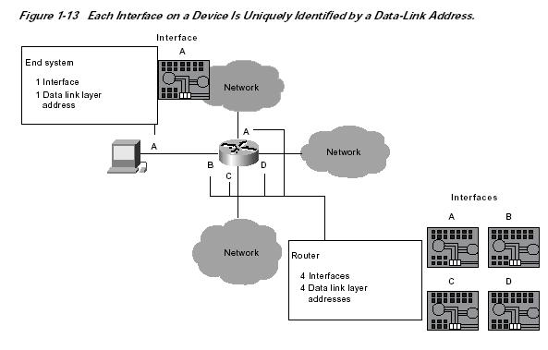

MAC Addresses

Media Access Control (MAC) addresses consist of a subset of data link layer addresses. MAC addresses identify network entities in LANs that implement the IEEE MAC addresses of the data link layer. As with most data-link addresses, MAC addresses are unique for each LAN interface. Figure 1-14 illustrates the relationship between MAC addresses, data-link addresses, and the IEEE sub layers of the data link layer.

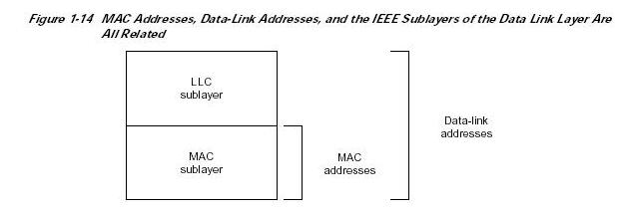

MAC addresses are 48 bits in length and are expressed as 12 hexadecimal digits. The first 6 hexadecimal digits, which are administered by the IEEE, identify the manufacturer or vendor and thus comprise the Organizationally Unique Identifier (OUI). The last 6 hexadecimal digits comprise the interface serial number, or another value administered by the specific vendor. MAC addresses sometimes are called burned-in addresses (BIAs) because they are burned into read-only memory (ROM) and are copied into random-access memory (RAM) when the interface card initializes. Figure 1-15 illustrates the MAC address format.

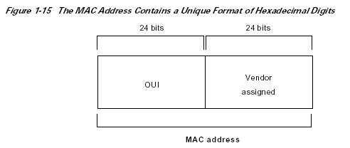

Mapping Addresses

Because internetworks generally use network addresses to route traffic around the network, there is a need to map network addresses to MAC addresses. When the network layer has determined the destination station’s network address, it must forward the information over a physical network using a MAC address. Different protocol suites use different methods to perform this mapping, but the most popular is Address Resolution Protocol (ARP). Different protocol suites use different methods for determining the MAC address of a device. The following three methods are used most often. Address Resolution Protocol (ARP) maps network addresses to MAC addresses. The Hello protocol enables network devices to learn the MAC addresses of other network devices. MAC addresses either are embedded in the network layer address or are generated by an algorithm. Address Resolution Protocol (ARP) is the method used in the TCP/IP suite. When a network device needs to send data to another device on the same network, it knows the source and destination network addresses for the data transfer. It must somehow map the destination address to a MAC address before forwarding the data. First, the sending station will check its ARP table to see if it has already discovered this destination station’s MAC address. If it has not, it will send a broadcast on the network with the destination station’s IP address contained in the broadcast. Every station on the network receives the
broadcast and compares the embedded IP address to its own. Only the station with the matching IP address replies to the sending station with a packet containing the MAC address for the station. The first station then adds this information to its ARP table for future reference and proceeds to transfer the data. When the destination device lies on a remote network, one beyond a router, the process is the same except that the sending station sends the ARP request for the MAC address of its default gateway. It then forwards the information to that device. The default gateway will then forward the information over whatever networks necessary to deliver the packet to the network on which the destination device resides. The router on the destination device’s network then uses ARP to obtain the MAC of the actual destination device and delivers the packet. The Hello protocol is a network layer protocol that enables network devices to identify one another and indicate that they are still functional. When a new end system powers up, for example, it broadcasts hello messages onto the network. Devices on the network then return hello replies, and hello messages are also sent at specific intervals to indicate that they are still functional. Network devices can learn the MAC addresses of other devices by examining Hello protocol packets. Three protocols use predictable MAC addresses. In these protocol suites, MAC addresses are predictable because the network layer either embeds the MAC address in the network layer address or uses an algorithm to determine the MAC address. The three protocols are Xerox Network systems (XNS), Novell Internetwork Packet Exchange (IPX), and DECnet Phase IV.

Network Layer Addresses

A network layer address identifies an entity at the network layer of the OSI layers. Network addresses usually exist within a hierarchical address space and sometimes are called virtual or logical addresses. The relationship between a network address and a device is logical and unfixed; it typically is based either on physical network characteristics (the device is on a particular network segment) or on groupings that have no physical basis (the device is part of an AppleTalk zone). End systems require one network layer address for each network layer protocol that they support. (This assumes that the device has only one physical network connection.) Routers and other internetworking devices require one network layer address per physical network connection for each network layer protocol supported.

Designing Campus Networks

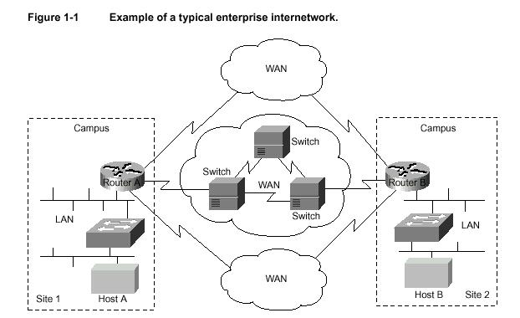

A campus is a building or group of buildings all connected into one enterprise network that consists of many local area networks (LANs). A campus is generally a portion of a company (or the whole company) constrained to a fixed geographic area, as shown in Figure 1-2.

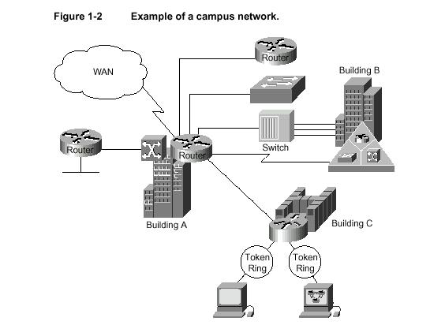

The distinct characteristic of a campus environment is that the company that owns the campus network usually owns the physical wires deployed in the campus. The campus network topology is primarily LAN technology connecting all the end systems within the building. Campus networks generally use LAN technologies, such as Ethernet, Token Ring, Fiber Distributed Data Interface (FDDI), Fast Ethernet, Gigabit Ethernet, and Asynchronous Transfer Mode (ATM).

A large campus with groups of buildings can also use WAN technology to connect the buildings. Although the wiring and protocols of a campus might be based on WAN technology, they do not share the WAN constraint of the high cost of bandwidth. After the wire is installed, bandwidth is inexpensive because the company owns the wires and there is no recurring cost to a service provider. However, upgrading the physical wiring can be expensive. Consequently, network designers generally deploy a campus design that is optimized for the fastest functional architecture that runs on existing physical wire. They might also upgrade wiring to meet the requirements of emerging applications. For example, higher-speed technologies, such as Fast Ethernet, Gigabit Ethernet, and ATM as a backbone architecture, and Layer 2 switching provide dedicated bandwidth to the desktop.

Trends in Campus Design

In the past, network designers had only a limited number of hardware options—routers or hubs—when purchasing a technology for their campus networks. Consequently, it was rare to make a hardware design mistake. Hubs were for wiring closets and routers were for the data center or main
telecommunications operations. Recently, local-area networking has been revolutionized by the exploding use of LAN switching at Layer 2 (the data link layer) to increase performance and to provide more bandwidth to meet new data networking applications. LAN switches provide this performance benefit by increasing bandwidth and throughput for workgroups and local servers. Network designers are deploying LAN switches out toward the network’s edge in wiring closets. As Figure 1-3 shows, these switches are
usually installed to replace shared concentrator hubs and give higher bandwidth connections to the end user.
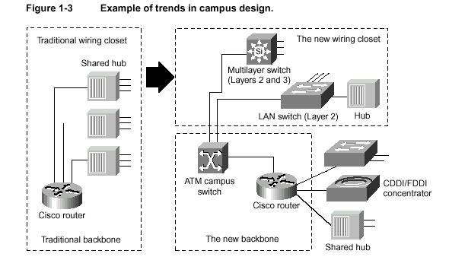

Layer 3 networking is required in the network to interconnect the switched workgroups and to provide services that include security, quality of service (QoS), and traffic management. Routing integrates these switched networks, and provides the security, stability, and control needed to build functional and scalable networks.

Traditionally, Layer 2 switching was provided by LAN switches, and Layer 3 networking has been provided by routers. Increasingly, these two networking functions are being integrated into common platforms. For example, multilayer switches that provide Layer 2 and 3 functionality are now appearing in the marketplace. With the advent of such technologies as Layer 3 switching, LAN switching, and virtual LANs (VLANs), building campus networks is becoming more complex than in the past. Table 1-1
summarizes the various LAN technologies that are required to build successful campus networks.
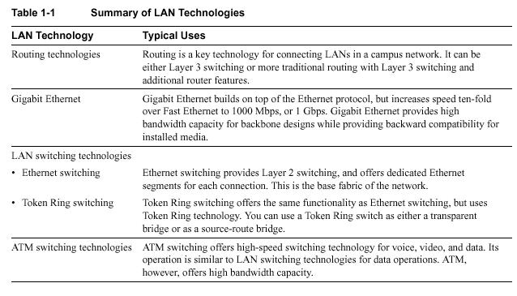

WAN

WAN communication occurs between geographically separated areas. In enterprise internetworks, WANs connect campuses together. When a local end station wants to communicate with a remote end station (an end station located at a different site), information must be sent over one or more WAN links. Routers within enterprise internetworks represent the LAN/WAN junction points of an internetwork. These routers determine the most appropriate path through the internetwork for the required data streams. WAN links are connected by switches, which are devices that relay information through the WAN and dictate the service provided by the WAN. WAN communication is often called a service because the network provider often charges users for the services provided by the WAN (called tariffs). WAN services are provided through the following three primary switching technologies:

LAN Technology Typical Uses

Routing technologies Routing is a key technology for connecting LANs in a campus network. It can be either Layer 3 switching or more traditional routing with Layer 3 switching and additional router features. Gigabit Ethernet Gigabit Ethernet builds on top of the Ethernet protocol, but increases speed ten-fold over Fast Ethernet to 1000 Mbps, or 1 Gbps. Gigabit Ethernet provides high bandwidth capacity for backbone designs while providing backward compatibility for installed media.

LAN switching technologies

• Ethernet switching
• Token Ring switching

Ethernet switching provides Layer 2 switching, and offers dedicated Ethernet segments for each connection. This is the base fabric of the network. Token Ring switching offers the same functionality as Ethernet switching, but uses Token Ring technology. You can use a Token Ring switch as either a transparent bridge or as a source-route bridge. ATM switching technologies ATM switching offers high-speed switching technology for voice, video, and data. Its operation is similar to LAN switching technologies for data operations. ATM, however, offers high bandwidth capacity

• Circuit switching
• Packet switching
• Cell switching

Each switching technique has advantages and disadvantages. For example, circuit-switched networks offer users dedicated bandwidth that cannot be infringed upon by other users. In contrast, packet-switched networks have traditionally offered more flexibility and used network bandwidth
more efficiently than circuit-switched networks. Cell switching, however, combines some aspects of circuit and packet switching to produce networks with low latency and high throughput. Cell switching is rapidly gaining in popularity. ATM is currently the most prominent cell-switched
technology.

Trends in WAN Design

Traditionally, WAN communication has been characterized by relatively low throughput, high delay, and high error rates. WAN connections are mostly characterized by the cost of renting media (wire) from a service provider to connect two or more campuses together. Because the WAN infrastructure is often rented from a service provider, WAN network designs must optimize the cost of bandwidth and bandwidth efficiency.

For example, all technologies and features used to connect campuses over
a WAN are developed to meet the following design requirements:
• Optimize WAN bandwidth
• Minimize the tariff cost
• Maximize the effective service to the end users
Recently, traditional shared-media networks are being overtaxed because of the following new network requirements:
•Necessity to connect to remote sites
• Growing need for users to have remote access to their networks
• Explosive growth of the corporate intranets
• Increased use of enterprise servers

Network designers are turning to WAN technology to support these new requirements. WAN connections generally handle mission-critical information, and are optimized for price/performance bandwidth. The routers connecting the campuses, for example, generally apply traffic optimization, multiple paths for redundancy, dial backup for disaster recovery, and QoS for critical applications.

Leased line Leased lines can be used for Point-to-Point Protocol (PPP) networks and hub-and-spoke topologies, or for backup for another type of link.

Integrated Services Digital Network (ISDN) ISDN can be used for cost-effective
Remote access to corporate networks. It
provides support for voice and video as well
as a backup for another type of link.

Frame Relay Frame Relay provides a cost-effective, high- speed, low-latency mesh topology between remote sites. It can be used in both private and carrier-provided networks.

Switched Multimegabit Data Service (SMDS) SMDS provides high-speed, high-performance connections across public data networks. It can also be deployed in metropolitan-area networks (MANs).

X.25 X.25 can provide a reliable WAN circuit or backbone. It also provides support for legacy applications.

WAN ATM WAN ATM can be used to accelerate bandwidth requirements. It also provides support for multiple QoS classes for differing application requirements for delay and loss.

Table 1-2 Summary of WAN Technologies

Utilizing Remote Connection Design

Remote connections link single users (mobile users and/or telecommuters) and branch offices to a local campus or the Internet. Typically, a remote site is a small site that has few users and therefore needs a smaller size WAN connection. The remote requirements of an internetwork, however, usually involve a large number of remote single users or sites, which causes the aggregate WAN charge to be exaggerated. Because there are so many remote single users or sites, the aggregate WAN bandwidth cost is proportionally more important in remote connections than in WAN connections. Given that the three-year cost of a network is nonequipment expenses, the WAN media rental charge from a service provider is the largest cost component of a remote network. Unlike WAN connections, smaller sites or single users seldom need to connect 24 hours a day.
Consequently, network designers typically choose between dial-up and dedicated WAN options for remote connections. Remote connections generally run at speeds of 128 Kbps or lower. A network designer might also employ bridges in a remote site for their ease of implementation, simple
topology, and low traffic requirements.

Trends in Remote Connections

Today, there is a large selection of remote WAN media that include the following:

• Analog modem
• Asymmetric Digital Subscriber Line
• Leased line
• Frame Relay
• X.25
• ISDN

Remote connections also optimize for the appropriate WAN option to provide cost-effective bandwidth, minimize dial-up tariff costs, and maximize effective service to users.

Trends in LAN/WAN Integration

Today, 90 percent of computing power resides on desktops, and that power is growing exponentially. Distributed applications are increasingly andwidth hungry, and the emergence of the Internet is driving many LAN architectures to the limit. Voice communications have increased significantly with more reliance on centralized voice mail systems for verbal communications. The internetwork is the critical tool for information flow. Internetworks are being pressured to cost less, yet support the emerging applications and higher number of users with increased performance. To date, local- and wide-area communications have remained logically separate. In the LAN, bandwidth is free and connectivity is limited only by hardware and implementation costs. The LAN has carried data only. In the WAN, bandwidth has been the overriding cost, and such delay-sensitive traffic as voice has remained separate from data. New applications and the economics of supporting them, however, are forcing these conventions to change. The Internet is the first source of multimedia to the desktop, and immediately breaks the rules. Such Internet applications as voice and real-time video require better, more predictable LAN and WAN performance. These multimedia applications are fast becoming an essential part of the business productivity toolkit. As companies begin to consider implementing new intranet-based, bandwidth-intensive multimedia applications—such as video training, videoconferencing, and voice over IP—the impact of these applications on the existing networking infrastructure is a serious concern. If a company has relied on its corporate network for business-critical SNA traffic, for example, and wants to bring a new video training application on line, the network must be able to provide guaranteed quality of service (QoS) that delivers the multimedia traffic, but does not allow it to interfere with the business-critical traffic. ATM has emerged as one of the technologies for integrating LANs and WANs. The Quality of Service (QoS) features of ATMcan support any traffic type in separate or mixed streams, delay sensitive traffic, and nondelay-sensitive traffic, as shown in Figure 1-4.ATM can also scale from low to high speeds.

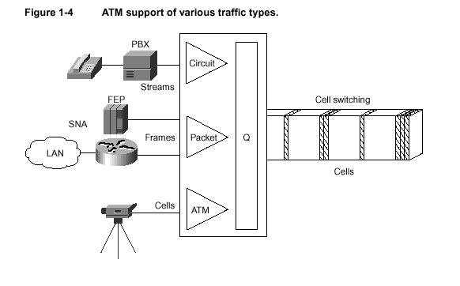
Figure 1-4 ATM support of various traffic types.

Determining Internetworking Requirements

Designing an internetwork can be a challenging task. Your first step is to understand your internetworking requirements. Internetworking devices must reflect the goals, characteristics, and policies of the organizations in which they operate. Two primary goals drive internetworking design and implementation:

• Application availability—Networks carry application information between computers. If the applications are not available to network users, the network is not doing its job.
• Cost of ownership—Information system (IS) budgets today often run in the millions of dollars.As large organizations increasingly rely on electronic data for managing business activities, the associated costs of computing resources will continue to rise. A well-designed internetwork can help to balance these objectives. When properly implemented, the network infrastructure can optimize application availability and allow the cost-effective use of existing network resources.

The Design Problem: Optimizing Availability and Cost.In general, the network design problem consists of the following three general elements:

• Environmental givens—Environmental givens include the location of hosts, servers, terminals, and other end nodes; the projected traffic for the environment; and the projected costs for delivering different service levels.
• Performance constraints—Performance constraints consist of network reliability, traffic throughput, and host/client computer speeds (for example, network interface cards and hard drive access speeds).
• Internetworking variables—Internetworking variables include the network topology, line capacities, and packet flow assignments. The goal is to minimize cost based on these elements while delivering service that does not
compromise established availability requirements. You face two primary concerns: availability and cost. These issues are essentially at odds. Any increase in availability must generally be reflected as an increase in cost. As a result, you must weigh the relative importance of resource availability and overall cost carefully.

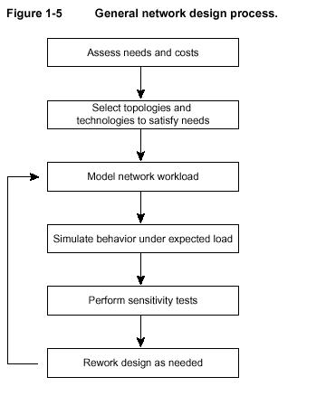

X.25

X.25 is an International Telecommunication Union–Telecommunication Standardization Sector (ITU-T) protocol standard for WAN communications that defines how connections between user devices and network devices are established and maintained. X.25 is designed to operate effectively regardless of the type of systems connected to the network. It is typically used in the packet-switched networks (PSNs) of common carriers, such as the telephone companies. Subscribers are charged based on their use of the network. The development of the X.25 standard was initiated by the common carriers in the 1970s. At that time, there was a need for WAN protocols capable of providing connectivity across public data networks (PDNs). X.25 is now administered as an international standard by ITU-T.

Virtual Private Networks

Some definitions claim that Frame Relay qualifies as a VPN when, in fact, it is an overlay network. Although an overlay network secures transmissions through a public network, it does so passively via logical separation of the data streams. VPNs provide a more active form of security by either encrypting or encapsulating data for transmission through an unsecured network. These two types of security—encryption and encapsulation—form the foundation of virtual private networking. However, both encryption and encapsulation are generic terms that describe a function that can be performed by a myriad of specific technologies.

ROUTING

- ROUTING is the act of moving information across an internetwork from a source to a destination. Along the way, at least one intermediate node typically is encountered.
- Physical devices deployed primarily at edge and end sites that route network traffic from source to destination. The routers connect local area networks to the MNT, which is a wide area network. Routers operate on network layer information and participate in running one or more network layer routing protocols. The Multi-Use Network utilizes Cisco model 8230 routers at the larger network aggregation points and Cisco model 6509 routers at the smaller network aggregation points.
- A device that forwards data packets along networks. A router is connected to at least two networks, commonly two LANs or WANs or a LAN and its ISP’s network. Routers are located at gateways, the places where two or more networks connect.
- A network traffic-managing device or in some cases, software in a computer, that sits in between sub-networks and determines the next network point an information packet should be sent. A router is located at any gateway Search Engine A database, or index that can be queried to help you find information on the World Wide Web. For example, AltaVista (Keyword: AltaVista) and Yahoo (Keyword: Yahoo).
- Routers use headers and forwarding tables to determine the best path for forwarding the packets, and they use protocols to communicate with each other and configure the best route between any two hosts. Very little filtering of data is done through routers.
- Routers are a vital component of the Internet -- they comprise an intricate network that delivers millions of e-mail messages every day. Routers are more complex internetworking devices and are also typically expensive than bridges. They use Network Layer Protocol information within each packet to route it from one LAN to another.

HOW ROUTERS WORK???

The Internet is one of the 20th century's greatest communications developments. It allows people around the world to send E-MAIL to one another in a matter of seconds, and it lets you read. We're all used to seeing the various parts of the Internet that come into our homes and offices – the WEBPAGES, e-mail messages and downloaded files that make the Internet a dynamic and valuable medium. But none of these parts would ever make it to your computer without a piece of the Internet that you've probably never seen. In fact, most people have never stood "face to machine" with the technology most responsible for allowing the Internet to exist at all: the router.

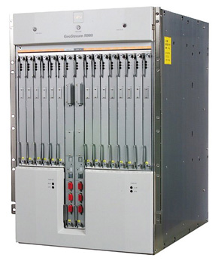
Photo courtesy Newstream.com
Fujitsu GeoStream R980 industrial strength router
Routers are specialized computers that send your messages and those of every other Internet user speeding to their destinations along thousands of pathways.

Keeping the Messages Moving
When you send e-mail to a friend on the other side of the country, how does the message know to end up on your friend's computer, rather than on one of the millions of other computers in the world? Much of the work to get a message from one computer to another is done by routers, because they're the crucial devices that let messages flow between networks, rather than within networks.
Let's look at what a very simple router might do. Imagine a small company that makes animated 3-D graphics for local television stations. There are 10 employees of the company, each with a computer. Four of the employees are animators, while the rest are in sales, accounting and management. The animators will need to send lots of very large files back and forth to one another as they work on projects. To do this, they'll use a network.

When one animator sends a file to another, the very large file will use up most of the network's capacity, making the network run very slowly for other users. One of the reasons that a single intensive user can affect the entire network stems from the way that Ethernet works. Each information packet sent from a computer is seen by all the other computers on the local network. Each computer then examines the packet and decides whether it was meant for its address. This keeps the basic plan of the network simple, but has performance consequences as the size of the network or level of network activity increases. To keep the animators' work from interfering with that of the folks in the front office, the company sets up two separate networks, one for the animators and one for the rest of the company. A router links the two networks and connects both networks to the Internet.

DirectingTraffic
The router is the only device that sees every message sent by any computer on either of the company's networks. When the animator in our example sends a huge file to another animator, the router looks at the recipient's address and keeps the traffic on the animator's network. When an animator, on the other hand, sends a message to the bookkeeper asking about an expense-account check, then the router sees the recipient's address and forwards the message between the two networks.

One of the tools a router uses to decide where a packet should go is a configuration table. A configuration table is a collection of information, including:
- Information on which connections lead to particular groups of addresses
- Priorities for connections to be used
- Rules for handling both routine and special cases of traffic
A configuration table can be as simple as a half-dozen lines in the smallest routers, but can grow to massive size and complexity in the very large routers that handle the bulk of Internet messages.
A router, then, has two separate but related jobs:
- The router ensures that information doesn't go where it's not needed. This is crucial for keeping large volumes of data from clogging the connections of "innocent bystanders."
- The router makes sure that information does make it to the intended destination.
In performing these two jobs, a router is extremely useful in dealing with two separate computer networks. It joins the two networks, passing information from one to the other and, in some cases, performing translations of various protocols between the two networks. It also protects the networks from one another, preventing the traffic on one from unnecessarily spilling over to the other. As the number of networks attached to one another grows, the configuration table for handling traffic among them grows, and the processing power of the router is increased. Regardless of how many networks are attached, though, the basic operation and function of the router remains the same. Since the Internet is one huge network made up of tens of thousands of smaller networks, its use of routers is an absolute necessity.

Transmitting Packets
When you make a telephone call to someone on the other side of the country, the telephone system establishes a stable circuit between your telephone and the telephone you're calling. The circuit might involve a half dozen or more steps through copper cables, switches, fiber optics, microwaves and satellitess, but those steps are established and remain constant for the duration of the call. This circuit approach means that the quality of the line between you and the person you're calling is consistent throughout the call, but a problem with any portion of the circuit -- maybe a tree falls across one of the lines used, or there's a power problem with a switch -- brings your call to an early and abrupt end. When you send an e-mail message with an attachment to the other side of the country, a very different process is used.

Internet data, whether in the form of a Web page, a downloaded file or an e-mail message, travels over a system known as a packet-switching network. In this system, the data in a message or file is broken up into packages about 1,500 bytes long. Each of these packages gets a wrapper that includes information on the sender's address, the receiver's address, the package's place in the entire message, and how the receiving computer can be sure that the package arrived intact. Each data package, called a packet, is then sent off to its destination via the best available route -- a route that might be taken by all the other packets in the message or by none of the other packets in the message. This might seem very complicated compared to the circuit approach used by the telephone system, but in a network designed for data there are two huge advantages to the packet- switching plan.
- The network can balance the load across various pieces of equipment on a millisecond-by-millisecond basis.
- If there is a problem with one piece of equipment in the network while a message is being transferred, packets can be routed around the problem, ensuring the delivery of the entire message.

Path Determination

Routing protocols use metrics to evaluate what path will be the best for a packet to travel. A metric is a standard of measurement, such as path bandwidth, that is used by routing algorithms to determine the optimal path to a destination. To aid the process of path determination, routing algorithms initialize and maintain routing tables, which contain route information. Route information varies depending on the routing algorithm used. Routing algorithms fill routing tables with a variety of information. Destination/next hop associations tell a router that a particular destination can be reached optimally by sending the packet to a particular router representing the “next hop” on the way to the final destination. When a router receives an incoming packet, it checks the destination address and attempts to associate this address with a next hop. Figure 5-1 depicts a sample destination/next hop routing table.

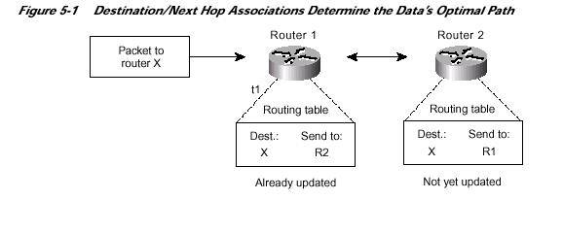

5- Routing tables also can contain other information, such as data about the desirability of a path. Routers compare metrics to determine optimal routes, and these metrics differ depending on the design of the routing algorithm used. A variety of common metrics will be introduced and described later in this chapter. Routers communicate with one another and maintain their routing tables through the transmission of a variety of messages. The routing update message is one such message that generally consists of all or a portion of a routing table. By analyzing routing updates from all other routers, a router can build a detailed picture of network topology. A link-state advertisement, another example of a message sent between routers, informs other routers of the state of the sender’s links. Link information also can be used to build a complete picture of network topology to enable routers to determine optimal routes to network destinations
The routers that make up the main part of the Internet can reconfigure the paths that packets take because they look at the information surrounding the data packet, and they tell each other about line conditions, such as delays in receiving and sending data and traffic on various pieces of the network. Not all routers do so many jobs, however. Routers come in different sizes.

Understanding the Protocols
The first and most basic job of the router is to know where to send information addressed to your computer. Just as the mail handler on the other side of the country knows enough to keep a birthday card coming toward you without knowing where your house is, most of the routers that forward an e-mail message to you don't know your computer's MAC address, but they know enough to keep the message flowing.
Routers are programmed to understand the most common network protocols. That means they know the format of the addresses, how many bytes are in the basic package of data sent out over the network, and how to make sure all the packages reach their destination and get reassembled. For the routers that are part of the Internet's main "backbone," this means looking at, and moving on, millions of information packages every second. And simply moving the package along to its destination isn't all that a router will do. It's just as important, in today's computerized world that they keep the message flowing by the best possible route.
In a modern network, every e-mail message is broken up into small pieces. The pieces are sent individually and reassembled when they're received at their final destination. Because the individual pieces of information are called packets and each packet can be sent along a different path, like a train going through a set of switches, this kind of network is called a packet-switched network. It means that you don't have to build a dedicated network between you and your friend on the other side of the country. Your e-mail flows over any one of thousands of different routes to get from one computer to the other.

Depending on the time of day and day of the week, some parts of the huge public packet-switched network may be busier than others. When this happens, the routers that make up this system will communicate with one another so that traffic not bound for the crowded area can be sent by less congested network routes. This lets the network function at full capacity without excessively burdening already busy areas.

How Routing Algorithms Work???
Routers need to have some information about network status in order to make decisions regarding how and where to send packets. But how do they gather this information?
The Basics
Routers use routing algorithms to find the best route to a destination. When we say "best route," we consider parameters like the number of hops (the trip a packet takes from one router or intermediate point to another in the network), time delay and communication cost of packet transmission.
Based on how routers gather information about the structure of a network and their analysis of information to specify the best route, we have two major routing algorithms: global routing algorithms and decentralized routing algorithms. In decentralized routing algorithms, each router has information about the routers it is directly connected to -- it doesn't know about every router in the network. These algorithms are also known as DV (distance vector) algorithms. In global routing algorithms, every router has complete information about all other routers in the network and the traffic status of the network. These algorithms are also known as LS (link state) algorithms

LS Algorithms
In LS algorithms, every router has to follow these steps:
- Identify the routers that are physically connected to them and get their IP addresses
When a router starts working, it first sends a "HELLO" packet over network. Each router that receives this packet replies with a message that contains its IP address.
- Measure the delay time (or any other important parameters of the network, such as average traffic) for neighbor routers
In order to do that, routers send echo packets over the network. Every router that receives these packets replies with an echo reply packet. By dividing round trip time by 2, routers can count the delay time. (Round trip time is a measure of the current delay on a network, found by timing a packet bounced off some remote host.) Note that this time includes both transmission and processing times -- the time it takes the packets to reach the destination and the time it takes the receiver to process it and reply.
- Broadcast its information over the network for other routers and receive the other routers' information
In this step, all routers share their knowledge and broadcast their information to each other. In this way, every router can know the structure and status of the network.
- Using an appropriate algorithm, identify the best route between two nodes of the network
In this step, routers choose the best route to every node. They do this using an algorithm, such as the Dijkstra shortest path algorithm. In this algorithm, a router, based on information that has been collected from other routers, builds a graph of the network. This graph shows the location of routers in the network and their links to each other. Every link is labeled with a number called the weight or cost. This number is a function of delay time, average traffic, and sometimes simply the number of hops between nodes. For example, if there are two links between a node and a destination, the router chooses the link with the lowest weight.

The Dijkstra algorithm goes through these steps:
- The router builds a graph of the network and identifies source and destination nodes, as V1 and V2 for example. Then it builds a matrix, called the "adjacency matrix." In this matrix, a coordinate indicates weight. For example, [i, j] is the weight of a link between Vi and Vj. If there is no direct link between Vi and Vj, this weight is identified as "infinity."
- The router builds a status record set for every node on the network. The record contains three fields:
  - Predecessor field - The first field shows the previous node.
  - Length field - The second field shows the sum of the weights from the source to that node.
  - Label field - The last field shows the status of node. Each node can have one status mode: "permanent" or "tentative."
- The router initializes the parameters of the status record set (for all nodes) and sets their length to "infinity" and their label to "tentative."
- The router sets a T-node. For example, if V1 is to be the source T-node, the router changes V1's label to "permanent." When a label changes to "permanent," it never changes again. A T-node is an agent and nothing more.
- The router updates the status record set for all tentative nodes that are directly linked to the source T-node.
- The router looks at all of the tentative nodes and chooses the one whose weight to V1 is lowest. That node is then the destination T-node.
- If this node is not V2 (the intended destination), the router goes back to step 5.
- If this node is V2, the router extracts its previous node from the status record set and does this until it arrives at V1. This list of nodes shows the best route from V1 to V2.

These steps are shown below as a flowchart.
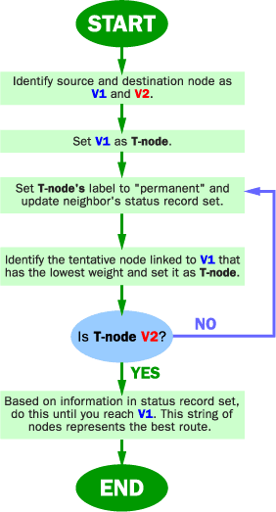

Example: Dijkstra Algorithm
Here we want to find the best route between A and E (see below). You can see that there are six possible routes between A and E (ABE, ACE, ABDE, ACDE, ABDCE, ACDBE), and it's obvious that ABDE is the best route because its weight is the lowest. But life is not always so easy, and there are some complicated cases in which we have to use algorithms to find the best route.
- As you see in the image below, the source node (A) has been chosen as T-node, and so its label is permanent (we show permanent nodes with filled circles and T-nodes with the --> symbol).
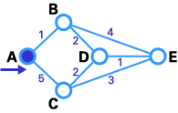
- In this step, you see that the status record set of tentative nodes directly linked to T-node (B, C) has been changed. Also, since B has less weight, it has been chosen as T-node and its label has changed to permanent (see below).
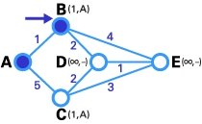
- In this step, like in step 2, the status record set of tentative nodes that have a direct link to T-node (D, E), has been changed. Also, since D has less weight, it has been chosen as T-node and its label has changed to permanent (see below).
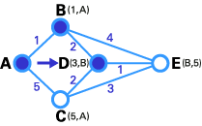
- In this step, we don't have any tentative nodes, so we just identify the next T-node. Since E has the least weight, it has been chosen as T-node.
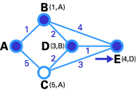
- E is the destination, so we stop here.
We are at end! Now we have to identify the route. The previous node of E is D, and the previous node of D is B, and B's previous node is A. So the best route is ABDE. In this case, the total weigh is 4 (1+2+1).
Although this algorithm works well, it's so complicated that it may take a long time for routers to process it, and the efficiency of the network fails. Also, if a router gives the wrong information to other routers, all routing decisions will be ineffective. To understand this algorithm better, here is the source of program written by C:
#define MAX_NODES 1024 /* maximum number of nodes */
#define INFINITY 1000000000 /* a number larger than every maximum path */
int n,dist[MAX_NODES][MAX_NODES]; /*dist[I][j] is the distance from i to j */
void shortest_path(int s,int t,int path[ ])
{struct state { /* the path being worked on */
int predecessor ; /*previous node */
int length /*length from source to this node*/
enum {permanent, tentative} label /*label state*/
}state[MAX_NODES];
int I, k, min;
struct state *
p;
for (p=&state[0];p < &state[n];p++){ /*initialize state*/
p->predecessor=-1
p->length=INFINITY
p->label=tentative;
}
state[t].length=0; state[t].label=permanent ;
k=t ; /*k is the initial working node */
do{ /* is the better path from k? */
for I=0; I < n; I++) /*this graph has n nodes */
if (dist[k][I] !=0 && state[I].label==tentative){
if (state[k].length+dist[k][I] < state[I].length){
state[I].predecessor=k;
state[I].length=state[k].length + dist[k][I]
}
}
/* Find the tentatively labeled node with the smallest label. */
k=0;min=INFINITY;
for (I=0;I < n;I++)
if(state[I].label==tentative && state[I].length <
min)=state[I].length;
k=I;
}
state[k].label=permanent
}while (k!=s);
/*Copy the path into output array*/
I=0;k=0
Do{path[I++]=k;k=state[k].predecessor;} while (k > =0);
}

DV Algorithms

DV algorithms are also known as Bellman-Ford routing algorithms and Ford-Fulkerson routing algorithms. In these algorithms, every router has a routing table that shows it the best route for any destination. A typical graph and routing table for router J is shown below.
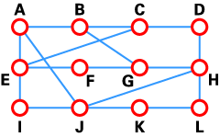

Destination | Weight | Line
A | 8 | A
B | 20 | A
C | 28 | I
D | 20 | H
E | 17 | I
F | 30 | I
G | 18 | H
H | 12 | H
I | 10 | I
J | 0 | ---
K | 6 | K
L | 15 | K
A typical network graph and routing table for router J
As the table shows, if router J wants to get packets to router D, it should send them to router H. When packets arrive at router H, it checks its own table and decides how to send the packets to D.

In DV algorithms, each router has to follow these steps:
- It counts the weight of the links directly connected to it and saves the information to its table.
- In a specific period of time, it send its table to its neighbor routers (not to all routers) and receive the routing table of each of its neighbors.
- Based on the information in its neighbors' routing tables, it updates its own.
One of the most important problems with DV algorithms is called "count to infinity." Let's examine this problem with an example:
Imagine a network with a graph as shown below. As you see in this graph, there is only one link between A and the other parts of the network. Here you can see the graph and routing table of all nodes:
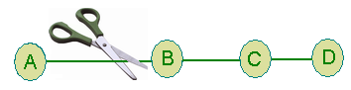

 | A | B | C | D
A | 0,- | 1,A | 2,B | 3,C
B | 1,B | 0,- | 2,C | 3,D
C | 2,B | 1,C | 0,- | 1,C
D | 3,B | 2,C | 1,D | 0,-
Network graph and routing tables

Now imagine that the link between A and B is cut. At this time, B corrects its table. After a specific amount of time, routers exchange their tables, and so B receives C's routing table. Since C doesn't know what has happened to the link between A and B, it says that it has a link to A with the weight of 2 (1 for C to B, and 1 for B to A -- it doesn't know B has no link to A). B receives this table and thinks there is a separate link between C and A, so it corrects its table and changes infinity to 3 (1 for B to C, and 2 for C to A, as C said). Once again, routers exchange their tables. When C receives B's routing table, it sees that B has changed the weight of its link to A from 1 to 3, so C updates its table and changes the weight of the link to A to 4 (1 for C to B, and 3 for B to A, as B said).
This process loops until all nodes find out that the weight of link to A is infinity. This situation is shown in the table below. In this way, experts say DV algorithms have a slow convergence rate.

 | B | C | D
Sum of weight to A after link cut | ,A | 2,B | 3,C
Sum of weight to B after 1st updating | 3,C | 2,B | 3,C
Sum of weight to A after 2nd updating | 3,C | 4,B | 3,C
Sum of weight to A after 3rd updating | 5,C | 4,B | 5,C
Sum of weight to A after 4th updating | 5,C | 6,B | 5,C
Sum of weight to A after 5th updating | 7,C | 6,B | 7,C
Sum of weight to A after nth updating | ... | ... | ...

The "count to infinity" problem
One way to solve this problem is for routers to send information only to the neighbors that are not exclusive links to the destination. For example, in this case, C shouldn't send any information to B about A, because B is the only way to A.

Switching

Switching algorithms is relatively simple; it is the same for most routing protocols. In most cases, a host determines that it must send a packet to another host. Having acquired a router’s address by some means, the source host sends a packet addressed specifically to a router’s physical (Media Access Control [MAC]-layer) address, this time with the protocol (network layer) address of the destination host. As it examines the packet’s destination protocol address, the router determines that it either knows or does not know how to forward the packet to the next hop. If the router does not know how to forward the packet, it typically drops the packet. If the router knows how to forward the packet, however, it changes the destination physical address to that of the next hop and transmits the packet. The next hop may be the ultimate destination host. If not, the next hop is usually another router, which executes the same switching decision process. As the packet moves through the internetwork, its physical address changes, but its protocol address remains constant, as illustrated in Figure 5-2. The preceding discussion describes switching between a source and a destination end system. The International Organization for Standardization (ISO) has developed a hierarchical terminology that is useful in describing this process. Using this terminology, network devices without the capability to forward packets between subnetworks are called end systems (ESs), whereas network devices with these capabilities are called intermediate systems (ISs). ISs are further divided into those that can communicate within routing domains (intradomain ISs) and those that communicate both within and between routing domains (interdomain ISs). A routing domain generally is considered a portion of an internetwork under common administrative authority that is regulated by a particular set of administrative guidelines. Routing domains are also called autonomous systems. With certain protocols, routing domains can be divided into routing areas, but intradomain routing protocols are still used or switching both within and between areas.
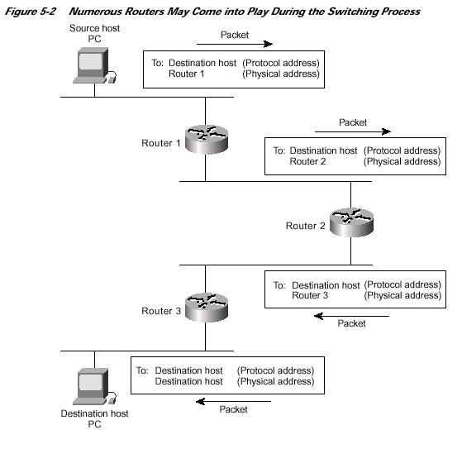

Routing Algorithms

Design Goals

Routing algorithms often have one or more of the following design goals:
• Optimality
• Simplicity and low overhead
• Robustness and stability
• Rapid convergence
• Flexibility

5-6

Algorithm Types

Routing algorithms can be classified by type. Key differentiators include these:
• Static versus dynamic
• Single-path versus multipath
• Flat versus hierarchical
• Host-intelligent versus router-intelligent
• Intradomain versus interdomain
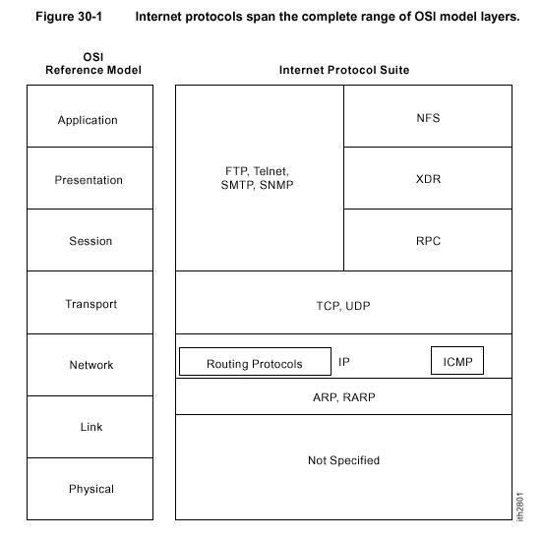

Internet Protocol (IP)

The Internet Protocol (IP) is a network-layer (Layer 3) protocol that contains addressing information and some control information that enables packets to be routed. IP is documented in RFC 791 and is the primary network-layer protocol in the Internet protocol suite. Along with the Transmission Control Protocol (TCP), IP represents the heart of the Internet protocols. IP has two primary responsibilities: providing connectionless, best-effort delivery of datagrams through an internetwork; and providing fragmentation and reassembly of datagrams to support data links with different maximum-transmission unit (MTU) sizes.

Address Resolution Protocol (ARP)

For two machines on a given network to communicate, they must know the other machine’s physical (or MAC) addresses. By broadcasting Address Resolution Protocols (ARPs), a host can dynamically discover the MAC-layer address corresponding to a particular IP network-layer address. After receiving a MAC-layer address, IP devices create an ARP cache to store the recently acquired IP-to-MAC address mapping, thus avoiding having to broadcast ARPS when they want to recontact a device. If the device does not respond within a specified time frame, the cache entry is flushed. In addition to the Reverse Address Resolution Protocol (RARP) is used to map MAC-layer addresses to IP addresses. RARP, which is the logical inverse of ARP, might be used by diskless workstations that do not know their IP addresses when they boot. RARP relies on the presence of a RARP server with table entries of MAC-layer-to-IP address mappings.

Internet Routing

Internet routing devices traditionally have been called gateways. In today’s terminology, however, the term gateway refers specifically to a device that performs application-layer protocol translation between devices. Interior gateways refer to devices that perform these protocol functions between machines or networks under the same administrative control or authority, such as a corporation’s internal network. These are known as autonomous systems. Exterior gateways perform protocol functions between independent networks. Routers within the Internet are organized hierarchically. Routers used for information exchange within autonomous systems are called interior routers, which use a variety of Interior Gateway Protocols (IGPs) to accomplish this purpose. The Routing Information Protocol (RIP) is an example of an IGP.
Routers that move information between autonomous systems are called exterior routers. These routers use an exterior gateway protocol to exchange information between autonomous systems. The Border Gateway Protocol (BGP) is an example of an exterior gateway protocol.

Transmission Control Protocol (TCP)

The TCP provides reliable transmission of data in an IP environment. TCP corresponds to the transport layer (Layer 4) of the OSI reference model. Among the services TCP provides are stream data transfer, reliability, efficient flow control, full-duplex operation, and multiplexing. With stream data transfer, TCP delivers an unstructured stream of bytes identified by sequence numbers. This service benefits applications because they do not have to chop data into blocks before handing it off to TCP. Instead, TCP groups bytes into segments and passes them to IP for delivery. TCP offers reliability by providing connection-oriented, end-to-end reliable packet delivery through an internetwork. It does this by sequencing bytes with a forwarding acknowledgment number that indicates to the destination the next byte the source expects to receive. Bytes not acknowledged within a specified time period are retransmitted. The reliability mechanism of TCP allows devices to deal with lost, delayed, duplicate, or misread packets. A time-out mechanism allows devices to detect lost packets and request retransmission. TCP offers efficient flow control, which means that, when sending acknowledgments back to the source, the receiving TCP process indicates the highest sequence number it can receive without overflowing its internal buffers. Full-duplex operation means that TCP processes can both send and receive at the same time. Finally, TCP’s multiplexing means that numerous simultaneous upper-layer conversations can be multiplexed over a single connection.

User Datagram Protocol (UDP)

The User Datagram Protocol (UDP) is a connectionless transport-layer protocol (Layer 4) that belongs to the Internet protocol family. UDP is basically an interface between IP and upper-layer processes. UDP protocol ports distinguish multiple applications running on a single device from one another. Because of UDP’s simplicity, UDP headers contain fewer bytes and consume less network overhead than TCP. UDP is useful in situations where the reliability mechanisms of TCP are not necessary, such as in cases where a higher-layer protocol might provide error and flow control. UDP is the transport protocol for several well-known application-layer protocols, including Network File System (NFS), Simple Network Management Protocol (SNMP), Domain Name System (DNS), and Trivial File Transfer Protocol (TFTP). The UDP packet format contains four fields, as shown in Figure 30-11. These include source and destination ports, length, and checksum fields.

Internet Protocols Application-Layer Protocols

The Internet protocol suite includes many application-layer protocols that represent a wide variety of applications, including the following:

• File Transfer Protocol (FTP)—Moves files between devices

• Simple Network-Management Protocol (SNMP)—Primarily reports anomalous network conditions and sets network threshold values

• Telnet—Serves as a terminal emulation protocol

• X Windows—Serves as a distributed windowing and graphics system used for communication between X terminals and UNIX workstations

• Network File System (NFS), External Data Representation (XDR), and Remote Procedure Call(RPC)—Work together to enable transparent access to remote network resources

• Simple Mail Transfer Protocol (SMTP)—Provides electronic mail services

• Domain Name System (DNS)—Translates the names of network nodes into network addresses

Integrated Services Digital Network

Integrated Services Digital Network (ISDN) is comprised of digital telephony and data-transport services offered by regional telephone carriers. ISDN involves the digitization of the telephone network, which permits voice, data, text, graphics, music, video, and other source material to be transmitted over existing telephone wires. The emergence of ISDN represents an effort to standardize subscriber services, user/network interfaces, and network and internetwork capabilities. ISDN applications include high-speed image applications (such as Group IV facsimile), additional telephone lines in homes to serve the telecommuting industry, high-speed file transfer, and videoconferencing. Voice service is also an application for ISDN. This chapter summarizes the underlying technologies and services associated with ISDN.

Backbone Network Elements

1) Network Timing Protocol (NTP):

There are NTP servers for backbone network, which derives clock from standard Stratum-1/2 clock, which is derived from Atomic clock. This device then distributes timing reference on NTP protocol to all the devices in the network in-band. NTP ensures that all devices’ timing in the network is synchronized. If the synchronization equipment has inbuilt NTP server capability, the same shall be used in the network for NTP.

2) Lightweight Directory Access Protocol (LDAP):

A LDAP server for the directory policy resolutions of servers including that of user database. These servers could be common for the ISP / IXP operation also.

3) Authentication, Authorization and Accounting (AAA) / Syslog server (for Internal usage):

A central authentication server for controlling the log of all devices deployed in the data network. These AAA servers are different from the one used for ISP operations and are planned on TCP authentication mechanism. The functionality is for central authentication for all Reliance management users from all locations before allowing them to do any changes / modifications in the device configurations. The log particulars are stored in Syslog servers. The logins in the Syslog servers are used for debugging.

4) Core dump / Collector Servers:

Core dumps are used in the network as a storage point for collecting the router OS settings at any given point. This would enable persons to analyze the data in the event of any device failure / or soft ware crashes. The routers are configured to dump their settings into the coredump when such crash occurs. This Data is transferred to the central EMS for further analysis.
The Collectors are storage devices to collect the billing and accounting information (bytes transferred) from different devices and passed on to the central Mediation device for further billing activities. The core dump and collector devices are the same storage device physically but doing dual functionality.

5)Domain Name server (DNS):

The purpose of the DNS server is to resolve the Name to IP address request from internal users. These servers could be common for the ISP / IXP / NAP devices also. Separate DNS servers are deployed for Public Infrastructure, which could be included in the ISP design.

5.1) Primary DNS server:

The basic function of this server is to synchronies with other zones on a regular interval. Militarized Zone (MZ).

5.2) Secondary DNS server:

This server is used by NOC users for Name to IP resolution for network devices. This server has to be synchronized with Primary DNS server at regular interval of time for the latest updates. Demilitarized Zone (DMZ) which is accessible to legitimate internet users.

Integration with NMS (NOC) and Integrated Business System (IBS)

The data network provides a standard based platform for the implementation of an automated IBS for customer Relation Management (CRM) network management, Revenue assurance and billing. The network management information for data network as well as other wireline and wireless network components are carried on an in-band Data Communication Network (DCN) in the data backbone network. The scope for EMS is to provide a open platform such as north bound CORBA and support for XML so as to integrate with OSS and Billing systems. The EMS is used to monitor, manage, configure, provision, network capacity management, service data collection, event correlation, etc.

DATA COMMUNICATION NETWORK (DCN)

The basic ideology in creating a DCN division is to provide a state-of-art data communication network to carry out Fault, Configuration, Administration and Performance and security management of all Element Managers (distributed across the network) to the central NOC. The main objective of the Reliance Infocomm DCN network is to provide communication with high reliability, security, integrity and availability. O

bjective of DCN is to provide a state-of-art data communication network to carry out Fault, Configuration, Administration and Performance and security management. DCN at present works at connectivity rate of E1.

Elements included into the scope of the DCN are as follows:

1) Wireline (TDM) Switch

2) Wireless (CDMA) only MSC locations

3) Transport Network SDH

4) Fiber Management System (FMS)

5) Synchronization

6) Infrastructure alarms connectivity at all MSC and IS locations.

7) Building security alarm devices and video monitoring connectivity

Parameters that are involved in the implementation of the DCN structure are IP Address Design for DCN, Traffic Engineering, Alarm Management, Element Management System, NOC Requirements, Fault Management, Network Administration, AAA Server setup, Syslog server setup, Security Requirements, Dimensioning Rules.

Features of the DCN at Reliance Infocomm

- DCN network comprises of infrastructure & utilities such as HVAC units, DG sets, A.C units, battery panel, fire alarms, and LT panel and security systems.

- Data Communication Network of Reliance is designed to carry these alarms from various locations to Element Managers at aggregation sites over IP. The telemetry inputs and analog alarms are converted into IP packets and sent over DCN via SNMP or TL1.

RELIANCE DATA NETWORKS (RDN)

The in-house Reliance network works on STM-1 level connectivity encompassing all the Reliance facilities through the RDN implementation in all the cities and location under Phase-I & II, this includes all the commercial offices, Webstores, MCN’s, IDCs, NOC, etc. providing the required connectivity to host the following services:

- Intranet portals
- Internet Access
- In-house Mail Server
- CRM related activities
- SAP
- In-house Resource management sites
- Actual payload of each departmental data

This is achieved through the installation of the relevant provider class router that is capable of providing the service to all local MCN’s as well as all the commercial installations in the localized zone/ring. The secondary core locations are generally the ones that are connected to the backbone and hence are in a position to provide the services to the collector locations as well .

WORKS

The complete planning is done at the national level that includes the level of connectivity to be given to a particular ring as well as the IP to be assigned to the relevant locations in the ring all the various services that the location has to get are planned at the central level. The initial installation and subsequently the upgrades that are to be done in relation to the router and the port configuration is the task assigned to the data engineers at all locations.

- Routine check carried out on the equipment and loss determination in signal if any is taking place.
- Provide the required field support to the field staff
- Provide support to NOC
- Fault repair as well as up gradation process

THE RELIANCE EXPERIENCE

“ Think big think fast think ahead. Ideas are no one’s monopoly. “

Well after coming in direct contact with people working for one of the biggest companies in India and understanding the ideologies, the technology, and the commitment that the employees of the company show to reach their deadline all cumulatively contribute in maintaining an annual turnover of the company that is 3 % of the entire nation’s GDP. The 40 days long internship at MCN, Jaipur has exposed me to an environment where ideas and work are the only merit points that pave the path to success for you. Reliance Infocomm, the dream project of Late Shri. Dhirubhai H. Ambani has matured quite a lot since it was launched last December and is in constant phase of growth. The project as perceived by my standards is a product of intense amount of centralized planning and commissioning. This unique philosophy of least manned organization and complete centralized control over every activity has borne fruit for the company and thus the growth figures prove the point.

The internship at Reliance facility in Jaipur has proved to be an enriching experience that will definitely go a long way in choosing the right field of specialization in terms of a career. The internship program was the ideal launch pad with which I presume the next leap will definitely be something special and on the same lines of thought the idea of working as a full time employee of Reliance will always enthuse towards the unlimited avenues of growth. To end the quote from the visionary behind the company seems worth consideration.

“ Give the youth a proper environment. Motivate them. Extend them the support they need. Each one of them has infinite sources of energy. They will deliver. ”

