HUTCHISON WHAMPOA LIMITED

Hutchison Whampoa Limited (HWL) is a leading international corporation committed to innovation and technology with businesses spanning the globe. Its diverse array of holdings range from some of the world's biggest retailers to property development and infrastructure to the most technologically-advanced and marketing-savvy telecommunications operators.

Hutchison Group has five core businesses in Asia:

Ports and Related Services
Telecommunications and E-commerce
Property and Hotels
Retail and Manufacturing
Energy, Infrastructure, Finance and Investments

Group Structure

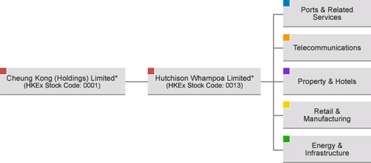

OVERVIEW

Hutchison Whampoa Limited is among the largest companies listed on the main board of the Hong Kong Stock Exchange. Flagship companies include Hutchison Port Holdings, Hutchison Telecom, Hutchison Whampoa Properties, A.S. Watson and Cheung Kong Infrastructure.

Hutchison's achievements include being:
- A pioneer of mobile multimedia communications with the launch of third-generation (3G) mobile phones and networks under the "3" brand.
- The world's leading port investor, developer and operator with 35 ports across Europe, the Americas, Asia, the Middle East and Africa.
- The third largest health and beauty retailer in the world.
- One of Asia's largest retailers through the PARKnSHOP chain of food stores and Watson’s personal care stores.

Hutchison has a strong commitment to the highest standards of corporate governance, transparency and accountability - principles that have been recognized by the receipt of numerous awards and commendations.



- PORTS AND RELATED SERVICES


Hutchison Port Holdings (HPH) operates in 17 countries. The port and related services group operates a total of 187 berths in 35 ports. It operates in five of the seven busiest container ports in the world. Its headquarters are at Hong Kong International Terminals, the world's largest and busiest privately owned container terminal operator.

- TELECOMMUNICATIONS


Hutchison Telecommunications is a leader at the forefront of the continuing telecommunications revolution. As one of the first operators in the world to introduce third-generation (3G) mobile phones and networks, it provides consumers in Europe, Australia and Hong Kong with multimedia applications such as Internet access and video clips accessed via video mobiles.

Formed in 1983, Hutchison Telecommunications is one of the leading owners and operators of telecommunications and Internet infrastructure, offering a wide range of related services in 17 countries. These include fixed-line services, Internet services, fibre optic broadband networks, and radio broadcasting as well as mobile phone systems.

Hutchison Telecom's businesses in Hong Kong, Australia, Israel and India have all enjoyed great success with the Orange brand.


- PROPERTY AND HOTELS

The Hotel Group was established in 1997 to focus on the development and operations of Hutchison’s hotel business worldwide. The Hotel Group has expanded rapidly and is currently operating hotels in Hong Kong and the Mainland China.

- Retail and Manufacturing

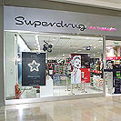
A.S. Watson, the Group's retailing and manufacturing arm operates three retail business chains: PARKnSHOP supermarkets, Watsons Your Personal Stores and Fortress electrical appliance stores. A.S. Watson Group operates in its three core business areas: Health and Beauty; Food, Electronics and General Merchandise; and Manufacturing.

- Energy and Infrastructure

The Group has become involved in a number of power-generation and toll roads and bridges projects in Mainland China, as well as power and gas distribution businesses in Australia. Cheung Kong Infrastructure (CKI), the Group's infrastructure arm, is a diversified infrastructure company with businesses in transportation, energy, infrastructure materials, water plants and related operations. CKI's businesses span Hong Kong, Mainland China, Australia, Canada, the Philippines and UK.

HUTCHISON TELECOM

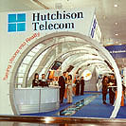
The Hutchison Group - one of the largest cellular operators in India - is also one of the world's leading telecommunication companies. Hutchison Telecom is a part of Hutchison Whampoa Limited (HWL); a Hong Kong based diversified multinational conglomerate spread across Asia Pacific, Europe and America. It is one of the largest companies listed on the Hong Kong Stock Exchange, operates across 41 countries and employs around 1,50,000 people worldwide. Having started its services way back in 1985, Hutchison Telecom is now recognized as one of the first cellular operators in the world.

Hutchison Telecom is ranked among the global leaders in mobile communications. It offers a wide range of integrated telecommunications services including fixed line services, Internet services, broadband networks, mobile telephony (voice and data), trunked mobile radio and radio broadcasting.

ABOUT HUTCHISON TELECOM

Hutchison Telecommunications is a wholly owned subsidiary of Hutchison Whampoa Limited. It operates a wide range of integrated telecommunications services in over 17 countries. Formed in 1983 to run a cellular network in Hong Kong, it has now become a formidable force in mobile communications. With business interests in Internet services, fiber optics, and mobile telephony, among others - its main interest internationally is in providing mobile telephony.

Hutchison Telecom has a successful track record in identifying potential countries and technologies, developing them and creating shareholder value over a long term. It is one of the largest 3G players worldwide - and operates in Australia, Italy, UK, and many others.

ABOUT HUTCH

Hutchison Telecom, one of the world’s leading cellular service providers, brings Hutch to you. We are known for our innovative approach and world-class technology. Our goal is to provide you superior products and services, anytime and anywhere.

Our values are stated simply. To be fair and transparent in what we do and how we do it. To provide you quality services with more customer friendly practices. To make your communications experience simple, pleasurable and fun. Where you don't simply get technology - but technology that is relevant. Where solutions are not just promised in the future - but delivered in the present.

CORPORATE PROFILE

Hutchison established its presence in India in 1994, through a joint venture with Max India Limited. In 1995, Hutchison Max Telecom became the first operator in India to launch its cellular service.

Today, Hutchison is the one of the largest providers of cellular services in India with presence in all the major regions - Orange in Mumbai and Hutch in Delhi, Karnataka, Andhra Pradesh, Chennai, Kolkata, Gujarat, Haryana, Rajasthan, UP (E), Punjab, West Bengal, UP (W), Sikkim, and Tamil Nadu.
It is also the country's largest roaming operator, with a more extensive network in India and around the world than any other operator.

It is part of the Hong Kong based multinational conglomerate Hutchison Whampoa Limited, a Fortune 500 company, and one of the largest companies listed on the Hong Kong Stock Exchange. Its operations span 41 countries across the Asia Pacific region, Europe and the Americas.

Hutchison affiliates jointly account for the largest number of cellular subscribers in India numbering over 5.7 million.

Hutchison affiliates

In India, Hutchison Telecom operates cellular services in 15 circles covering over 70% of the country's purchasing power - including Orange in Mumbai and Hutch in Delhi, Karnataka, Andhra Pradesh, Chennai, Kolkata, Gujarat, Haryana, Rajasthan, UP (E), Punjab, West Bengal, UP (W), Sikkim, and Tamil Nadu.

In fact, Hutchison now has a combined subscriber base of over 5 million cellular subscribers and was recently polled as “India's Most Respected Telecom Company” by a Business World-IMRB Survey.

Hutch Rajasthan
Hutch Delhi
Hutch Haryana
Hutch UP (E)
Hutch Kolkata
Hutch Andhra Pradesh
Hutch Karnataka
Hutch Chennai
Hutch Gujarat
Orange (Mumbai)

Hutch in Rajasthan

Hutch is a leading telecom communications company in India and is one of the major cellular service providers in Rajasthan. It is striving to bring the best of mobile telephony at the most affordable rates.

Through leading-edge technology, 24/7 customer support and sophisticated value-added services across the world and in India, Hutch continues to assure its users a world-class experience. Now in Rajasthan, as in all other telecom circles in India, Hutch is all set to be the preferred cellular service - with the widest and most extensive coverage in the state add to it a wide range of innovative and user-friendly services to our customers. So no matter where you are - basements, closed buildings and other normally low-receptivity areas - you stay connected and are well within reach, always.
COMPANY STRUCTURE
Chief Operating Officer
Marketing Dept.

IT Services Dept.

Human Resource Dept.
Finance Dept.
Sales Dept.
Audit Review Dept.

Customer Care Dept.

Advertising
Display
Designing of various schemes
Identify customer needs
Network Operation Dept.
Recruiting
Training
Transfer
Promotion
Compensat-ion
Separations
Pre-paid
Post-paid
Call-centre
Showroom
Letters through dealers
Written Communi-cation
Fund and Retention
Customer Data Admn.

SERVICES PROVIDED BY HUTCH

- CALL MANAGEMENT SERVICES: Call Wait, Call Divert, Call Line Identity Presentation.
- FUN WITH SMS: Access Yahoo! Mail, Yahoo! Messenger, download goodies, and enjoy a host of services - all with SMS.
- VOICE RESPONSE SERVICES: Access information, download ring tones and logos, and more.
- ITEMISED BILLING: Get your phone usage explained down to the last detail.
- HUTCHWORLD: From video replays of the most happening events, to hi-end gaming, MMS, and more – your Hutch GPRS phone is a world of entertainment.
- HUTCHMAIL: Your friends can now send you an SMS without using a mobile phone.

VARIOUS TECHNOLOGIES

The Wireless Evolution is achieved through the GSM family of wireless
technology platforms - today's GSM, GPRS, EDGE & 3GSM.

It is the basis of a powerful family of platforms for the future - providing a direct link into next generation solutions including GPRS (General Packet Radio Services) EDGE (Enhanced Data for GSM Evolution) and 3GSM.

GSM's unrivalled success can be attributed to many factors, including the unparalleled co-operation and support between all those supplying, running and exploiting the platform. It is based upon a true end-to-end solution, from infrastructure and services to handsets and billing systems.

GSM is a standard that embraces all areas of technology, resulting in global, seamless wireless services for all its customers. It's all part of the Wireless Evolution.



What is GSM?

GSM is a standard for a Global System for Mobile communications. Global System for Mobile communications, a mobile phone system based on multiple radio cells (cellular mobile phone network). It has been agreed upon and is completed by ETSI, the European Telecommunications Standards Institute.

Two main standards are followed:
- GSM 900 (global system for mobile communications in the 900 MHz band)
- DCS 1800 (digital cellular system for the 1800 MHz band)

GSM 900 is a designed for extensive radio coverage even in rural areas. DCS 1800 is designed for radio coverage in areas with very high subscriber density.

GSM is a global standard, GSM 900 being used in most European, Asian and pacific countries, GSM 1800 being used in the same place to increase the capacity of the system, and GSM 1900 being used primarily in the US.

Global System for Mobile Communication (GSM) is a set of ETSI standards specifying the infrastructure for a digital cellular service. The standard is used in approx. 85 countries in the world including such locations as Europe, Japan and Australia¹.

The international designation of a public mobile radio network is PLMN (public land mobile network), as opposed to the PSTN (public switched telephone network).

Several PLMN, which are designed on the basis of same standards, are compatible to each other. Therefore, a mobile subscriber can use the GSM/DCS specific mobile equipment and services in these compatible networks.

What is GPRS?

The General Packet Radio Service (GPRS) is a new non-voice value added service that allows information to be sent and received across a mobile telephone network. It supplements today's Circuit Switched Data and Short Message Service. GPRS is NOT related to GPS (the Global Positioning System), a similar acronym that is often used in mobile contexts.

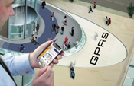
General Packet Radio Service (GPRS) enabled networks offer 'always-on', higher capacity, Internet-based content and packet-based data services. This enables services such as color Internet browsing, e-mail on the move, powerful visual communications, multimedia messages and location-based services.

GPRS is used to implement high-speed data transmission between the MS and some other party. GPRS utilizes multiple BTSs in the same BSS. The MS sends different packets to different BTSs, which are reconstructed at the SGSN. This enables the MS to use a higher transmission speed than one transmission channel can handle.

GPRS facilitates several new applications that have not previously been available over GSM networks due to the limitations in speed of Circuit Switched Data (9.6 kbps) and message length of the Short Message Service (160 characters). GPRS will fully enable the Internet applications you are used to on your desktop from web browsing to chat over the mobile network. Other new applications for GPRS, profiled later, include file transfer and home automation- the ability to remotely access and control in-house appliances and machines.

It should be noted right that the General Packet Radio Service is not only a service designed to be deployed on mobile networks that are based on the GSM digital mobile phone standard. The IS-136 Time Division Multiple Access (TDMA) standard, popular in North and South America, will also support GPRS. This follows an agreement to follow the same evolution path towards third generation mobile phone networks concluded in early 1999 by the industry associations that support these two network types.

What is EDGE?

Further enhancements in data capability over the core GSM network will be provided with the introduction of Enhanced Data rates for GSM Evolution - known as EDGE*. This will achieve the delivery of advanced mobile services such as the downloading of video and music clips, full multimedia messaging, high-speed color Internet access and e-mail on the move.

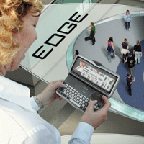
EDGE (or Enhanced Data Rates for Global Evolution) is a 3G technology that delivers broadband-like data speeds to mobile devices. It allows consumers to connect to the Internet and send and receive data, including digital images, web pages and photographs, three times faster than possible with an ordinary GSM/GPRS network. EDGE enables GSM operators to offer higher-speed mobile-data access, serve more mobile-data customers, and free up GSM network capacity to accommodate additional voice traffic.

The technology EDGE has been designed to increase GPRS on-air data rates 2.5 to 3 times while meeting essentially the same bandwidth occupancy as the original 0.3-GMSK signals. EDGE technology also enables each base station transceiver to carry more voice and/or data traffic.

What is 3GSM?

3GSM is the latest addition to the GSM family. 3GSM is about having third generation mobile multimedia services available globally. 3GSM focuses on visionary communications, in more ways than one. It's about the new visual ways in which people will communicate and the unique vision of the GSM community, which has always focused on the future needs of our customers.

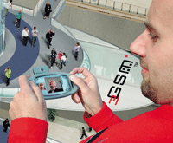
The technology on which 3GSM services will be delivered is built around a core GSM network with a Wideband-CDMA (W-CDMA) air interface, in some markets, EDGE air interfaces, which has been developed as an open standard by operators in conjunction with the 3GPP standards development organization. Allocated 3G spectrum in the 2GHz band selected 3GSM as the best technology to deliver the optimum combination of speed, capacity and capability in a broadband wireless world. No other standard is as open as 3GSM. It offers the flexible combination of voice and data performance and capacity delivered by 3GSM underpinned by Wideband-CDMA. No other standard is as open as 3GSM. Already over 85% of the world's network operators have chosen 3GSM's underlying technology platform to deliver their third generation services. 3GSM is a key element of GSM-The Wireless Evolution.

Main differences between GSM/DCS PLMN and PSTN:

PSTN | GSM/DCS PLMN
The terminal equipment is connected via a fixed line to the exchange. | The mobile subscriber accesses the network via a digital radio interface.
From a network operator’s point of view, a subscriber is synonymous with its subscriber line. | A mobile subscriber identifies itself by means of a personal chip card. In order to make a call, the subscriber only needs to insert this card in any GSM mobile equipment.

A BRIEF HISTORY OF GSM

The development and success of GSM has been an outstanding example of international enterprise in action. Operators, governments and manufacturers have come together in a remarkable venture that has created a new, dynamic and genuinely global telecommunications market. It’s an example of co-operation that has affected and will continue to affect, the lives of millions both socially and economically.

THE BEGINNING:

The scenario of mobile phones in the 1980’s can be summed up quite beautifully by considering the case of a car that race through the autobahns of GERMANY but stops dead when it crosses the border and enters FRANCE.

As the business was becoming increasingly international the cutting edge of the communication industry focused on exclusively local cellular solutions. And none of these was remotely compatible with other. NMT 450 in the Nordic and Benelux countries. TACS in the UK and C-NETZ in Germany. Radiocom 2000 in France and RTMI/RTMS in Italy. All these networks enabled you to call the office if you were in your own home, but not if you were with a client in another country.

Each country developed its own system, which was incompatible with everyone else's in equipment and operation. This was an undesirable situation, because not only was the mobile equipment limited to operation within national boundaries, which in a unified Europe were increasingly unimportant, but there was a very limited market for each type of equipment, so economies of scale, and the subsequent savings, could not be realized.

It was clear that there would be an escalating demand for a technology that facilitated flexible and reliable mobile communication. But there was a big disadvantage, which threatened to affect the first generation mobile networks. It was the problem of capacity or the lack of it. It was this that leads to the decline of the entire analog networks in the early 1990’s; they collapsed under the pressure of demand.

It also became clear to industry watchers that localized solutions to the development of mobile communications did not make ling-term economic sense. Given the daunting R&D costs facing operators and manufacturers, it was essential to be able to exploit the economies of scale inherent in global market penetration. Home market revenue simply wouldn’t justify sustained programs of investment.

In the alphabet soup that is the communications industry, the CEPT merits a very special place in history. The Europeans realized this early on, and in 1982 the Conference of European Posts and Telegraphs (CEPT) formed a study group called the Groupe Spécial Mobile (GSM) to study and develop a pan-European public land mobile system. Its objective was to develop the specification for a pan-European mobile communications network capable of supporting the many millions of subscribers likely to turn to mobile communications in the years ahead. The proposed system had to meet certain criteria:

- Good subjective speech quality,
- Low terminal and service cost,
- Support for international roaming,
- Ability to support handhold terminals,
- Support for range of new services and facilities,
- Spectral efficiency, and
- ISDN compatibility.

From the start, the GSM had it in mind that the new standard was likely to employ digital rather than analogue technology and operate in the 900MHz frequency band. Digital technology offered an attractive combination of performance and spectral efficiency. In other words, it would provide high quality transmission and enable more callers simultaneously to use the limited radio band available. In addition, such a system would allow the development of advanced features like speech security and data communications.

By going digital it would also be possible to employ the VLSI technology. It would have severe implications both for manufacturers and consumers. Handsets could be cheaper and smaller.

Finally the digital approach neatly complemented the Integrated Services Digital Network (ISDN) which was being developed by the land line communications networks and with which the GSM systems had to interact.

In 1989, GSM responsibility was transferred to the European Telecommunication Standards Institute (ETSI), and phase I of the GSM specifications was published in 1990. Commercial service was started in mid1991, and by 1993 there were 36 GSM networks in 22 countries, with 25 additional countries having already selected or considering GSM. This is not only a European standard - South Africa, Australia, and many Middle and Far East countries have chosen GSM. By the beginning of 1994, there were 1.3 million subscribers worldwide. The acronym GSM now stands for Global System for Mobile telecommunications.

GSM differs from first generation wireless systems in that it uses digital technology and time division multiple access transmission methods. Voice is digitally encoded via a unique encoder, which emulates the characteristics of human speech. This method of transmission permits a very efficient data rate/information content ratio.

GSM Milestones

Year | Milestone
1982 | GSM formed
1986 | Field test
1987 | TDMA chosen as access method
1988 | Memorandum of understanding signed
1989 | Validation of GSM system
1990 | Pre-operation system
1991 | Commercial system start-up
1992 | Coverage of larger cities/airports
1993 | Coverage of main roads
1995 | Coverage of rural areas

GSM (Global System for Mobile communication) is a digital mobile telephone system that is widely used in Europe and other parts of the world. GSM uses a variation of time division multiple access (TDMA) and is the most widely used of the three digital wireless telephone technologies (TDMA, GSM, and CDMA). GSM digitizes and compresses data, then sends it down a channel with two other streams of user data, each in its own time slot. It operates at either the 900 MHz or 1800 MHz frequency band.
GSM is the de facto wireless telephone standard in Europe. GSM has over 120 million users worldwide and is available in 120 countries, according to the GSM MoU Association. Since many GSM network operators have roaming agreements with foreign operators, users can often continue to use their mobile phones when they travel to other countries.

SMART AND SECURE

GSM is so secure and flexible with its functionalities – and so easy to manipulate – that there are all sorts of uses for it that we haven’t even thought of yet. One of the most attractive features of GSM is that it is a very secure network. All communications, both speech and data, are encrypted to prevent eavesdropping. In fact, in the early stages of its development it was found that the encryption algorithm was too powerful for certain technology export regulators. This could have had serious implications for the global spread of GSM by limiting the number of countries to which it could be sold. Fortunately, the MoU reacted promptly to this threat. Alternative algorithms were developed that enabled the free dissemination of the technology worldwide.

GSM subscribers are identified by their Subscriber Identity; Module (SIM) card. This holds their identity number and authentication key and algorithm. While the choice of algorithm is the responsibility off individual GSM operators, they all work closely together through the MoU to ensure security of authentication.

TODAY’S GSM

Today’s GSM platform is a hugely successful wireless technology and an unprecedented story of global achievement. In less than ten years since the first GSM network was commercially launched, it became the world’s leading and fastest growing mobile standard, spanning over 200 countries.

Today, GSM technology is in use by more than one in six of the world’s population and it is estimated that at the end of Jan 2004 there were over 1 billion GSM subscribers across more than 200 countries of the world.

The growth of GSM continues unabated with more than 160 million new customers in the last 12 months. Since 1997, the number of GSM subscribers has increased by a staggering 10 fold. The progress hasn’t stopped there. Today’s GSM platform is living, growing and evolving and already offers and expanded and feature-rich ‘family’ of voice and data enabling services.

GSM Telecommunication Services

The ETSI Standards define the telecommunication services. With D900/D1800 the GSM telecommunication services offered to the GSM subscriber are subdivided as follows:

- Bearer services (for data only)
- Tele-services (for voice and data)
- Supplementary services

Bearer services and tele-services are also called basic telecommunication services. The use of GSM telecommunication services is subject to subscription. A basic subscription permits participation in those GSM telecommunication services that are generally available.

If a GSM subscriber roams out of the entitled area there is no possibility of establishing communication (roaming not allowed), except the use of the tele-service emergency call.

- Bearer Services

Bearer services are telecommunication services providing the capability of transmission of signals between access points. The bearer services describe what the network can offer (e.g. speech, data and fax).

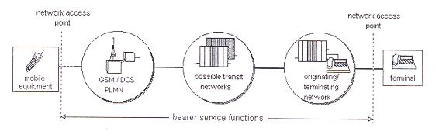
The bearer services are pure transport services for data. Some of the transmission modes and rates already used in modern data networks are implemented; others are planned. The following, already implemented, bearer services provide unrestricted information transfer between the reference points in the mobile stations.

- Data CDA (circuit duplex asynchronous) + basic PAD (packet assembler
Disassembler) access
- Data CDS (circuit duplex synchronous)
- PAD CDA (dedicated PAD access)
- Alternate speech/data CDA (circuit duplex asynchronous)
- Speech followed by data CDA (circuit duplex asynchronous)
- Data compression on the GSM radio interface

- Teleservices

Teleservices are telecommunication services including terminal equipment functions, which provide communication between users according to protocols established by agreement between network operators. The teleservices are user end-to-end services (e.g. emergency call and short message service).

Tele-services use both low layer and high layer functions for the control of communication from terminal to terminal. The following tele-services have already been realized:

- Telephony
- Emergency call
- Short message service (SMS)
- Short message cell broadcast
- Automatic facsimile (group 3)
- Alternative speech and facsimile (group 3)

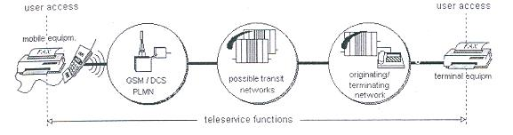

- Supplementary Services

Supplementary Services modify or supplement a basic telecommunication service. Consequently, they cannot be offered to a customer as a stand-alone service. They must be offered together or in association with a basic telecommunication service. The same supplementary service may be applicable to a number of telecommunication services. Most supplementary services are directly inherited from a fixed network, with minor modifications (when needed) to adapt to mobility. Examples of supplementary services are calling line identification and call waiting.

Supplementary services extend beyond the normal bearer services and teleservices (basic telecommunication services) and can be subscribed to separately. In the following a supplementary service is called simply service, in contrast to basic telecommunication service.

- Number Identification Services
  - Calling line identification presentation (CLIP)
  - Calling line identification restriction (CLIR)
- Call Offering Services
  - Call forwarding unconditional (CFU)
  - Call forwarding on mobile subscriber busy (CFB)
  - Call forwarding on no reply (CFNRy)
  - Call forwarding on mobile subscriber not reachable (CFNRc)
- Call Completion Services
  - Call hold
  - Call waiting (CW)
- Multi-Party Service
- Charging Services
  - Advice of charge (AOC)
- Call Restriction Services
  - Barring of all outgoing calls (BAOC)
  - Barring of all outgoing international calls (BOIC)
  - Barring of all outgoing international calls except to home PLMN country (BOICexHC)
  - Barring of all incoming calls (BAIC)
  - Barring of all incoming calls when roaming outside home PLMN country (BIC Roam)
- Closed User Group (CUG)

GSM Specifications:
- bandwidth—the range of a channel's limits; the broader the bandwidth, the faster data can be sent
- bits per second (bps)—a single on-off pulse of data; eight bits are equivalent to one byte
- frequency—the number of cycles per unit of time; frequency is measured in hertz (Hz)
- kilo (k)—kilo is the designation for 1,000; kbps represents 1,000 bits per second
- megahertz (MHz)—1,000,000 hertz (cycles per second)
- milliseconds (ms)—one-thousandth of a second
- watt (W)—a measure of power of a transmitter
Specifications and Characteristics for GSM:
- Frequency band—the frequency range specified for GSM is 1,850 to 1,990 MHz (mobile station to base station).
- Duplex distance—the duplex distance is 80 MHz. Duplex distance is the distance between the uplink and downlink frequencies. A channel has two frequencies, 80 MHz apart.
- Channel separation—the separation between adjacent carrier frequencies. In GSM, this is 200 kHz.
- Modulation—Modulation is the process of sending a signal by changing the characteristics of a carrier frequency. This is done in GSM via Gaussian minimum shift keying (GMSK).
- Transmission rate—GSM is a digital system with an over-the-air bit rate of 270 kbps.
- Access method—GSM utilizes the time division multiple access (TDMA) concept. TDMA is a technique in which several different calls may share the same carrier. Each call is assigned a particular time slot.
- Speech coder—GSM uses linear predictive coding (LPC). The purpose of LPC is to reduce the bit rate. The LPC provides parameters for a filter that mimics the vocal tract. The signal passes through this filter, leaving behind a residual signal. Speech is encoded at 13 kbps.

GSM Frequencies

In principle the GSM system can be implemented in any frequency band. However there are several bands where GSM terminals are, or will shortly be available. Furthermore, GSM terminals may incorporate one or more of the GSM frequency bands listed below to facilitate roaming on a global basis.

Frequency | Range
GSM900 | 880 - 915 MHz paired with 925 - 960 MHz
GSM1800 | 1710 - 1785 MHz paired with 1805 - 1880 MHz
GSM1900 | 1850 - 1910 MHz paired with 1930 - 1990 MHz

MOBILE STATION

The MS includes radio equipment and the man machine interface (MMI) that a subscribe needs in order to access the services provided by the GSM PLMN. MS can be installed in Vehicles or can be portable or handheld stations. The MS may include provisions for data communication as well as voice. A mobile transmits and receives message to and from the GSM system over the air interface to establish and continue connections through the system.

Different type of MSs can provide different type of data interfaces. To provide a common model for describing these different MS configuration, ”reference configuration” for MS, similar to those defined for ISDN land stations, has been defined.

Each MS is identified by an IMEI that is permanently stored in the mobile unit. Upon request, the MS sends this number over the signaling channel to the MSC. The IMEI can be used to identify mobile units that are reported stolen or operating incorrectly.

Just as the IMEI identities the mobile equipment, other numbers are used to identity the mobile subscriber. Different subscriber identities are used in different phases of call setup. The Mobile Subscriber ISDN Number (MSISDN) is the number that the calling party dials in order to reach the subscriber. It is used by the land network to route calls toward an appropriate MSC. The international mobile subscribe identity (IMSI) is the primary function of the subscriber within the mobile network and is permanently assigned to him. The GSM system can also assign a Temporary Mobile Subscriber Identity (TMSI) to identity a mobile. This number can be periodically changed by the system and protect the subscriber from being identified by those attempting to monitor the radio channel.

Functions of MS

The primary functions of MS are to transmit and receive voice and data over the air interface of the GSM system. MS performs the signal processing function of digitizing, encoding, error protecting, encrypting, and modulating the transmitted signals. It also performs the inverse functions on the received signals from the BS.

In order to transmit voice and data signals, the mobile must be in synchronization with the system so that the messages are the transmitted and received by the mobile at the correct instant. To achieve this, the MS automatically tunes and synchronizes to the frequency and TDMA timeslot specified by the BSC. This message is received over a dedicated timeslot several times within a multiframe period of 51 frames. The exact synchronization will also include adjusting the timing advance to compensate for varying distance of the mobile from the BTS.

MS keeps the GSM network informed of its location during both national and international roaming, even when it is inactive. This enables the System to page in its present LA.

Finally, the MS can store and display short received alphanumeric messages on the liquid crystal display (LCD) that is used to show call dialing and status in formation. These messages are limited to 160 characters in length (varies from mobile to mobile).

Power Levels

These are five different categories of mobile telephone units specified by the European GSM system: 20W, 8W, 5W, 2W, and 0.8W. These correspond to 43-dBm, 39-dBm, 37-dBm, 33-dBm, and 29-dBm power levels. The 20-W and 8-W units (peak power) are either for vehicle-mounted or portable station use.

The MS power is adjustable in 2-dB steps from its nominal value down to 20mW (13 dBm). This is done automatically under remote control from the BTS, which monitors the received power and adjusts the MS transmitter to the minimum power setting necessary for reliable transmission.

SIMCard 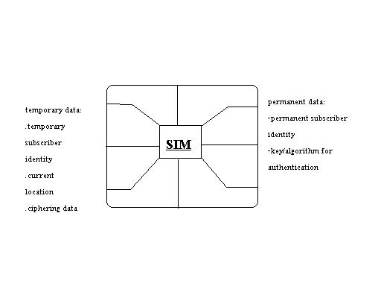
GSM subscribers are provided with a SIM (subscriber identity module) card with its unique identification at the very beginning of the service. By divorcing the subscriber ID from the equipment ID, the subscriber may never own the GSM mobile equipment set. The subscriber is identified in the system when he inserts the SIM card in the mobile equipment. This provides an enormous amount of flexibility to the subscribers since they can now use any GSM-specified mobile equipment. Thus with a SIM card the idea of “Personalize” the equipment currently in use and the respective information used by the network (location information) needs to be updated. The smart card SIM is portable between Mobile Equipment (ME) units. The user only needs to take his smart card on a trip. He can then rent a ME unit at the destination, even in another country, and insert his own SIM. Any calls he makes will be charged to his home GSM account. Also, the GSM system will be able to reach him at the ME unit he is currently using. This is the main advantage of GSM over CDMA.

The SIM is a removable, the size of a credit card, and contains an integrated circuit chip with a microprocessor, random access memory (RAM), and read only memory (ROM). The subscriber inserts it in the MS unit when he or she wants to use the MS to make or receive a call. As stated, a SIM also comes in a modular from that can be mounted in the subscriber’s equipment.

When a mobile subscriber wants to use the system, he or she mounts their SIM card and provide their Personal Identification Number (PIN), which is compared with a PIN stored within the SIM. If the user enters three incorrect PIN codes, the SIM is disabled. The service provider if requested by the subscriber can also permanently bypass the PIN. Disabling the PIN code simplifies the call setup but reduces the protection of the user’s account in the event of a stolen SIM.

Mobile subscriber identities in GSM

- International Mobile Subscriber Identity (IMSI)

An IMSI is assigned to each authorized GSM user. It consists of a mobile country code (MCC), mobile network code (MNC) (to identify the PLMN), and a PLMN unique mobile subscriber identification number (MSIN). The IMSI is the only absolute identity that a subscriber has within the GSM system. The IMSI consists of the MCC followed by the MNC and MSIN and shall not exceed 15 digits. It is used in the case of system-internal signaling transactions in order to identify a subscriber. The first two digits of the MSIN identify the HLR where the mobile subscriber is administrated.

- Temporary Mobile Subscriber Identity (TMSI)

A TMSI is a MSC-VLR specific alias that is designed to maintain user confidentiality. It is assigned only after successful subscriber authentication. The correlation of a TMSI to an IMSI only occurs during a mobile subscriber’s initial transaction with an MSC (for example, location updating). Under certain condition (such as traffic system disruption and malfunctioning of the system), the MSC can direct individual TMSIs to provide the MSC with their IMSI.

- Mobile Station ISDN Number

The MS international number must be dialed after the international prefix in order to obtain a mobile subscriber in another country. The MSISDN numbers is composed of the country code (CC) followed by the National Destination Code (NDC), Subscriber Number (SN), which shall not exceed 15 digits. Here too the first two digits of the SN identify the HLR where the mobile subscriber is administrated.

- The Mobile Station Roaming Number (MSRN)

The MSRN is allocated on temporary basis when the MS roams into another numbering area. The MSRN number is used by the HLR for rerouting calls to the MS. It is assigned upon demand by the HLR on a per-call basis. The MSRN for PSTN/ISDN routing shall have the same structure as international ISDN numbers in the area in which the MSRN is allocated. The HLR knows in what MSC/VLR service area the subscriber is located. At the reception of the MSRN, HLR sends it to the GMSC, which can now route the call to the MSC/VLR exchange where the called subscriber is currently registered.

- International Mobile Equipment Identity

The IMEI is the unique identity of the equipment used by a subscriber by each PLMN and is used to determine authorized (white), unauthorized (black), and malfunctioning (gray) GSM hardware. In conjunction with the IMSI, it is used to ensure that only authorized users are granted access to the system.

GSM ARCHITECTURE

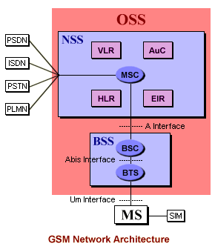

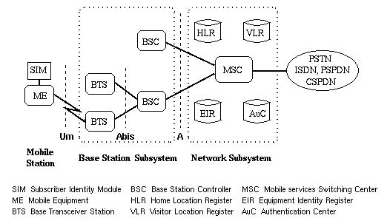

INTRODUCTION

A GSM system is basically designed as a combination of three major subsystems: the network (switching) subsystem (SSS), the radio subsystem (RSS), and the operation and maintenance subsystem (OMS).

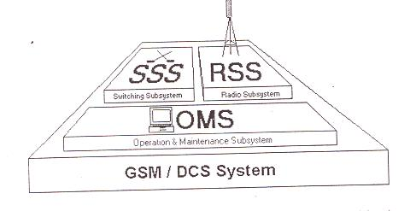

In order to ensure that network operators will have several sources of cellular infrastructure equipment, GSM decided to specify not only the air interface, but also the main interfaces that identify different parts. There are three dominant interfaces, namely, an interface between MSC and the BSC (An interface), BSC and Base Transceiver Station (BTS) (Abis interface), and an Um interface between the BTS and MS.

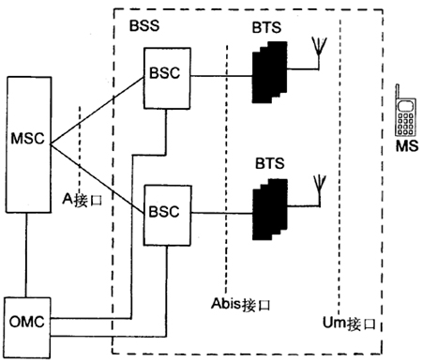

GSM NETWORK STRUCTURE

Every telephone network needs a well-designed structure in order to route incoming called to the correct exchange and finally to the called subscriber. In a mobile network, this structure is of great importance because of the mobility of all its subscribers. In the GSM system, the network is divided into the following partitioned areas:

- GSM service area;
- PLMN service area;
- MSC service area;
- Location area;
- Cells.

The GSM service is the total area served by the combination of all member countries where a mobile can be serviced. The next level is the PLMN service area. There can be several within a country, based on its size. The links between a GSM/PLMN network and other PSTN, ISDN, or PLMN network will be on the level of international or national transit exchange. All incoming calls for a GSM/PLMN network will be routed to a gateway MSC. A gateway MSC works as an incoming transit exchange for the GSM/PLMN. In a GSM/PLMN network, all mobile-terminated calls will be routed to a gateway MSC. Call connections between PLMNs, or to fixed networks, must be routed through certain designated MSCs called a gateway MSC. The gateway MSC contains the interworking functions to make these connections. They also route incoming calls to the proper MSC within the network. The next level of division is the MSC/VLR service area. In one PLMN there can be several MSC/VLR service areas. MSC/VLR is a role controller of calls within its jurisdiction.

In order to route a call to a mobile subscriber, the path through links to the MSC in the MSC area where the subscriber is currently located. The mobile location can be uniquely identified since the MS is registered in a VLR, which is generally associated with an MSC.

The next division level is that of the LA’s within a MSC/VLR combination. There are several LA’s within one MSc/VLR combination. A LA is a part of the MSC/VLR service area in which a MS may move freely without updating location information to the MSC/VLR exchange that control the LA. Within a LA a paging message is broadcast in order to find the called mobile subscriber. The LA can be identified by the system using the Location Area Identity (LAI). The LA is used by the GSM system to search for a subscriber in an active state.

Lastly, a LA is divided into many cells. A cell is an identity served by one BTS. The MS distinguishes between cells using the Base Station Identification code (BSIC) that the cell site broadcast over the air.

Network Components of the Radio Subsystem (RSS)

The Radio Subsystem (RSS) consists of:

- Mobile Equipment (ME)
- Base Station (BS)
- Radio Interface (Um)

The Base Station (BS) terminates the radio interface (Um) on the stationary network side. The BS has a modular design and includes the:

- Base Transceiver Station (BTS)
- Base Station Controller (BSC)
- Transcoding and Rate Adaptation Unit (TRAU)

A BSC can control several BTS. Every BSC contained in the network controls one BSS.
The interface between BSC and BTS is called A_{bis} - interface.
The BSC, the TRAU and BTS form a unit, which is called Base Station System (BSS) in the GSM terminology. 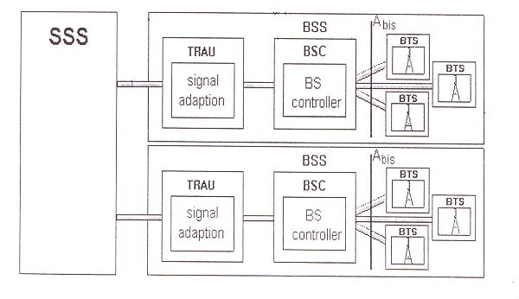
A sub interface
A interface

Base Station System (BSS)

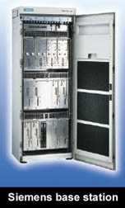
The BSS is a set of BS equipment (such as transceivers and controllers) that is in view by the MSC through a single A interface as being the entity responsible for communicating with MSs in a certain area. The radio equipment of a BSS may be composed of one or more cells. A BSS may consist of one or more BS. The interface between BSC and BTS is designed as an A_{bis} interface. The BSS includes two types of machines: the BTS in contact with the MSs through the radio interface; and the BSC, the latter being in contact with the MSC. The function split is basically between transmission equipment, the BTS and managing equipment at the BSC. All radio-related functions are performed in the BSS, which consists of base station controllers (BSCs) and the base transceiver stations (BTSs).

- Base Station Controller (BSC)
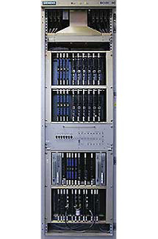
A BSC is a network component in the PLMN that function for control of one or more BTS. It is a functional entity that handles common control functions within a BTS. BSC within a mobile network is a key component for handling and routing information. The BSC provides all the control functions and physical links between the MSC and BTS. It is a high-capacity switch that provides functions such as handover, cell configuration data, and control of radio frequency (RF) power levels in base transceiver stations. A number of BSCs are served by an MSC.
The BSC is connected to the MSC on one side and to the BTS on the other. The BSC performs the Radio Resource (RR) management for the cells under its control. It assigns and releases frequencies and timeslots for all MSs in its

own area. The BSC performs the intercell handover for MSs moving between
BTS in its control. It also reallocates frequencies to the BTSs in its area to meet locally heavy demands during peak hours or on special events. The BSC controls the power transmission of both BSSs and MSs in its area. The minimum power level for a mobile unit is broadcast over the BCCH. The BSC provides the time and frequency synchronization reference signals broadcast by its BTSs. The BSC also measures the time delay of received MS signals relative to the BTS clock. If the received MS signal is not centered in its assigned timeslot at the BTS, The BSC can direct the BTS to notify the MS to advance the timing such that proper synchronization takes place. The BSC may also perform traffic concentration to reduce the number of transmission lines from the BSC to its BTSs.

- Base Terminal Station (BTS)
The BTS handles the radio interface to the mobile station. The BTS is the radio equipment (transceivers and antennas) needed to service each cell in the network. A group of BTSs are controlled by a BSC.
A BTS is a network component that serves one cell and is controlled by a BSC. BTS is typically able to handle three to five radio carries, carrying between 24 and 40 simultaneous communication. Reducing the BTS volume is important to keeping down the cost of the cell sites.
A BTS compares radio transmission and reception devices, up to and including the antennas, and also all the signal processing specific to the radio interface. A single transceiver within BTS supports eight basic radio channels of the same TDM frame.

Functions of BTS

The primary responsibility of the BTS is to transmit and receive radio signals from a mobile unit over an air interface. To perform this function completely, the signals are encoded, encrypted, multiplexed, modulated, and then fed to the antenna system at the cell site. Transcoding to bring 13-kbps speech to a standard data rate of 16 kbps and then combining four of these signals to 64 kbps is essentially a part of BTS, though; it can be done at BSC or at MSC. The voice communication can be either at a full or half rate over logical speech channel. In order to keep the mobile synchronized, BTS transmits frequency and time synchronization signals over frequency correction channel (FCCH and BCCH logical channels. The received signal from the mobile is decoded, decrypted, and equalized for channel impairments.

Random access detection is made by BTS, which then sends the message to BSC. The channel subsequent assignment is made by BSC. Timing advance is determined by BTS. BTS signals the mobile for proper timing adjustment. Uplink radio channel measurement corresponding to the downlink measurements made by MS has to be made by BTS.

BTS-BSC Configurations

There are several BTS-BSC configurations: single site, single cell; single site, multicell; and multisite, multicell. These configurations are chosen based on the rural or urban application. These configurations make the GSM system economical since the operation has options to adapt the best layout based on the traffic requirement. Thus, in some sense, system optimization is possible by the proper choice of the configuration. These include omni-directional rural configuration where the BSC and BTS are on the same site; chain and multidrop loop configuration in which several BTSs are controlled by a single remote BSC with a chain or ring connection topology; rural star configuration in which several BTSs are connected by individual lines to the same BSC; and sectorized urban configuration in which three BTSs share the same site and are controlled by either a collocated or remote BSC.

In rural areas, most BTSs are installed to provide maximum coverage rather then maximum capacity.

- Transcoder and Rate Adaptation Unit (TRAU):

An important component of the BSS that is considered in the GSM architecture as a part of the BTS is the Transcoder/Rate Adaptation Unit (TRAU). The TRAU is the equipment in which coding and decoding is carried out as well as rate adaptation in case of data. Although the specifications consider the TRAU as a subpart of the BTS, it can be sited away from the BTS (at MSC), and even between the BSC and the MSC. The TRAU adapts the 64 Kbps from the MSC to the comparatively low transmission rate of the radio interface of 16 Kbps.

The interface between the MSC and the BSS is a standardized SS7 interface (A-interface) that, as stated before, is fully defined in the GSM recommendations. This allows the system operator to purchase switching equipment from one supplier and radio equipment and the controller from another. The interface between the BSC and a remote BTS likewise is a standard the A_{bis.} In splitting the BSS functions between BTS and BSC, the main principle was that only such functions that had to reside close to the radio transmitters/receivers should be placed in BTS. This will also help reduce the complexity of the BTS.

Transcoder

Depending on the relative costs of a transmission plant for a particular cellular operator, there may be some benefit, for larger cells and certain network topologies, in having the transcoder either at the BTS, BSC or MSC location. If the transcoder is located at MSC, they are still considered functionally a part of the BSS. This approach allows for the maximum of flexibility and innovation in optimizing the transmission between MSC and BTS.

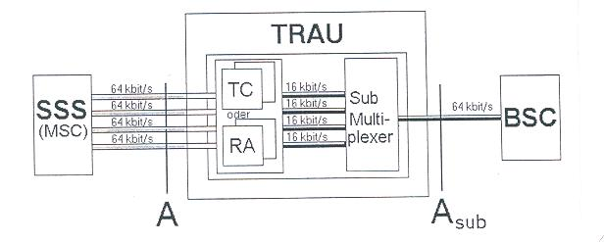

The transcoder is the device that takes 13-Kbps speech or 3.6/6/12-Kbps data multiplexes and four of them to convert into standard 64-Kbps data. First, the 13 Kbps or the data at 3.6/6/12 Kbps are brought up to the level of 16 Kbps by inserting additional synchronizing data to make up the difference between a 13-Kbps speech or lower rate data, and then four of them are combined in the transcoder to provide 64 Kbps channel within the BSS. Four traffic channels can then be multiplexed on one 64-Kbps circuit. Thus, the TRAU output data rate is 64 Kbps. Then, up to 30 such 64-Kbps channels are multiplexed onto a 2.048 Mbps if a CEPT1 channel is provided on the A_{bis} interface. This channel can carry up to 120-(16x 120) traffic and control signals. Since the data rate to the PSTN is normally at 2 Mbps, which is the result of combining 30-Kbps by 64-Kbps channels, or 120- Kbps by 16-Kbps channels.

Network Components of the Switching Subsystem (SSS)

The Switching Subsystem (SSS) comprises of:

- Mobile services Switching Centre (MSC)
- Home Location Register (HLR)
- Visitor Location Register (VLR)
- Authentication Centre (AC)
- Equipment Identification Register (EIR)

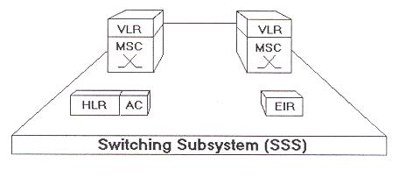
The network and the switching subsystem together include the main switching functions of GSM as well as the databases needed for subscriber data and mobility management (VLR). The main role of the MSC is to manage the communications between the GSM users and other telecommunication network users. The basic switching function is performed by the MSC, whose main function is to coordinate setting up calls to and from GSM users. The MSC has interface with the BSS on one side (through which MSC VLR is in contact with GSM users) and the external networks on the other (ISDN/PSTN/PSPDN). The main difference between a MSC and an exchange in a fixed network is that the MSC has to take into account the impact of the allocation of RRs and the mobile nature of the subscribers and has to perform, in addition, at least, activities required for the location registration and handover.

The MSC is a telephony switch that performs all the switching functions for MSs located in a geographical area as the MSC area. The MSC must also handle different types of numbers and identities related to the same MS and contained in different registers: IMSI, TMSI, ISDN number, and MSRN. In general identities are used in the interface between the MSC and the MS, while numbers are used in the fixed part of the network, such as, for routing.

- Mobile services Switching Centre (MSC)
An MSC is the point of connection to the network for mobile subscribers of a wireless telephone network. It connects to the subscribers through base stations and radio transmission equipment that control the air interface, and to the network of other MSCs and wireless infrastructure through voice trunks and SS7. An MSC includes the procedures for mobile registration and is generally co-sited with a visitor location register (VLR) that is used to temporarily store information relating to the mobile subscribers temporarily connected to that MSC. The MSC performs the telephony switching functions of the system. It controls calls to and from other telephone and data systems. It also performs such functions as toll ticketing, network interfacing, common channel signaling, and others.
Functions of MSC

As stated, the main function of the MSC is to coordinate the set up of calls between GSM mobile and PSTN users. Specifically, it performs functions such as paging, resource allocation, location registration, and encryption.

Specifically, the call-handling function of paging is controlled by MSC. MSC coordinates the set up of call to and from all GSM subscribers operating in its areas. The dynamics allocation of access resources is done in coordination with the BSS. More specifically, the MSC decides when and which types of channels should be assigned to which MS. The channel identity and related radio parameters are the responsibility of the BSS; The MSC provides the control of interworking with different networks. It is transparent for the subscriber authentication procedure. The MSC supervises the connection transfer between different BSSs for MSs, with an active call, moving from one call to another. This is ensured if the two BSSs are connected to the same MSC but also when they are not. In this latter case the procedure is more complex, since more then one MSC involved. The MSC performs billing on calls for all subscribers based in its areas. When the subscriber is roaming elsewhere, the MSC obtains data for the call billing from the visited MSC. Encryption parameters transfers from VLR to BSS to facilitate ciphering on the radio interface are done by MSC. The exchange of signaling information on the various interface toward the other network elements and the management of the interface themselves are all controlled by the MSC.

Short Message Service Center (SMSC)

Finally, the MSC serves as a SMS gateway to forward SMS messages from Short Message Service Centers (SMSC) to the subscribers and from the subscribers to the SMSCs. It thus acts as a message mailbox and delivery system
The SMSC is a store-and-forward device used to provide peer-to-peer text messaging services in mobile networks. Any text message issued from a mobile handset is forwarded to the SMSC, where the location of the called subscriber is determined by consulting the appropriate HLR. If the subscriber is currently connected to a reachable network, the location is determined and the text message is transmitted. If not, the message is stored for later transmission once the subscriber becomes available. The SMSC also includes back-end interfaces for the connection of enhanced service platforms that can be used to implement a variety of SMS services such as televoting and premium rate data services (e.g., weather, traffic, sports, and news).

- Visitor Location Register
The VLR is a database that contains temporary information about subscribers that is needed by the MSC in order to service visiting subscribers. The VLR is always integrated with the MSC. When a mobile station roams into a new MSC area, the VLR connected to that MSC will request data about the mobile station from the HLR. Later, if the mobile station makes a call, the VLR will have the information needed for call setup without having to interrogate the HLR each time.
The VLR is allocated with an MSC. A MS roaming in an MSC area is controlled by the VLR responsible for that area. When a MS appears in a LA, it starts a registration procedure. The MSC for that area notices this registration and transfers to the VLR the identity of the LA where the MS is situated. A VLR may

be in charge of one or several MSC LA’s. The VLR constitutes the databases that support the MSC in the storage and retrieval of the data of subscribers present in its area. When an MS enters the MSC area borders, it signals its arrival to the MSC that stores it’s identity in the VLR. The information necessary to manage the MS is contained in the HLR and is transferred to the VLR so that they can be easily retrieved if so required.

Data Stored in VLR: The data contained in the VLR and in the HLR are more or less the same. Nevertheless the data are present in the VLR only as long as the MS is registered in the area related to that VLR. Data associated with the movement of mobile are IMSI, MSISDN, MSRN, and TMSI. The terms permanent and temporary, in this case, are meaningful only during that time interval. Some data are mandatory, others are optional.

  - Home Location Register

The HLR is a database that permanently stores data related to a given set of subscribers. The HLR is the reference database for subscriber parameters. Various identification numbers and addresses as well as authentication parameters, services subscribed, and special routing information are stored. Current subscriber status including a subscriber’s temporary roaming number and associated VLR if the mobile is roaming, are maintained.
The HLR is a database used for storage and management of subscriptions. The HLR is considered the most important database, as it stores permanent data about subscribers, including a subscriber's service profile, location information, and activity status. When an individual buys a subscription from one of the PCS operators, he or she is registered in the HLR of that operator. Once a mobile user is registered with a network, the current location is stored in the HLR, thus allowing incoming calls to be routed to the subscriber.
The HLR provides data needed to route calls to all MS-SIMs home based in its MSC area, even when they are roaming out of area or in other GSM networks. The HLR provides the current location data needed to support searching for and paging the MS-SIM for incoming calls, wherever the MS-SIM may be. The HLR is responsible for storage and provision of SIM authentication and encryption parameters needed by the MSC where the MS-SIM is operating. It obtains these parameters from the AUC.

The HLR maintains record of which supplementary service each user has subscribed to and provides permission control in granting services. The HLR stores the identification of SMS gateways that have messages for the subscriber under the SMS until they can be transmitted to the subscriber and receipt is knowledge.

Some data are mandatory, other data are optional. Both the HLR and the VLR can be implemented in the same equipment in an MSC (collocated). A PLMN may contain one or several HLRs.

- Authentication Centre
A unit called the AUC provides authentication and encryption parameters that verify the user's identity and ensure the confidentiality of each call. The AUC protects network operators from different types of fraud found in today's cellular world.
The AUC stores information that is necessary to protect communication through the air interface against intrusions, to which the mobile is vulnerable. The legitimacy of the subscriber is established through authentication and ciphering, which protects the user information against unwanted disclosure. Authentication information and ciphering keys are stored in a database within the AUC, which protects the user information against unwanted disclosure and access.
In the authentication procedure, the key Ki is never transmitted to the mobile over the air path, only a random number is sent. In order to gain access to the system, the mobile must provide the correct Signed Response (SRES) in answer to a random number (RAND) generated by AUC.

Also, Ki and the cipher key Kc are never transmitted across the air interface between the BTS and the MS. Only the random challenge and the calculated response are transmitted. Thus, the value of Ki and Kc are kept secure. The cipher key, on the other hand, is transmitted on the SS7 link between the home HLR/AUC and the visited MSC, which is a point of potential vulnerability. On the other hand, the random number and cipher key is supposed to change with each phone call, so finding them on one call will not benefit using them on the next call.

The HLR is also responsible for the “authentication” of the subscriber each time he makes or receives a call. The AUC, which actually performs this function, is a separate GSM entity that will often be physically included with the HLR. Being separate, it will use separate processing equipment for the AUC database functions.

- Equipment Identity Register
The EIR is a database that contains information about the identity of mobile equipment that prevents calls from stolen, unauthorized, or defective mobile stations. The AUC and EIR are implemented as stand-alone nodes or as a combined AUC/EIR node.
EIR is a database that stores the IMEI numbers for all registered ME units. The IMEI uniquely identifies all registered ME. There is generally one EIR per PLMN. It interfaces to the various HLR in the PLMN. The EIR keeps track of all ME units in the PLMN. It maintains various lists of message. The database stores the ME identification and has nothing do with subscriber who is receiving or originating call. There are three classes of ME that are stored in the database, and each group has different characteristics:

White List: contains those IMEIs that are known to have been assigned to valid MS’s. This is the category of genuine equipment.
Black List: contains IMEIs of mobiles that have been reported stolen.
Gray List: contains IMEIs of mobiles that have problems (for example, faulty software, and wrong make of the equipment). This list contains all MEs with faults not important enough for barring.

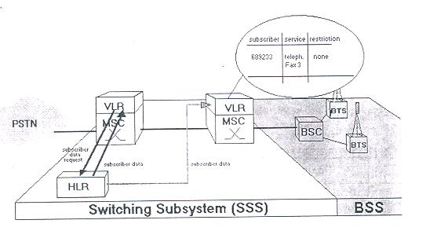

- Echo Chancellor

EC is used on the PSTN side of the MSC for all voice circuits. The EC is required at the MSC PSTN interface to reduce the effect of GSM delay when the mobile is connected to the PSTN circuit. The total round-trip delay introduced by the GSM system, which is the result of speech encoding, decoding and signal processing, is of the order of 180 ms. Normally this delay would not be an annoying factor to the mobile, except when communicating to PSTN as it requires a two-wire to four-wire hybrid transformer in the circuit. This hybrid is required at the local switching office because the standard local loop is a two-wire circuit. Due to the presence of this hybrid, some of the energy at its four-wire receive side from the mobile is coupled to the four-wire transmit side and thus retransmitted to the mobile. This causes the echo, which does not affect the land subscriber but is an annoying factor to the mobile. The standard EC cancels about 70 ms of delay.

During a normal PSTN (land-to-land call), no echo is apparent because the delay is too short and the land user is unable to distinguish between the echo and the normal telephone “side tones” However, with the GSM round-trip delay added and without the EC, the effect would be irritating to the MS subscriber.

OPERATION AND MAINTENANCE SUBSYSTEM (OMS)

An OMS consists of one or more Operation & Maintenance Centre (OMC).

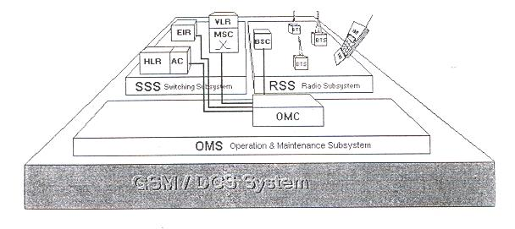

The operations and maintenance center (OMC) is connected to all equipment in the switching system and to the BSC. The implementation of OMC is called the operation and support system (OSS). The OSS is the functional entity from which the network operator monitors and controls the system. The purpose of OSS is to offer the customer cost-effective support for centralized, regional and local operational and maintenance activities that are required for a GSM network. An important function of OSS is to provide a network overview and support the maintenance activities of different operation and maintenance organizations.
The OMC provides alarm-handling functions to report and log alarms generated by the other network entities. The maintenance personnel at the OMC can define that criticality of the alarm. Maintenance covers both technical and administrative actions to maintain and correct the system operation, or to restore normal operations after a breakdown, in the shortest possible time.

The fault management functions of the OMC allow network devices to be manually or automatically removed from or restored to service. The status of network devices can be checked, and tests and diagnostics on various devices can be invoked. For example, diagnostics may be initiated remotely by the OMC. A mobile call trace facility can also be invoked. The performance management functions included collecting traffic statistics from the GSM network entities and archiving them in disk files or displaying them for analysis. Because a potential to collect large amounts of data exists, maintenance personal can select which of the detailed statistics to be collected based on personal interests and past experience. As a result of performance analysis, if necessary, an alarm can be set remotely.

The OMC provides system change control for the software revisions and configuration data bases in the network entities or uploaded to the OMC. The OMC also keeps track of the different software versions running on different subsystem of the GSM.

GSM Network Areas
The GSM network is made up of geographic areas. As shown in Figure, these areas include cells, location areas (LAs), MSC/VLR service areas, and public land mobile network (PLMN) areas.
Network Areas
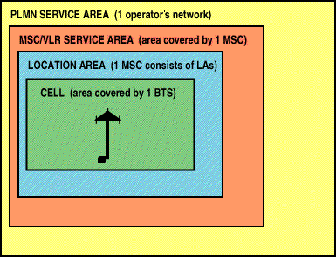
The cell is the area given radio coverage by one base transceiver station. The GSM network identifies each cell via the cell global identity (CGI) number assigned to each cell. The location area is a group of cells. It is the area in which the subscriber is paged. Each LA is served by one or more base station controllers, yet only by a single MSC (see Figure). Each LA is assigned a location area identity (LAI) number.

Location Areas

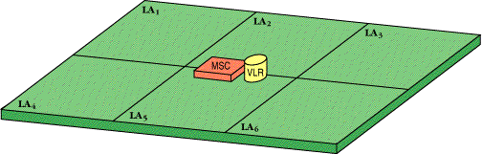
An MSC/VLR service area represents the part of the GSM network that is covered by one MSC and which is reachable, as it is registered in the VLR of the MSC (see Figure).

MSC/VLR Service Areas

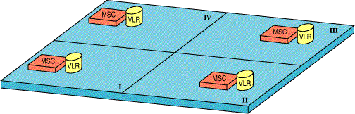

The Radio interface (Um)
The International Telecommunication Union (ITU), which manages the international allocation of radio spectrum (among other functions) allocated the bands 890-915 MHz for the uplink (mobile station to base station) and 935-960 MHz for the downlink (base station to mobile station) for mobile networks in Europe. Since this range was already being used in the early 1980s by the analog systems of the day, the CEPT had the foresight to reserve the top 10 MHz of each band for the GSM network that was still being developed. Eventually, GSM will be allocated the entire 2x25 MHz bandwidth.
Since radio spectrum is a limited resource shared by all users, a method must be devised to divide up the bandwidth among as many users as possible. The method chosen by GSM is a combination of Time and Frequency Division Multiple Access (TDMA/FDMA). The FDMA part involves the division by frequency of the total 25 MHz bandwidth into 124 carrier frequencies of 200 kHz bandwidth. One or more carrier frequencies are then assigned to each base station. Each of these carrier frequencies is then divided in time, using a TDMA scheme, into eight time slots. One time slot is used for transmission by the mobile and one for reception. They are separated in time so that the mobile unit does not receive and transmit at the same time, a fact that simplifies the electronics.

Channel structure

A total of 156.25 bits is transmitted in 0.577 milliseconds, giving a gross bit rate of 270.833 kbps. There are three other types of burst structure for frame and carrier synchronization and frequency correction. The 26bit training sequence is used for equalization, as described above. The 8.25 bit guard time allows for some propagation time delay in the arrival of bursts. 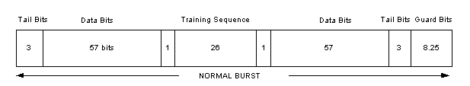
Physical channels
- In the air interface, frequency channel C0 and time slots TS0 and TS1 on that channel constitute the physical channels. Each cell has a dedicated C0 channel. Most logical control channels for signaling across the air interface are carried by LAPDm.
- In the interface between the base station and the BSC, all signaling is carried by LAPD links, which in turn use PCM channels. Signaling that is also transported across the air interface is carried by links having 0 as the service access point identifier (SAPI) address. Since a BSC is responsible for the maintenance of its base stations, BSC-BTS communication is extensive. The maintenance signals are carried by LAPD links having 62 as the SAPI address for base station maintenance and 63 for maintenance of LAPD. The LAPD links are in turn carried by a time slot (usually TS1) on the PCM link connecting a base station to its BSC.
- In the interface between a BSC and its MSC, there are three levels of physical channels. The topmost level is the discrimination mechanism of the BSSAP protocol, which distinguishes between signals to be

transported between a mobile and the MSC and signals that are to be transported only between the MSC and the BSC. In both cases, BSSAP signals are carried by the SCCP in SS7. All call-related signaling uses SCCP's connection-oriented service, while the connectionless service is used in all other cases. SS7 normally uses one or more time slots in a PCM system.
The physical channels - together with the relay functions - are used to create logical channels through all or part of the access network. In the air interface, these logical channels are divided into nine types of control channel and two types of traffic channel, all of which are mapped onto the time slots of the physical channels.

Control channels
Control channels are divided into three classes, based on how and when they are used: broadcast channels (BCH); common control channels (CCCH); and dedicated control channels (DCCH).
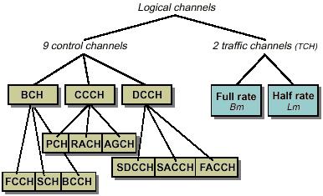
The GSM system has 11 logical channels

- Broadcast channels
Class BCH channels continuously send information about cell and network parameters to the mobiles. They are unidirectional (from base station to mobile) and used jointly by all mobiles.
There are three types of broadcast channel:
- A frequency correction channel (FCCH) carries frequency correction information.
- A synchronization channel (SCH) carries frame synchronization information and information for identifying the base station.
- A broadcast control channel (BCCH) carries cell-specific information.
These channels are shown in the lower part of Figure.
- Common control channels
Class CCCH channels are used for access to the network. These three channels, too, are common to all mobiles.
    - A paging channel (PCH) is used by the network to call terminals.
- A random access channel (RACH) is used by a mobile to answer paging calls and call the network when the mobile initiates set-up.
- An access granted channel (AGCH) is used by the network to allocate a dedicated control channel (SDCCH - see below) for continued signaling or some other channel (FACCH - see below) for handover.
All these logical channels are unidirectional: PCH and AGCH from network to mobile and RACH from mobile to network. The signals sent on RACH, AGCH and PCH are relayed via the base station and transferred to and from the BSC on LAPD links.

- Dedicated control channels
Class DCCH channels are used for signaling between a mobile and the network before and during a call. These three channels are allocated to individual connections and are always bidirectional.
- A stand-alone dedicated control channel (SDCCH) is used for signaling during the set-up phase; that is, before traffic channel has been allocated. This channel is also used for registration, authentication and signaling in connection with clearing.
- A slow associated control channel (SACCH) is a locating channel that the mobile uses to continuously report received signal strength in the visited cell and from surrounding cells. The channel can also be used for controlling the output power of the mobile. Note, however, that SACCH does not have the signaling capacity required to control handover.
- A fast associated control channel (FACCH) - only available in conversation state - is used for handover operations. FACCH is allocated 20 ms of the traffic channel when rapid signaling is required. The listening party does not notice the loss of 20 ms conversation because the receiving unit repeats the last 20 ms. There is one FACCH for each traffic channel.
Signals on SACCH, FACCH and SDCCH are relayed to the BSC via the base station. Signals related to call handling; authentication and registration are relayed via SDCCH and then sent to the MSC. Connection handling is performed in both the BSC and the MSC.
All control channels except SCH and FCCH use LAPDm.
The following comments complete the information given in figure:
- Between the BSC and base stations, LAPD links are used for maintenance of base stations (base control function, BCF, in GSM).
- Between the BSC and the MSC, BSSAP (discrim.) signaling is used for paging (in the case of a call to a mobile) and for handover, if the MSC is involved in this handover.

Traffic channels

A traffic channel (TCH) is used to carry speech and data traffic. Traffic channels are defined using a 26-frame multiframe, or group of 26 TDMA frames. The length of a 26-frame multiframe is 120 ms, which is how the length of a burst period is defined (120 ms divided by 26 frames divided by 8 burst periods per frame). Out of the 26 frames, 24 are used for traffic, 1 is used for the Slow Associated Control Channel (SACCH) and 1 is currently unused (see Figure). TCHs for the uplink and downlink are separated in time by 3 burst periods, so that the mobile station does not have to transmit and receive simultaneously, thus simplifying the electronics.

In addition to these full-rate TCHs, there are also half-rate TCHs defined, although they are not yet implemented. Half-rate TCHs will effectively double the capacity of a system once half-rate speech coders are specified (i.e., speech coding at around 7 kbps, instead of 13 kbps). Eighth-rate TCHs are also specified, and are used for signaling. In the recommendations, they are called Stand-alone Dedicated Control Channels (SDCCH).

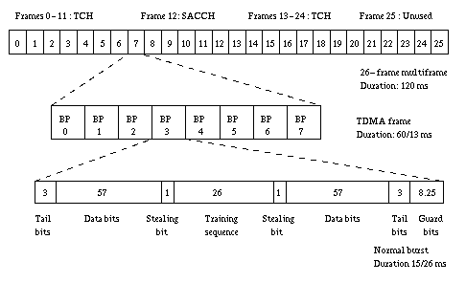

Figure. Organization of bursts, TDMA frames, and multiframes for speech and data

Mapping of control channels onto physical channels
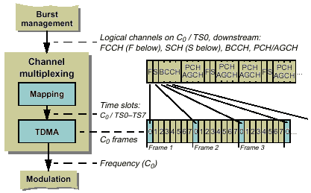
Figure: for Example of the mapping of logical channels onto time slot 0, frequency channel C0

A multiframe structure is used for several of the "downstream" control channels. Here we will focus on time slot 0 on frequency channel C0. "Downstream", the time slot is used for control channels FCCH, SCH and BCCH (all of which are of the broadcast type), and for PCH and AGCH. "Upstream", the time slot is only used for the random access channel, RACH, so no multiframe is necessary from mobile to base station.
The multiframe covers 51 TDMA frames. During the time it takes to receive the frames (about 0.25 s), BCCH occupies four time slots, SCH and FCCH five each, and PCH and AGCH together thirty-six time slots.
Time slot 1 on frequency channel C0 is used for control channels SDCCH and SACCH.
As we have seen, the only remaining control channel in the air interface - FACCH - uses traffic channels.

Burst structure

There are four different types of bursts used for transmission in GSM. The normal burst is used to carry data and most signaling. It has a total length of 156.25 bits, made up of two 57 bit information bits, a 26 bit training sequence used for equalization, 1 stealing bit for each information block (used for FACCH), 3 tail bits at each end, and an 8.25 bit guard sequence, as shown in Figure 2. The 156.25 bits are transmitted in 0.577 ms, giving a gross bit rate of 270.833 kbps.

The F burst, used on the FCCH, and the S burst, used on the SCH, have the same length as a normal burst, but a different internal structure, which differentiates them from normal bursts (thus allowing synchronization). The access burst is shorter than the normal burst, and is used only on the RACH.

Frequency hopping

The mobile station already has to be frequency agile, meaning it can move between a transmit, receive, and monitor time slot within one TDMA frame, which may be on different frequencies. GSM makes use of this inherent frequency agility to implement slow frequency hopping, where the mobile and BTS transmit each TDMA frame on a different carrier frequency. The frequency-hopping algorithm is broadcast on the Broadcast Control Channel. Since multipath fading is (mildly) dependent on carrier frequency, slow frequency hopping helps alleviate the problem. In addition, cochannel interference is in effect randomized.

FH may be classified as fast or slow. Fast FH occurs if there is frequency hop for each transmitted symbol. Thus, fast FH implies hat the hopping rate equals or exceeds the information symbol rate. Slow FH occurs if two or more symbols are transmitted in the time interval between frequency hops.
FH allows communicators to hop out of frequency channels with interference or to hop out of fades. To exploit this capability, error-correcting codes, appropriate interleaving, and disjointed frequency channels are nearly always used.

Authentication
When a new subscription is registered in GSM, the mobile is given a subscriber authentication key (Ki) and a telephone number, or international mobile subscriber identity (IMSI), which are used in the network to identify the mobile. The Ki and IMSI are stored both in the mobile and in a special network element called AUC. The AUC uses the Ki and IMSI to calculate an identification parameter called signal response (SRES). SRES is calculated as a function of Ki and a random number (RAND) generated by the AUC. RAND and SRES are then stored in the HLR for use in set-up procedures.

Set-up or registration will not be accepted until authentication has been performed. Using the mobile's IMSI, the MSC fetches the corresponding RAND and SRES from the HLR. RAND is sent to the mobile, which uses its stored Ki value to calculate SRES. It then returns the calculated SRES to the MSC, where it is compared with the SRES value received from the HLR. If the values tally, the set-up is accepted; if not, set-up is rejected.
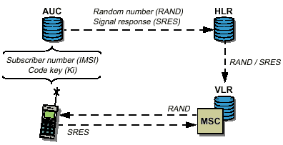
Authentication in GSM

Encryption
Since radio communications can be intercepted by practically anyone in the immediate surroundings, protection against eavesdropping is an important service in a mobile network.
The best solution is an encrypted air interface, for both traffic and control channels. Since encryption of voice requires digital coding, it cannot be used in analog mobile networks. Control channels can, in principle, be encrypted in both analog and digital systems, but encryption is more common in mobile networks that use digital control channels, such as GSM and D-AMPS.

In GSM, voice is encrypted as follows: In addition to SRES, the AUC calculates an encryption key (Kc) based on Ki and RAND. This key is stored in the HLR together with RAND and SRES. In connection with authentication, the mobile calculates a Kc value based on the RAND value received from the MSC and on the Ki value stored in the mobile. If the result of the authentication is approved, the MSC will store the encryption key in the base station (via the BSC) for use in encryption/decryption operations. The BSC then sends a "test signal" (encryption mode command) to the mobile. In response, the mobile should generate an encrypted signal (encryption mode complete) which - if the BSC can interpret it - permits continued signaling and communication. All signals, including voice signals, are encrypted.
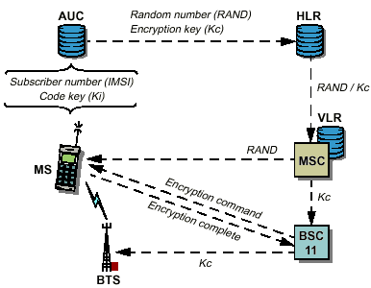
Figure for Encryption in GSM

Equipment identification
The purpose of equipment identification is to ensure that no stolen or otherwise unauthorized mobiles are used in the network. To this end, every mobile is provided with a tamper-proof equipment number in the manufacturing process, in GSM an international mobile equipment identity (IMEI). During the set-up phase, the MSC can request this number from the mobile and then send it on for checking in the network element called EIR (in GSM). If the number is barred or unknown, the set-up attempt is rejected.
Subscriber identity confidentiality
Subscriber identity confidentiality means that the operator tries to protect the user's telephone number (the IMSI) from unauthorized tapping. A temporary mobile subscriber number (TMSI in GSM) is used in the dialogue between the mobile and the network, except for the first contact attempt in a set-up phase. The MSC gives the mobile a random TMSI for each set-up.

LOCATION AREA IDENTITY (LAI)

It identifies the current location of the subscriber.

LAI=MNC+MCC+LAC
Where:

MCC= Mobile Country Code
MNC= Mobile Network Code (2 digit). Identifies the GSM PLMN in that country and takes the same value as the MNC in IMSI.
LAC= Location Area Code (max. 16 bits). Identifies a location area within a GSM PLMN Network & enabling 65536 different location areas to be defined in one GSM PLMN.

SUBSCRIBER AUTHENTICATION KEY (Ki)

It is used to authenticate the SIM card.

PERSONAL IDENTITY NO.

It is used to unlock the MS. If one enters the wrong PIN three times it will lock the SIM. The SIM can be protected by use of PIN password.

PIN UNBLOCKING KEY (PUK)

In case of PIN, the PUK is needed for unlocking the SIM again. PUK is numeric only, with eight digits. If a correct PUK is entered, an indication is given to the user. After 10 consecutive incorrect entries the SIM is blocked. Either the IMSI or the MSISDN Number may access the subscriber data. Some of the parameters like IAI will be continuously updated to reflect the current location of the subscriber. The SIM is capable of storing additional information such as accumulated call charges. This information will be accessible to the customer via handset key entry.

Handover
Handover, or handoff as it is called in North America, is the switching of an ongoing call to a different channel or cell. There are four different types of handover in the GSM system, which involve transferring a call between
- Channels (time slots) in the same cell,
- Cells (Base Transceiver Stations) under the control of the same Base Station Controller (BSC),
- Cells under the control of different BSCs, but belonging to the same Mobile services Switching Center (MSC), and
- Cells under the control of different MSCs.
The first two types of handover, called internal handovers, involve only one Base Station Controller (BSC). To save signaling bandwidth, they are managed by the BSC without involving the Mobile service Switching Center (MSC), except to notify it at the completion of the handover. The last two types of handover, called external handovers, are handled by the MSCs involved. Note that call control, such as provision of supplementary services and requests for further handoffs, is handled by the original MSC.
Handovers can be initiated by either the mobile or the MSC (as a means of traffic load balancing). During its idle time slots, the mobile scans the Broadcast Control Channel of up to 16 neighboring cells, and forms a list of the six best candidates for possible handover, based on the received signal strength. This information is passed to the BSC and MSC, and is used by the handover algorithm.
The algorithm for when a handover decision should be taken is not specified in the GSM recommendations. There are two basic algorithms used, both closely tied in with power control. This is because the BSC usually does not know whether the poor signal quality is due to multipath fading or to the mobile having moved to another cell. This is especially true in small urban cells.
The 'minimum acceptable performance' algorithm [Bal91] gives precedence to power control over handover, so that when the signal degrades beyond a certain point, the power level of the mobile is increased. If further power increases do not improve the signal, then a handover is considered. This is the simpler and

more common method, but it creates 'smeared' cell boundaries when a mobile transmitting at peak power goes some distance beyond its original cell boundaries into another cell.
The 'power budget' method [Bal91] uses handover to try to maintain or improve a certain level of signal quality at the same or lower power level. It thus gives precedence to handover over power control. It avoids the 'smeared' cell boundary problem and reduces co-channel interference, but it is quite complicated.

Intra –MSC Handover

- The MS determines that a handover is required, it sends the Measurement Report message to the serving BSS. This message contains the signal strength measurements.
- The serving BSS sends a Handover Request message to the MSC. This message contains a rank-ordered list of the target BSSs that are qualified to receive the call.
- The MSC reviews the global cell identity associated with the best candidate to determine if one of the BSSs that it controls is responsible for the cell area. In this scenario the MSC determines that the cell area is associated with the target BSS. To perform an intra-MSC handover, two resources are required: a trunk between the MSC and the target BSS and a radio TCH in the new cell area. The MSC reserves a rank and sends a Handover Request message to the target BSS. This message includes the desired cell area for handover, the identity of the MSC-BSS trunk that was reserved, and the encryption key ( ).
- The target BSS selects and reserves the appropriate resources to support the handover pending the connection execution. The target BSS sends a Handover Request Acknowledgment to the MSC. The message contains the new radio channel identification.
- The MSC sends the Handover Command message to the serving BSS. In this message the new radio channel identification supplied by the target BSS is included.
- The serving BSS forwards the Handover Command message t o the MS.
- The MS retunes to the new radio channel and sends the Handover Access message to the target BSS on the new radio channel.

- The target BSS sends the Physical Information message to the MS.
- The target BSS informs the MSC when it begins detecting the MS handing over with the Handover Detected message.
- The target BSS and the MS exchange messages to synchronize/align the Ms’s transmission in the proper time slot. On the completion, the MS sends the Handover Completed message to the target BSS.
- The MSC sends a Release message to other serving BSS to release the old radio TCH.
- At this point, the serving BSS releases all resources with the MS and sends the Release Complete message to the MSC.

INTER-MSC HANDOVER
In this scenario we assume that a call has already been established. The serving BSS is connected to the serving MSC and the target BSS to the target MSC.
- Same as step 1 in the intra-MSC handover.
- Same as step 2 in the intra-MSC handover.
- When a call is handed over from the serving MSC to the target MSC via PSTN, the serving MSC sets up an inter-MSC voice connection by placing a call to the directory number that belongs to the target MSC. When the serving MSC places this call, the PSTN is unaware that the call is a handover and follows the normal call routing procedures, delivering the call to the target MSC. The serving MSC sends a Prepare Handover message to the target MSC.
- The target MSC sends an Allocate Handover message to its VLR to assign the TMSI.
- The target VLR sends the TMSI in the Send Handover Report message.
- Same as step 3 in the intra-MSC handover.
- Same as step 4 in the intra-MSC handover.
- The target MSC sends the Prepare Handover (acknowledge) message to the serving MSC indicating that is ready for the handover.
- The serving MSC sends the Send Handover (acknowledge) message to the target MSC.

- The target MSC sends a Send Handover Request (acknowledge) message to the target VLR.
- Same as step 5 in the intra-MSC handover.
- Same as step 6 in the intra-MSC handover.
- Same as step 7 in the intra-MSC handover.
- Same as step 8 in the intra-MSC handover.
- Same as step 9 in the intra-MSC handover.
- Same as step 10 in the intra-MSC handover.
- Same as step 11 in the intra-MSC handover.
- The target MSC sends a Process Access Signaling message to the serving MSC.
- At this point the handover has been completed, and the target MSC sends a Send End Signal message to the serving MSC.
- Same as step 12 in the intra-MSC handover.
- Same as step 13 in the intra-MSC handover.
- The serving MSC sends a Send End Signal (acknowledge) message to the target MSC.

Location updating and call routing
The MSC provides the interface between the GSM mobile network and the public fixed network. From the fixed network's point of view, the MSC is just another switching node. However, switching is a little more complicated in a mobile network since the MSC has to know where the mobile is currently roaming - and in GSM it could even be roaming in another country. The way GSM accomplishes location updating and call routing to the mobile is by using two location registers: the Home Location Register (HLR) and the Visitor Location Register (VLR).
Location updating is initiated by the mobile when, by monitoring the Broadcast Control Channel, it notices that the location area broadcast is not the same as the one previously stored in the mobile's memory. An update request and the IMSI or previous TMSI is sent to the new VLR via the new MSC. A Mobile Station Roaming Number (MSRN) is allocated and sent to the mobile's HLR (which always keeps the most current location) by the new VLR. The MSRN is a regular telephone number that routes the call to the new VLR and is subsequently translated to the TMSI of the mobile. The HLR sends back the necessary call control parameters, and also sends a cancel message to the old VLR, so that the previous MSRN can be reallocated. Finally, a new TMSI is allocated and sent to the mobile, to identify it in future paging or call initiation requests.
With the above location updating procedure, call routing to a roaming mobile is easily performed. The most general case is where a call from a fixed network (Public Switched Telecommunications Network or Integrated Services Digital Network) is placed to a mobile subscriber. Using the Mobile Subscriber's telephone number (MSISDN, the ISDN numbering plan), the call is routed through the fixed land network to a gateway MSC for the GSM network (an MSC that interfaces with the fixed land network, thus requiring an echo canceller). The gateway MSC uses the MSISDN to query the Home Location Register, which returns the current roaming number (MSRN). The MSRN is used by the gateway MSC to route the call to the current MSC (which is usually coupled with the VLR). The VLR then converts the roaming number to the mobile's TMSI, and the cells under the control of the current BSC to inform the mobile broadcast a paging call.

Value added services

Call waiting

With Call Waiting on a Hutch phone, you can receive and hold an incoming call when you are already talking to another person. When this service is activated, the network notifies you of a new incoming call while you have a call in progress, which means that if another person tries calling you midway through a conversation, he/she will hear a message informing him/her that your line is busy, while you will hear beeps at intervals.

Call Divert
In case you are busy in a meeting, or if your cell phone is switched off, you can forward incoming calls to a landline or another mobile phone - where someone can receive messages on your behalf. You can also forward an incoming call while speaking to someone.

Voice response services
By using these services one can access information, download ringtones and logos, and more. For this one has to just dial and speak on a no. for the desired service. With Hutch World, one can enjoy a host of GPRS-based services exclusively on Hutch GPRS phone. From astrology to photo messaging, gaming, chat, news and even internet access.

Mail
One can now send an SMS - without even using a mobile phone, from wherever they are. All they need to do is type in their message and send it as e-mail.

Roaming
Roaming is defined as the ability for a cellular customer to automatically make & receive voice calls, send & receive data, or access other services when traveling outside the geographical coverage area of the home network, by means of using a visited network.
If the visited network is in the same country as the home network, this is known as National Roaming. If the visited network is outside the home country, this is known as International Roaming (the term Global Roaming has also been used).
If the visited network operates on a different technical standard than the home network, this is known as Inter-standard roaming.
GSM Roaming, which involves roaming between GSM networks, offers the convenience of a single number, a single bill and a single phone with worldwide access to over 205 countries. The convenience of GSM Roaming has been a key driver behind the global success of the GSM Platform.
GSM Coverage Maps is a unique resource containing information supplied and approved by the members of the GSM Association.
Network, Services and Roaming information are continually updated to reflect the evolving situation worldwide. Interactive coverage maps, updated quarterly, allow you to navigate to see where exactly you can use your phone.

SMS
The Short Message Service (SMS) is the ability to send and receive text messages to and from mobile telephones. The text can comprise of words or numbers or an alphanumeric combination. SMS was created as part of the GSM Phase 1 standard. The first short message is believed to have been sent in December 1992 from a Personal Computer (PC) to a mobile phone on the Vodafone GSM network in the UK. Each short message is up to 160 characters is length when Latin alphabets are used, and 70 characters in length when non-Latin alphabets such as Arabic and Chinese are used.
- Consumer Applications using SMS
The vast majority of SMS usage is accounted for by consumer applications. The main consumer applications based on SMS are:
- SIMPLE PERSON-TO-PERSON MESSAGING
- VOICE AND FAX MAIL NOTIFICATIONS
- UNIFIED MESSAGING
- INTERNET EMAIL ALERTS
- RINGTONES
- CHAT
- INFORMATION SERVICES
- Corporate Applications using SMS
Corporate applications that use the Short Message Service are currently few and far between. Most of the SMS messaging volumes are generated by consumer applications. The main corporate applications based on SMS are:
- CORPORATE EMAIL
- AFFINITY PROGRAMS
- MOBILE BANKING
- ELECTRONIC COMMERCE
- CUSTOMER SERVICE
- VEHICLE POSITIONING
- JOB DISPATCH
- REMOTE POINT OF SALE
- OVER THE AIR
- REMOTE MONITORING

MMS
Multimedia Messaging Service (MMS) is a store and forward messaging service that allows mobile subscribers to exchange multimedia messages with other mobile subscribers. As such it can be seen as an evolution of SMS, with MMS supporting the transmission of additional media types:
- text
- picture
- audio
- video
- combinations of the above
Multimedia Messaging Service (MMS) is an important emerging service, which allows the sending of multiple media in a single message, and the ability to send a message to multiple recipients. The originator can easily create a Multimedia Message, either using a built-in or accessory camera, or can use images and sounds stored previously in the phone (and possibly downloaded from a web site).
Even if the recipient phone is not switched on, the Multimedia Message will be stored and sent to the recipient as soon as they switch on their phone. In a non-roaming case, it is expected that the subscriber will allow a Multimedia Message to be downloaded automatically to their phone and then they would be notified and could see the Multimedia Message immediately.

A number of Multimedia Messages can be stored in the users handset and reviewed or forwarded at a later date.

Each Multimedia Message contains a number of pages. On each page, there can be one image and one set of text. An audio file can also be attached. The time that each “page” is displayed can be specified, so the user experience is somewhat like a slide show.

How does MMS work?

Depending upon the operator, a typical example of how an MMS message can be sent and received between two compatible MMS phones is detailed below:

STEP 1: |  | Using an MMS compatible phone, take a photo.
STEP 2: |  | Use your phone to personalize the message by adding text, sound clip or your own voice.
STEP 3: |  | Send the MMS message

On a compatible phone, the MMS message will appear with a new message alert. The picture message will open on the screen, the text will appear below the image and the sound will begin to play automatically.

If the message is sent to a non-compatible MMS phone the user will receive a SMS message along the lines of:
"You have been sent a picture message!"

They may then be given a website address, and possibly and username and password on which they can view the message.

System Interface

